云南大学数学与统计学院

上机实践报告

|  |  |  |
| --- | --- | --- |
| **课程名称**：数据结构与算法实验 | **年级**：2015级 | **上机实践成绩**： |
| **指导教师**：陆正福 | **姓名**：刘鹏 |  |
| **上机实践名称**：树结构实验 | **学号**：20151910042 | **上机实践日期**：2017-05-03 |
| **上机实践编号**：No.08 | **组号**： | **上机实践时间**：上午3、4节 |

# 一、实验目的

1. 熟悉与树和二叉树有关的数据结构与算法；

2. 熟悉主讲教材Chapter 8的代码片段。

# 二、实验内容

# 三、实验平台

Windows 10 1703 Enterprise 中文版；

Python 3.6.0；

Wing IDE Professional 6.0.5-1集成开发环境。

# 四、实验记录与实验结果分析

1题

程序代码：

|  |  |
| --- | --- |
| 1  2  3  4  5  6  7  8  9  10  11  12  13  14  15  16  17  18  19  20  21  22  23  24  25  26  27  28  29  30  31  32  33  34  35  36  37  38  39  40  41  42  43  44  45  46  47  48  49  50  51  52  53  54  55  56  57  58  59  60  61  62  63  64  65  66  67  68  69  70  71  72  73  74  75  76  77  78  79  80  81  82  83  84  85  86  87  88  89  90  91  92  93  94  95  96  97  98  99  100  101  102  103  104  105  106  107  108  109  110  111  112  113  114  115  116  117  118  119  120  121  122  123  124  125  126  127  128  129  130  131  132  133  134  135  136  137  138  139  140  141  142  143  144  145  146  147  148  149  150  151  152  153  154  155  156  157  158  159  160  161  162  163  164  165  166  167  168  169  170  171  172  173  174  175  176  177  178  179  180  181  182  183  184  185  186  187  188  189  190  191  192  193  194  195  196  197  198  199  200  201  202  203  204  205  206  207  208  209  210  211  212  213  214  215  216  217  218  219  220  221  222  223  224  225  226  227  228  229  230  231  232  233  234  235  236  237  238  239  240  241  242  243  244  245  246  247  248  249  250  251  252  253  254  255  256  257  258  259  260  261  262  263  264  265  266  267  268  269  270  271  272  273  274  275  276  277  278  279  280  281  282  283  284  285  286  287  288  289  290  291  292  293  294 | # 8.2.1 The Binary Tree Abstrct Data Type  **class** **Tree:**  """Abstract base class representing a tree structure."""  #------------------- nested Position class -------------------  **class** **Position:**  """An abstraction representing the location of a single element."""  **def** element**(**self**):**  """Return the element stored at this Position."""  **raise** NotImplementedError**(**'must be implemented by subclass'**)**  **def** __eq__**(**self**,**other**):**  """Return True if other Positon represents the same location."""  **raise** NotImplementedError**(**'must be implemented by subclass'**)**  **def** __ne__**(**self**,**other**):**  """Return True if other does not represent the same location."""  **return** **not** **(**self **==** other**)**  #---------- abstract methods that concrete subclass must support ----------  **def** root**(**self**):**  """Return Position representing the tree's root (or None if empty)."""  **raise** NotImplementedError**(**'must be implemented by subclass'**)**  **def** parent**(**self**,**p**):**  """Return Position representing p's parent (or None if p is root)."""  **raise** NotImplementedError**(**'must be implemented by subclass'**)**  **def** num_children**(**self**,**p**):**  """Return the number of children that Position p has."""  **raise** NotImplementedError**(**'must be implemented by subclass'**)**  **def** children**(**self**,**p**):**  """Generate an iteration of Positions representing p's children."""  **raise** NotImplementedError**(**'must be implemented by subclass'**)**  **def** __len__**(**self**):**  """Return the total number of elements in the tree."""  **raise** NotImplementedError**(**'must be implemented by subclass'**)**  #---------- concrete methods implemented in this class ----------  **def** is_root**(**self**,**p**):**  """Return True if Position p represents the root of the tree."""  **return** self**.**root**()** **==** p  **def** is_leaf**(**self**,**p**):**  """Return True if Positoin p does not have any children."""  **return** self**.**num_children **==** 0  **def** is_empty**(**self**):**  """Return True if the tree is empty."""  **return** len**(**self**)** **==** 0  #---------- new methods in this section ----------  **def** depth**(**self**,**p**):**  """Return the number of levels separating Positon p from the root."""  **if** self**.**is_root**(**p**):**  **return** 0  **else:**  **return** 1 **+** self**.**depth**(**self**.**parent**(**p**))**  **def** _height1**(**self**):** # works, but O(n^2) worst-case time  """Return the height of the tree."""  **return** max**(**self**.**depth**(**p**)** **for** p **in** self**.**positions**()** **if** self**.**is_leaf**(**p**))**  **def** _height2**(**self**,**p**):**  """Ruturn the height of the subtree rooted at Postion p."""  **if** self**.**is_leaf**(**p**):**  **return** 0  **else:**  **return** 1 **+** max**(**self**.**_height2**(**c**)** **for** c **in** self**.**children**(**p**))**  **def** height**(**self**,**p**=None):**  """Return the height of the subtree rooted ar Position p.  If p is None, return the height of the entire tree.  """  **if** p **is** **None:**  p **=** self**.**root**()**  **return** self**.**_height2**(**p**)** # start _height2 recursion  **class** **BinaryTree(**Tree**):**  """Abstract base class representint a bianry tree structure."""  #--------------------- additional abstract methods ---------------------  **def** left**(**self**,**p**):**  """Return a Position representing p's left child.  Return None if p does not have a left child.  """  **raise** NotImplementedError**(**'must be implemented by subclass'**)**  **def** right**(**self**,**p**):**  """Return a Position representing p's right child.  Return None if p does not have a right child.  """  **raise** NotImplementedError**(**'must be implemented by subclass'**)**  #---------- concrete methods implemented in this class ----------  **def** sibling**(**self**,**p**):**  """  Return a Position representing p's sibling  (or None if no sibling).  """  parent **=** self**.**parent**(**p**)**  **if** parent **is** **None:** # p must be the root  **return** **None** # root has no sibling  **else:**  **if** p **==** self**.**left**(**parent**):**  **return** self**.**right**(**parent**)** # possibly None  **else:**  **return** self**.**left**(**parent**)** # possibly None  **def** children**(**self**,**p**):**  """Generate an iteration of Positions representing p's children."""  **if** self**.**left**(**p**)** **is** **not** **None:**  **yield** self**.**left**(**p**)**  **if** self**.**right**(**p**)** **is** **not** **None:**  **yield** self**.**right**(**p**)**  **class** **LinkedBinaryTree(**BinaryTree**):**  """Linked representation of a binary tree structure."""  **class** **_Node:** # Lightweight, nonpublic class for storing a node.  __slots__ **=** '_element'**,**'_parent'**,**'_left'**,**'_right'  **def** __init__**(**self**,**element**,**parent**=None,**left**=None,**right**=None):**  self**.**_element **=** element  self**.**_parent **=** parent  self**.**_left **=** left  self**.**_right **=** right  **class** **Position(**BinaryTree**.**Position**):**  """An abstraction representing the location of a single element."""  **def** __init__**(**self**,**container**,**node**):**  """Constructor should not be invoked by user."""  self**.**_container **=** container  self**.**_node **=** node  **def** element**(**self**):**  """Return the element stored at this Position."""  **return** self**.**_node**.**_element  **def** __eq__**(**self**,**other**):**  """Return True if other is a Position representing  the same location."""  **return** type**(**other**)** **is** type**(**self**)** **and** other **.**_node **is** self**.**_node  **def** _validate**(**self**,**p**):**  """Return associated node, if position is valid."""  **if** **not** isinstance**(**p**,**self**.**Position**):**  **raise** TypeError**(**'p must be proper Positon type'**)**  **if** p**.**_container **is** **not** self**:**  **raise** ValueError**(**'p does not belong to this type'**)**  **if** p**.**_node**.**_parent **is** p**.**_node**:** # convention for deprecated nodes  **raise** ValueError**(**'p is not longer valid'**)**  **return** p**.**_node  **def** _make_position**(**self**,**node**):**  """Return Position instance for given node (or None if no node)."""  **return** self**.**Position**(**self**,**node**)if** node **is** **not** **None** **else** **None**  #---------------------- binary tree constructor ----------------------  **def** __init__**(**self**):**  """Create an initially empty binary tree."""  self**.**_root **=** **None**  self**.**_size **=** 0  #-------------------------- public accessors --------------------------  **def** __len__**(**self**):**  """Return the total number of elements in the tree."""  **return** self**.**_size  **def** root**(**self**):**  """Return the root Position of the tree (or None if tree is empty)."""  **return** self**.**_make_position**(**self**.**_root**)**  **def** parent**(**self**,**p**):**  """Return the Position of p's parent (or None if p is root)."""  node **=** self**.**_validate**(**p**)**  **return** self**.**_make_position**(**node**.**_parent**)**  **def** left**(**self**,**p**):**  """Return the Position of p's left child (or None if no left child)."""  node **=** self**.**_validate**(**p**)**  **return** self**.**_make_position**(**node**.**_left**)**  **def** right**(**self**,**p**):**  """  Return the Position of p's right child  (or None if no right child).  """  node **=** self**.**_validate**(**p**)**  **return** self**.**_make_position**(**node**.**_right**)**  **def** num_children**(**self**,**p**):**  """Return the number of children of Position p."""  node **=** self**.**_validate**(**p**)**  count **=** 0  **if** node**.**_left **is** **not** **None:** # left child exists  count **+=** 1  **if** node**.**_right **is** **not** **None:** # right child exists  count **+=** 1  **return** count  **def** _add_root**(**self**,**e**):**  """Place element e at the root of an empty tree and return new Position.    Raise ValueError if tree is nonempty.  """  **if** self**.**_root **is** **not** **None:** **raise** ValueError**(**'Root exists'**)**  self**.**_size **=** 1  self**.**_root **=** self**.**_Node**(**e**)**  **return** self**.**_make_position**(**self**.**_root**)**  **def** _add_left**(**self**,**p**,**e**):**  """Create a new left child for Position p, storing element e.    Return the Position of new node.  Raise ValueError if Position p is invalid or p already has a left child.  """  node **=** self**.**_validate**(**p**)**  **if** node**.**_left **is** **not** **None:** **raise** ValueError**(**'Left child exists'**)**  self**.**_size **+=** 1  node**.**_left **=** self**.**_Node**(**e**,**node**)** # node is its parent  **return** self**.**_make_position**(**node**.**_left**)**  **def** _add_right**(**self**,**p**,**e**):**  """Create a new right child for Position p, storing element e.    Return the Position of new node.  Raise ValueError if Position p is invalid or p already has  a righr child.  """  node **=** self**.**_validate**(**p**)**  **if** node**.**_right **is** **not** **None:** **raise** ValueError**(**'Right chid exists'**)**  self**.**size **+=** 1  node**.**_right **=** self**.**_Node**(**e**,**node**)** # node is its parent  **return** self**.**_make_position**(**node**.**_right**)**  **def** _replace**(**self**,**p**,**e**):**  """Replace the element at position p with e, and return old element."""  node **=** self**.**_validate**(**p**)**  old **=** node**.**_element  node**.**_element **=** e  **return** old  **def** _delete**(**self**,**p**):**  """Delete the node at Positon p, and replace it with its child, if any.    Return the element that had been stored at Position p.  Raise ValueError if Position p is invalid or p has two children.  """  node **=** self**.**_validate**(**p**)**  **if** self**.**num_children**(**p**)** **==** 2**:** **raise** ValueError**(**'p has two children'**)**  child **=** node**.**_left **if** node**.**_left **else** node**.**_right # might be None  **if** child **is** **not** **None:**  child**.**_parent **=** node**.**_parent # child's grandparent becomes parent  **if** node **is** self**.**_root**:**  self**.**_root **=** child # child becomes root  **else:**  parent **=** node**.**_parent  **if** node **is** parent**.**_left**:**  parent**.**_left **=** child  **else:**  parent**.**right **=** child  self**.**_size **-=** 1  node**.**_parent **=** node # convention for deprecated node  **return** node**.**_element  **def** _attach**(**self**,**p**,**t1**,**t2**):**  """Atach trees t1 and t2 as left and right subtrees of external p."""  node **=** self**.**_validate**(**p**)**  **if** **not** self**.**is_leaf**(**p**):** **raise** ValueError**(**'position must be leaf'**)**  **if** **not** type**(**self**)** **is** type**(**t1**)** **is** type**(**t2**):**  # all 3 trees must be same type  **raise** TypeError**(**'Tree type must match'**)**  self**.**_size **+=** len**(**t1**)** **+** len**(**t2**)**  **if** **not** t1**.**is_empty**():** # attached t1 as left subtree of node  t1**.**_root**.**_parent **=** node  node**.**_left **=** t1**.**_root  t1**.**_root **=** **None** # set t1 instance to empty  t1**.**_size **=** 0  **if** **not** t2**.**is_empty**:** # attached t2 as right subtree of node  t2**.**_root**.**_parent **=** node  node**.**_right **=** t2**.**_root  t2**.**_root **=** **None** # set t2 instance to empty  t2**.**_size **=** 0  #----------------------------- my main function ----------------------------- |

运行结果：

2题

程序代码：

|  |  |
| --- | --- |
| 1  2  3  4  5  6  7  8  9  10  11  12  13  14  15  16  17  18  19  20  21  22  23  24  25  26  27  28  29  30  31  32  33  34  35  36  37  38  39  40  41  42  43  44  45  46  47  48  49  50  51  52  53  54  55  56  57  58  59  60  61  62  63  64  65  66  67  68  69  70  71  72  73  74  75  76  77  78  79  80  81  82  83  84  85  86  87  88  89  90  91  92  93  94  95  96  97  98  99  100  101  102  103  104  105  106  107  108  109  110  111  112  113  114  115  116  117  118  119  120  121  122  123  124  125  126  127  128  129  130  131  132  133  134  135  136  137  138  139  140  141  142  143  144  145  146  147  148  149  150  151  152  153  154  155  156  157  158  159  160  161  162  163  164  165  166  167  168  169  170  171  172  173  174  175  176  177  178  179  180  181  182  183  184  185  186  187  188  189  190  191  192  193  194  195  196  197  198  199  200  201  202  203  204  205  206  207  208  209  210  211  212  213  214  215  216  217  218  219  220  221  222  223  224  225  226  227  228  229  230  231  232  233  234  235  236  237  238  239  240  241  242  243  244  245  246  247  248  249  250 | # 8.4.4 Implementing Tree Traversals in Python  **class** **LinkedQueue:**  """FIFO queue implementation using a singly linked list for storage."""    **class** **_Node:**  """Lightweight, nonpublic class for storing a singly linked node."""  __slots__ **=** '_element'**,**'_next' # streamline memory usage    **def** __init__**(**self**,**element**,**next**):** # initialize node's field  self**.**_element **=** element # reference to user's element  self**.**_next **=** next # reference to next node  **def** __init__**(**self**):**  """Create an empty queue."""  self**.**_head **=** **None**  self**.**_tail **=** **None**  self**.**_size **=** 0 # number of queue elements  **def** __len__**(**self**):**  """Return the number of elements in the queue."""  **return** self**.**_size  **def** is_empty**(**self**):**  """Return True if the queue is empty."""  **return** self**.**_size **==** 0  **def** first**(**self**):**  """Return (but do not remove) the element at the front of the queue."""  **if** self**.**is_empty**():**  **raise** Empty**(**'Queue is empty'**)**  **return** self**.**_head**.**_element # front aligned with head of list  **def** dequeue**(**self**):**  """Remove and return the first element of the queue (i.e., FIFO).    Raise Empty exception if the queue is empty.  """  **if** self**.**is_empty**():**  **raise** Empty**(**'Queue is empty'**)**  answer **=** self**.**_head**.**_element  self**.**_head **=** self**.**_head**.**_next  self**.**_size **-=** 1  **if** self**.**is_empty**():** # special case as queue is empty  self**.**_tail **=** **None** # removed head had been the tail  **return** answer  **def** enqueue**(**self**,**e**):**  """Add an element to the back of queue."""  newest **=** self**.**_Node**(**e**,None)** # node will be new tail node  **if** self**.**is_empty**():**  self**.**_head **=** newest # special case: previously empty  **else:**  self**.**_tail**.**_next **=** newest  self**.**_tail **=** newest # update reference to tail node  self**.**_size **+=** 1  **class** **Tree:**  """Abstract base class representing a tree structure."""  #----------------------- nested Position class -----------------------  **class** **Position:**  """An abstraction representing the location of a single element."""  **def** element**(**self**):**  """Return the element stored at this Position."""  **raise** NotImplementedError**(**'must be implemented by subclass'**)**  **def** __eq__**(**self**,**other**):**  """Return True if other Positon represents the same location."""  **raise** NotImplementedError**(**'must be implemented by subclass'**)**  **def** __ne__**(**self**,**other**):**  """Return True if other does not represent the same location."""  **return** **not** **(**self **==** other**)**  #---------- abstract methods that concrete subclass must support ----------  **def** root**(**self**):**  """Return Position representing the tree's root (or None if empty)."""  **raise** NotImplementedError**(**'must be implemented by subclass'**)**  **def** parent**(**self**,**p**):**  """Return Position representing p's parent (or None if p is root)."""  **raise** NotImplementedError**(**'must be implemented by subclass'**)**  **def** num_children**(**self**,**p**):**  """Return the number of children that Position p has."""  **raise** NotImplementedError**(**'must be implemented by subclass'**)**  **def** children**(**self**,**p**):**  """Generate an iteration of Positions representing p's children."""  **raise** NotImplementedError**(**'must be implemented by subclass'**)**  **def** __len__**(**self**):**  """Return the total number of elements in the tree."""  **raise** NotImplementedError**(**'must be implemented by subclass'**)**  #---------- concrete methods implemented in this class ----------  **def** is_root**(**self**,**p**):**  """Return True if Position p represents the root of the tree."""  **return** self**.**root**()** **==** p  **def** is_leaf**(**self**,**p**):**  """Return True if Positoin p does not have any children."""  **return** self**.**num_children **==** 0  **def** is_empty**(**self**):**  """Return True if the tree is empty."""  **return** len**(**self**)** **==** 0  #---------- new methods in this section ----------  **def** depth**(**self**,**p**):**  """Return the number of levels separating Positon p from the root."""  **if** self**.**is_root**(**p**):**  **return** 0  **else:**  **return** 1 **+** self**.**depth**(**self**.**parent**(**p**))**  **def** _height1**(**self**):** # works, but O(n^2) worst-case time  """Return the height of the tree."""  **return** max**(**self**.**depth**(**p**)** **for** p **in** self**.**positions**()** **if** self**.**is_leaf**(**p**))**  **def** _height2**(**self**,**p**):**  """Ruturn the height of the subtree rooted at Postion p."""  **if** self**.**is_leaf**(**p**):**  **return** 0  **else:**  **return** 1 **+** max**(**self**.**_height2**(**c**)** **for** c **in** self**.**children**(**p**))**  **def** height**(**self**,**p**=None):**  """Return the height of the subtree rooted ar Position p.  If p is None, return the height of the entire tree.  """  **if** p **is** **None:**  p **=** self**.**root**()**  **return** self**.**_height2**(**p**)** # start _height2 recursion    #---------- new method in this section ----------  **def** __iter__**(**self**):**  """Generate an iteration of the tree's elements."""  **for** p **in** self**.**position**():** # use same order as position()  **yield** p**.**element**()** # but yield each element  **def** preorder**(**self**):**  """Generate a preorder iteration of positions in the tree."""  **if** **not** self**.**is_empty**():**  **for** p **in** self**.**_subtree_preorder**(**self**.**root**()):** # start recursion  **yield** p  **def** _subtree_preorder**(**self**,**p**):**  """Generate a preorder iteration of positions in subtree rooted at p."""  **yield** p # visit p before its subtrees  **for** c **in** self**.**children**(**p**):** # # for each child c  **for** other **in** self**.**_subtree_preorder**(**c**):** # do preorder of c's subtree  **yield** other # yielding each to our caller  **def** positions**(**self**):**  """Generate an iteration of the tree's positions."""  **return** self**.**preorder**()** # return entire preorder iteration  **def** postorder**(**self**):**  """Generate a postorder iteration of positions in the tree."""  **if** **not** self**.**is_empty**():**  **for** p **in** self**.**_subtree_preorder**(**self**.**root**()):** # start recursion  **yield** p  **def** _subtree_postorder**():**  """Generate a postorder iteration of postions in subtree rooted at p."""  **for** c **in** self**.**children**(**p**):** # for each child c  **for** other **in** self**.**_subtree_postorder**(**c**):**  # do postorder of c's subtree  **yield** other # yielding each to our caller  **yield** p # visit p after its subtrees    **def** breathfirst**(**self**):**  """Generate a breath-first iteration of the positions of the tree."""  **if** **not** self**.**is_empty**():**  finge **=** LinkedQueue**()** # known positions not yet yielded  fringe**.**enqueue**(**self**.**root**)** # starting with the root  **while** **not** fringe**.**is_empty**():**  p **=** fringe**.**dequeue**()** # renove from front of the queue  **yield** p # report this position  **for** c **in** self**.**children**(**p**):**  fringe**.**enqueue**(**c**)** # add children to back of queue  **class** **BinaryTree(**Tree**):**  """Abstract base class representint a bianry tree structure."""  #--------------------- additional abstract methods ---------------------  **def** left**(**self**,**p**):**  """Return a Position representing p's left child.  Return None if p does not have a left child.  """  **raise** NotImplementedError**(**'must be implemented by subclass'**)**  **def** right**(**self**,**p**):**  """Return a Position representing p's right child.  Return None if p does not have a right child.  """  **raise** NotImplementedError**(**'must be implemented by subclass'**)**  #---------- concrete methods implemented in this class ----------  **def** sibling**(**self**,**p**):**  """  Return a Position representing p's sibling  (or None if no sibling).  """  parent **=** self**.**parent**(**p**)**  **if** parent **is** **None:** # p must be the root  **return** **None** # root has no sibling  **else:**  **if** p **==** self**.**left**(**parent**):**  **return** self**.**right**(**parent**)** # possibly None  **else:**  **return** self**.**left**(**parent**)** # possibly None  **def** children**(**self**,**p**):**  """Generate an iteration of Positions representing p's children."""  **if** self**.**left**(**p**)** **is** **not** **None:**  **yield** self**.**left**(**p**)**  **if** self**.**right**(**p**)** **is** **not** **None:**  **yield** self**.**right**(**p**)**  **def** inorder**(**self**):**  """Generate an inorder iteration of positions in the tree."""  **if** **not** self**.**is_empty**():**  **for** p **in** self**.**_subtree_inorder**(**self**.**root**()):**  **yield** p  **def** _subtree_inorder**(**self**,**p**):**  """Generate an inorder iteration of positinos in subtree rooted at p."""  **if** self**.**left**(**p**)** **is** **not** **None:**  # if left child exists, traverse its subtree  **for** other **in** self**.**_subtree_inorder**(**self**.**left**(**p**)):**  **yield** p  **yield** p # visit p between its subtrees  **if** self**.**right**(**p**)** **is** **not** **None:**  # if right child exists, traverse its subtree  **for** other **in** self**.**_subtree_inorder**(**self**.**right**(**p**)):**  **yield** other    # override inherited version to make inorder the default  **def** positions**(**self**):**  """Generate an iteration of the tree's positions."""  **return** self**.**inorder**()** # make inorder the default  #----------------------------- my main function ----------------------------- |

# 五、教材翻译

**Translation**

**Chapter 8 Trees**

＊第八章 树

8.1 General Trees

＊8.1节 一般的树

Productivity experts say that breakthroughs come by thinking “nonlinearly.” In this chapter, we discuss one of the most important nonlinear data structures in computing – ***trees***. Tree structures are indeed a breakthrough in data organization, for they allow us to implement a host of algorithms much faster than when using linear data structures, such as array-based lists or linked lists. Trees also provide a natural organization for data, and consequently have become ubiquitous structures in file systems, graphical user interfaces, databases, Web sites, and other computer systems.

＊

It is not always clear what productivity experts mean by “nonlinear” thinking, but when we say that trees are “nonlinear,” we are referring to an organizational relationship that is richer than the simple “before” and “after” relationships be- tween objects in sequences. The relationships in a tree are ***hierarchical***, with some objects being “above” and some “below” others. Actually, the main terminology for tree data structures comes from family trees, with the terms “parent,” “child,” “ancestor,” and “descendant” being the most common words used to describe relationships. We show an example of a family tree in Figure 8.1

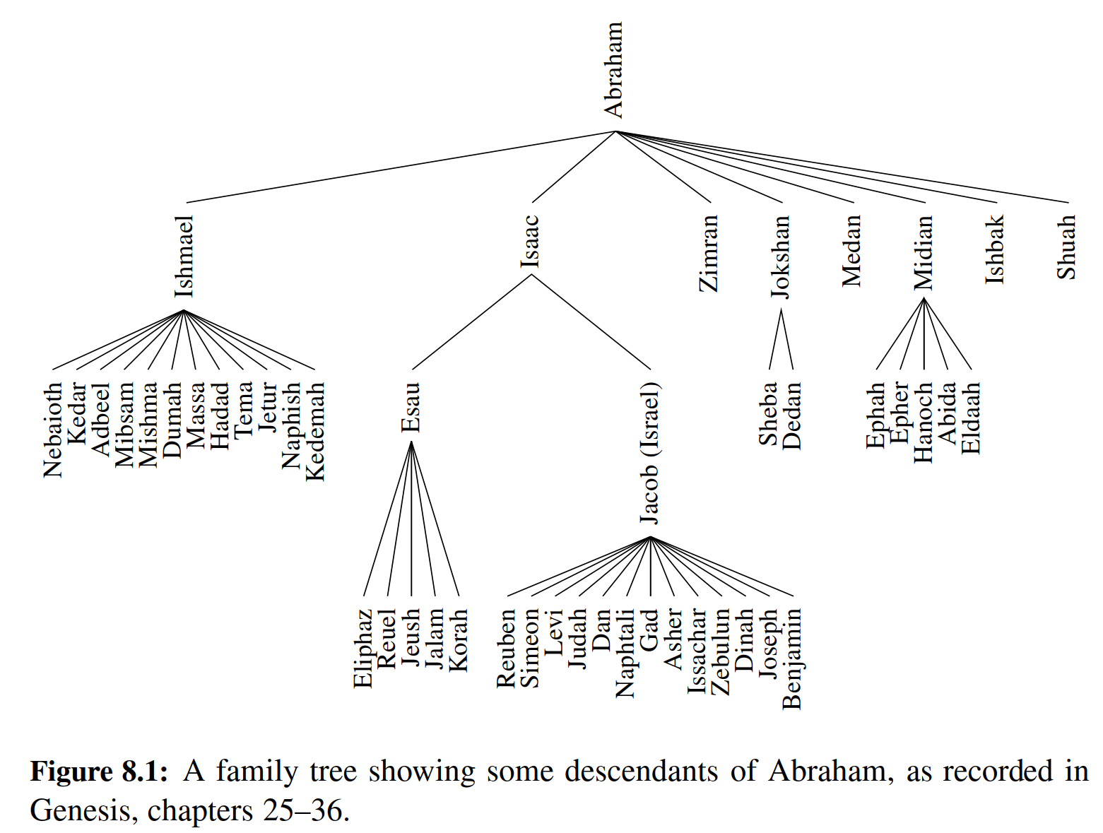

8.1.1 Tree Deﬁnitions and Properties

A tree is an abstract data type that stores elements hierarchically. With the excep- tion of the top element, each element in a tree has a parent element and zero or more children elements. A tree is usually visualized by placing elements inside ovals or rectangles, and by drawing the connections between parents and children with straight lines. (See Figure 8.2.) We typically call the top element the root of the tree, but it is drawn as the highest element, with the other elements being connected below (just the opposite of a botanical tree).

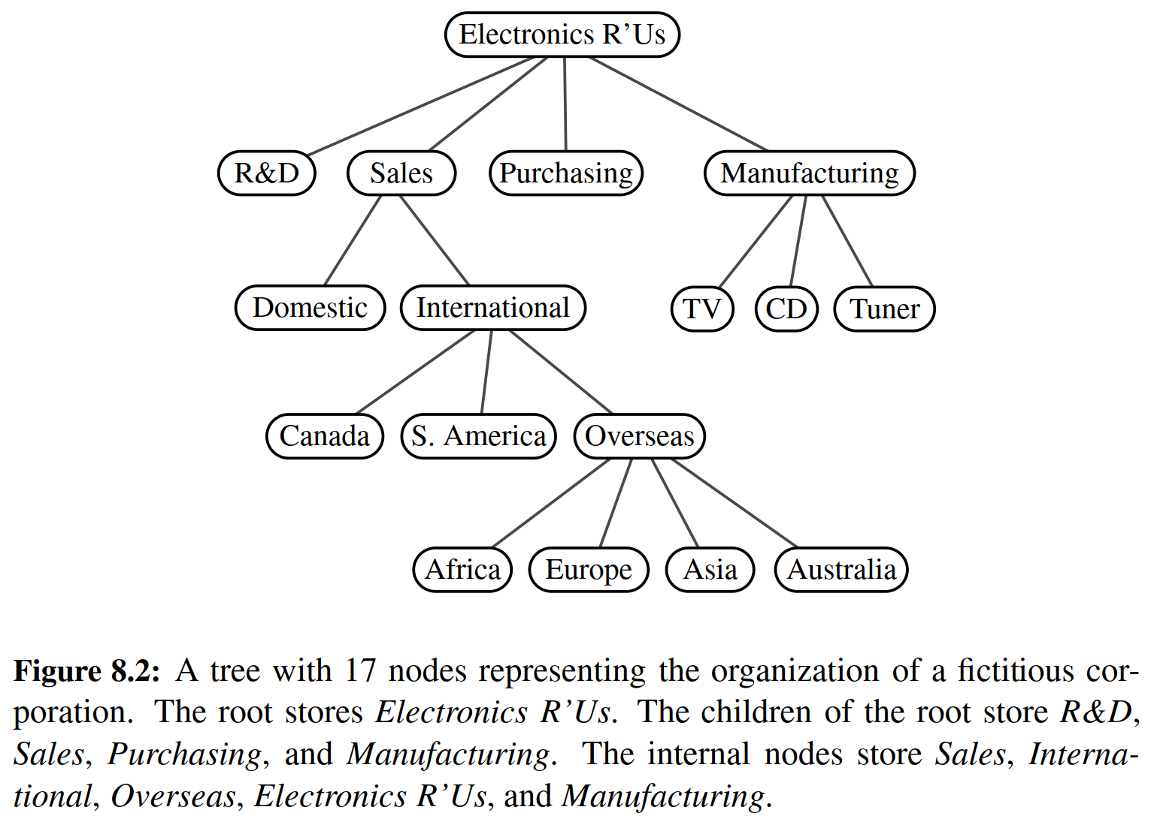

Formal Tree Deﬁnition

Formally, we deﬁne a tree T as a set of nodes storing elements such that the nodes have a parent-child relationship that satisﬁes the following properties:

• If T is nonempty, it has a special node, called the root of T , that has no parent.

Each node v of T different from the root has a unique parent node w; every node with parent w is a child of w.

Note that according to our deﬁnition, a tree can be empty, meaning that it does not have any nodes. This convention also allows us to deﬁne a tree recursively such that a tree T is either empty or consists of a node r, called the root of T , and a (possibly empty) set of subtrees whose roots are the children of r.

Other Node Relationships

Two nodes that are children of the same parent are siblings. A node v is external if v has no children. A node v is internal if it has one or more children. External nodes are also known as leaves.

Example 8.1: In Section 4.1.4, we discussed the hierarchical relationship be- tween ﬁles and directories in a computer’s ﬁle system, although at the time we did not emphasize the nomenclature of a ﬁle system as a tree. In Figure 8.3, we revisit an earlier example. We see that the internal nodes of the tree are associ- ated with directories and the leaves are associated with regular ﬁles. In the UNIX and Linux operating systems, the root of the tree is appropriately called the “root directory,” and is represented by the symbol “/.”

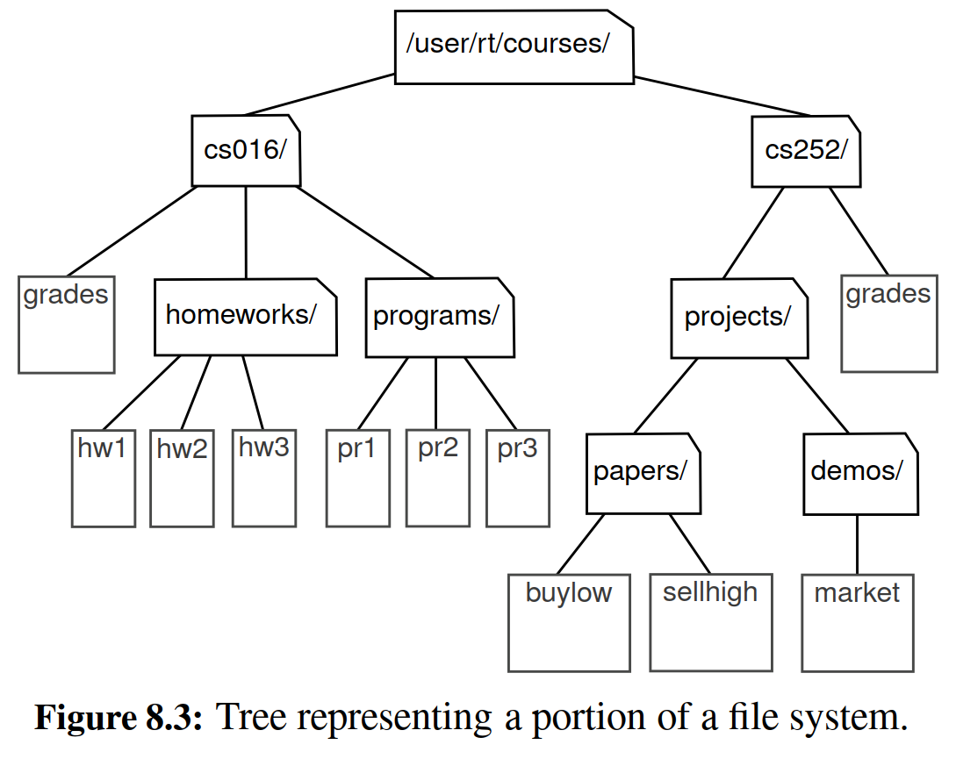

A node u is an ancestor of a node v if u = v or u is an ancestor of the parent of v. Conversely, we say that a node v is a descendant of a node u if u is an ancestor of v. For example, in Figure 8.3, cs252/ is an ancestor of papers/, and pr3 is a descendant of cs016/. The subtree of T rooted at a node v is the tree consisting of all the descendants of v in T (including v itself). In Figure 8.3, the subtree rooted at cs016/ consists of the nodes cs016/, grades, homeworks/, programs/, hw1, hw2, hw3, pr1, pr2, and pr3.

Edges and Paths in Trees

An edge of tree T is a pair of nodes (u, v) such that u is the parent of v, or vice versa. A path of T is a sequence of nodes such that any two consecutive nodes in the sequence form an edge. For example, the tree in Figure 8.3 contains the path (cs252/, projects/, demos/, market).

Example 8.2: The inheritance relation between classes in a Python program forms a tree when single inheritance is used. For example, in Section 2.4 we provided a summary of the hierarchy for Python’s exception types, as portrayed in Figure 8.4 (originally Figure 2.5). The BaseException class is the root of that hierarchy, while all user-deﬁned exception classes should conventionally be declared as descendants of the more speciﬁc Exception class. (See, for example, the Empty class we intro- duced in Code Fragment 6.1 of Chapter 6.)

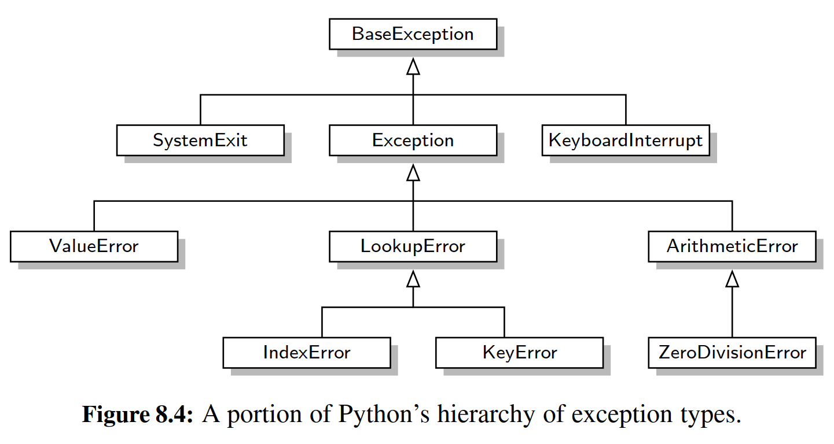

In Python, all classes are organized into a single hierarchy, as there exists a built-in class named object as the ultimate base class. It is a direct or indirect base class of all other types in Python (even if not declared as such when deﬁning a new class). Therefore, the hierarchy pictured in Figure 8.4 is only a portion of Python’s complete class hierarchy.

As a preview of the remainder of this chapter, Figure 8.5 portrays our own hierarchy of classes for representing various forms of a tree.

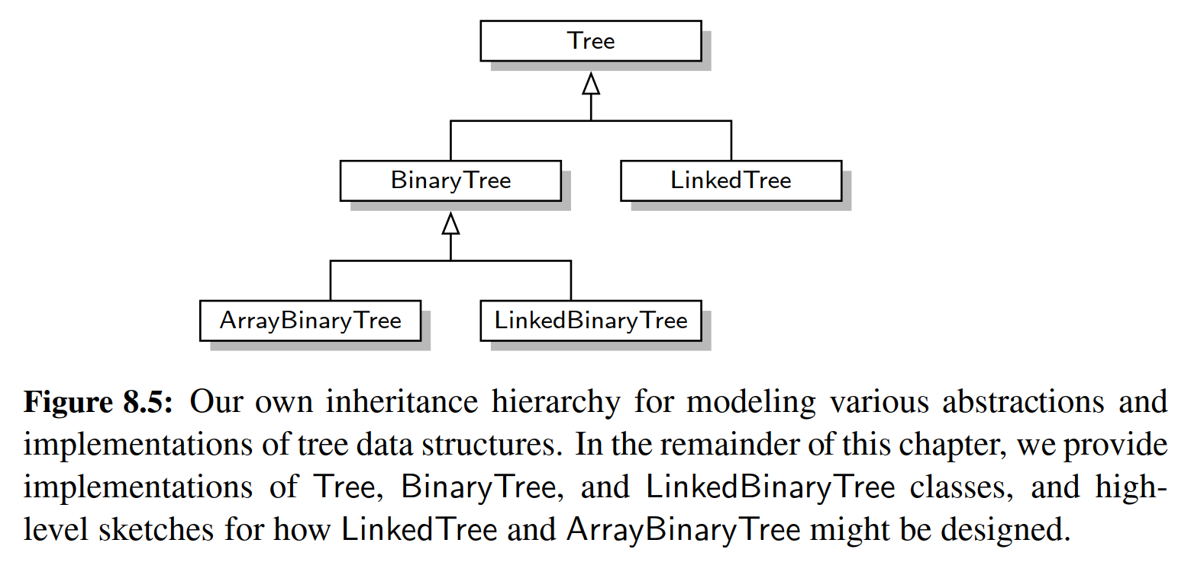

Ordered Trees

A tree is ordered if there is a meaningful linear order among the children of each node; that is, we purposefully identify the children of a node as being the ﬁrst, second, third, and so on. Such an order is usually visualized by arranging siblings left to right, according to their order.

Example 8.3: The components of a structured document, such as a book, are hier- archically organized as a tree whose internal nodes are parts, chapters, and sections, and whose leaves are paragraphs, tables, ﬁgures, and so on. (See Figure 8.6.) The root of the tree corresponds to the book itself. We could, in fact, consider expanding the tree further to show paragraphs consisting of sentences, sentences consisting of words, and words consisting of characters. Such a tree is an example of an ordered tree, because there is a well-deﬁned order among the children of each node.

Let’s look back at the other examples of trees that we have described thus far, and consider whether the order of children is signiﬁcant. A family tree that de- scribes generational relationships, as in Figure 8.1, is often modeled as an ordered tree, with siblings ordered according to their birth.

In contrast, an organizational chart for a company, as in Figure 8.2, is typically considered an unordered tree. Likewise, when using a tree to describe an inher- itance hierarchy, as in Figure 8.4, there is no particular signiﬁcance to the order among the subclasses of a parent class. Finally, we consider the use of a tree in modeling a computer’s ﬁle system, as in Figure 8.3. Although an operating system often displays entries of a directory in a particular order (e.g., alphabetical, chrono- logical), such an order is not typically inherent to the ﬁle system’s representation.

8.1.2 The Tree Abstract Data Type

As we did with positional lists in Section 7.4, we deﬁne a tree ADT using the concept of a position as an abstraction for a node of a tree. An element is stored at each position, and positions satisfy parent-child relationships that deﬁne the tree structure. A position object for a tree supports the method:

p.element( ): Return the element stored at position p.

The tree ADT then supports the following accessor methods, allowing a user to navigate the various positions of a tree:

T.root(): Return the position of the root of tree T, or None if T is empty.

T.is root(p): Return True if position p is the root of Tree T.

T.parent(p): Return the position of the parent of position p, or None if p is the root of T.

T.num children(p): Return the number of children of position p.

T.children(p): Generate an iteration of the children of position p.

T.is leaf(p): Return True if position p does not have any children.

len(T): Return the number of positions (and hence elements) that are contained in tree T.

T.is empty( ): Return True if tree T does not contain any positions.

T.positions( ): Generate an iteration of all positions of tree T.

iter(T): Generate an iteration of all elements stored within tree T. Any of the above methods that accepts a position as an argument should generate a

ValueError if that position is invalid for T.

If a tree T is ordered, then T.children(p) reports the children of p in the natural order. If p is a leaf, then T.children(p) generates an empty iteration. In similar regard, if tree T is empty, then both T.positions() and iter(T) generate empty iter- ations. We will discuss general means for iterating through all positions of a tree in Sections 8.4.

We do not deﬁne any methods for creating or modifying trees at this point. We prefer to describe different tree update methods in conjunction with speciﬁc implementations of the tree interface, and speciﬁc applications of trees.

A Tree Abstract Base Class in Python

In discussing the object-oriented design principle of abstraction in Section 2.1.2, we noted that a public interface for an abstract data type is often managed in Python via duck typing. For example, we deﬁned the notion of the public interface for a queue ADT in Section 6.2, and have since presented several classes that implement the queue interface (e.g., ArrayQueue in Section 6.2.2, LinkedQueue in Section 7.1.2, CircularQueue in Section 7.2.2). However, we never gave any formal deﬁnition of the queue ADT in Python; all of the concrete implementations were self-contained classes that just happen to adhere to the same public interface. A more formal mechanism to designate the relationships between different implementations of the same abstraction is through the deﬁnition of one class that serves as an abstract base class, via inheritance, for one or more concrete classes. (See Section 2.4.3.)

We choose to deﬁne a Tree class, in Code Fragment 8.1, that serves as an ab- stract base class corresponding to the tree ADT. Our reason for doing so is that there is quite a bit of useful code that we can provide, even at this level of abstraction, al- lowing greater code reuse in the concrete tree implementations we later deﬁne. The Tree class provides a deﬁnition of a nested Position class (which is also abstract), and declarations of many of the accessor methods included in the tree ADT.

However, our Tree class does not deﬁne any internal representation for stor- ing a tree, and ﬁve of the methods given in that code fragment remain abstract (root, parent, num children, children, and len ); each of these methods raises a NotImplementedError. (A more formal approach for deﬁning abstract base classes and abstract methods, using Python’s abc module, is described in Section 2.4.3.) The subclasses are responsible for overriding abstract methods, such as children, to provide a working implementation for each behavior, based on their chosen internal representation.

Although the Tree class is an abstract base class, it includes several concrete methods with implementations that rely on calls to the abstract methods of the class. In deﬁning the tree ADT in the previous section, we declare ten accessor methods. Five of those are the ones we left as abstract, in Code Fragment 8.1. The other ﬁve can be implemented based on the former. Code Fragment 8.2 provides concrete implementations for methods is root, is leaf, and is empty. In Section 8.4, we will explore general algorithms for traversing a tree that can be used to provide concrete implementations of the positions and iter methods within the Tree class. The beauty of this design is that the concrete methods deﬁned within the Tree abstract base class will be inherited by all subclasses. This promotes greater code reuse, as there will be no need for those subclasses to reimplement such behaviors.

We note that, with the Tree class being abstract, there is no reason to create a direct instance of it, nor would such an instance be useful. The class exists to serve as a base for inheritance, and users will create instances of concrete subclasses.

8.1.3 Computing Depth and Height

Let p be the position of a node of a tree T . The depth of p is the number of ancestors of p, excluding p itself. For example, in the tree of Figure 8.2, the node storing International has depth 2. Note that this deﬁnition implies that the depth of the root of T is 0. The depth of p can also be recursively deﬁned as follows:

• If p is the root, then the depth of p is 0.

• Otherwise, the depth of p is one plus the depth of the parent of p.

Based on this deﬁnition, we present a simple, recursive algorithm, depth, in Code Fragment 8.3, for computing the depth of a position p in Tree T . This method calls itself recursively on the parent of p, and adds 1 to the value returned.

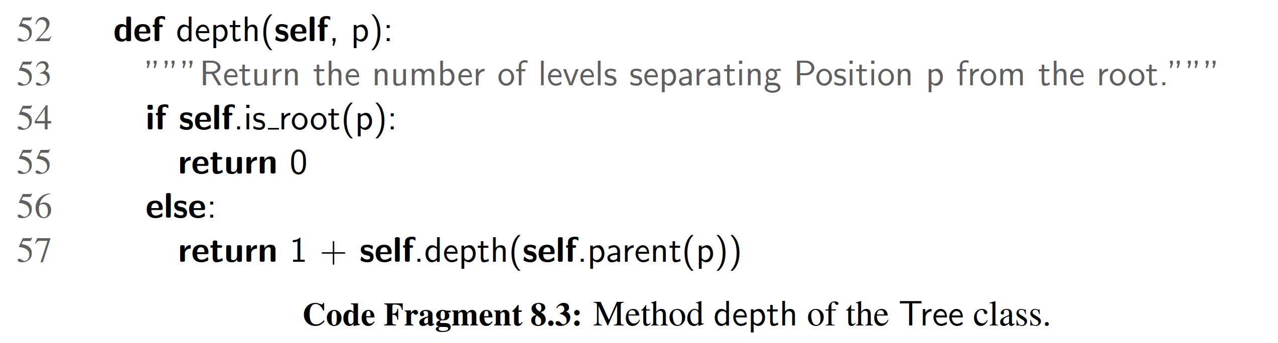

The running time of T.depth(p) for position p is O(dp + 1), where dp denotes the depth of p in the tree T , because the algorithm performs a constant-time recur- sive step for each ancestor of p. Thus, algorithm T.depth(p) runs in O(n) worst- case time, where n is the total number of positions of T , because a position of T

may have depth n − 1 if all nodes form a single branch. Although such a running

time is a function of the input size, it is more informative to characterize the running time in terms of the parameter dp, as this parameter may be much smaller than n.

Height

The height of a position p in a tree T is also deﬁned recursively:

• If p is a leaf, then the height of p is 0.

• Otherwise, the height of p is one more than the maximum of the heights of

p’s children.

The height of a nonempty tree T is the height of the root of T . For example, the tree of Figure 8.2 has height 4. In addition, height can also be viewed as follows.

Proposition 8.4: The height of a nonempty tree T is equal to the maximum of the depths of its leaf positions.

We leave the justiﬁcation of this fact to an exercise (R-8.3). We present an algorithm, height1, implemented in Code Fragment 8.4 as a nonpublic method height1 of the Tree class. It computes the height of a nonempty tree T based on Proposition 8.4 and the algorithm depth from Code Fragment 8.3.

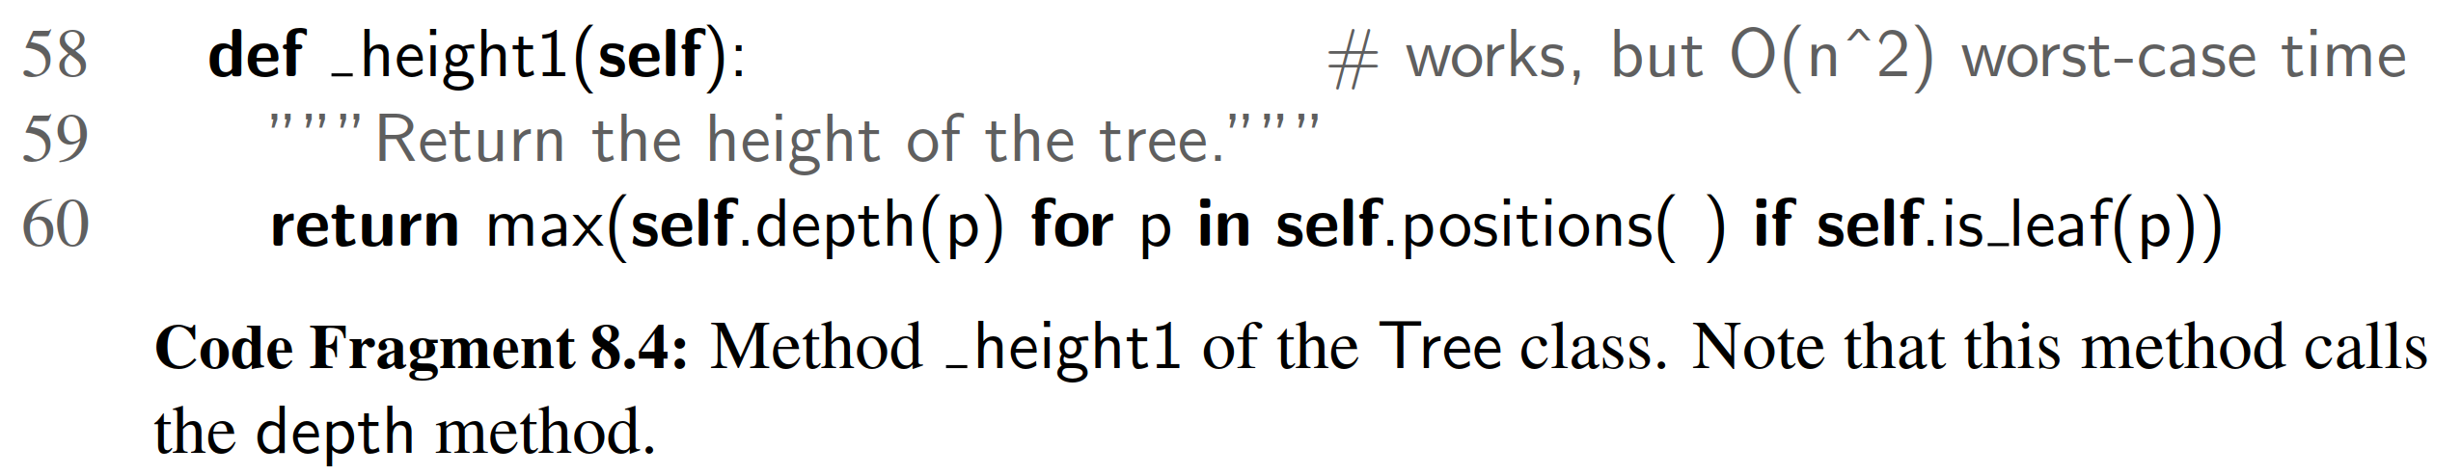

Unfortunately, algorithm height1 is not very efﬁcient. We have not yet deﬁned the positions() method; we will see that it can be implemented to run in O(n) time, where n is the number of positions of T . Because height1 calls algorithm depth(p)

on each leaf of T , its running time is O(n + p∈L(dp + 1)), where L is the set of leaf positions of T . In the worst case, the sum p∈L(dp + 1) is proportional to n2. (See Exercise C-8.33.) Thus, algorithm height1 runs in O(n2) worst-case time.

We can compute the height of a tree more efﬁciently, in O(n) worst-case time, by relying instead on the original recursive deﬁnition. To do this, we will param- eterize a function based on a position within the tree, and calculate the height of the subtree rooted at that position. Algorithm height2, shown as nonpublic method height2 in Code Fragment 8.5, computes the height of tree T in this way.

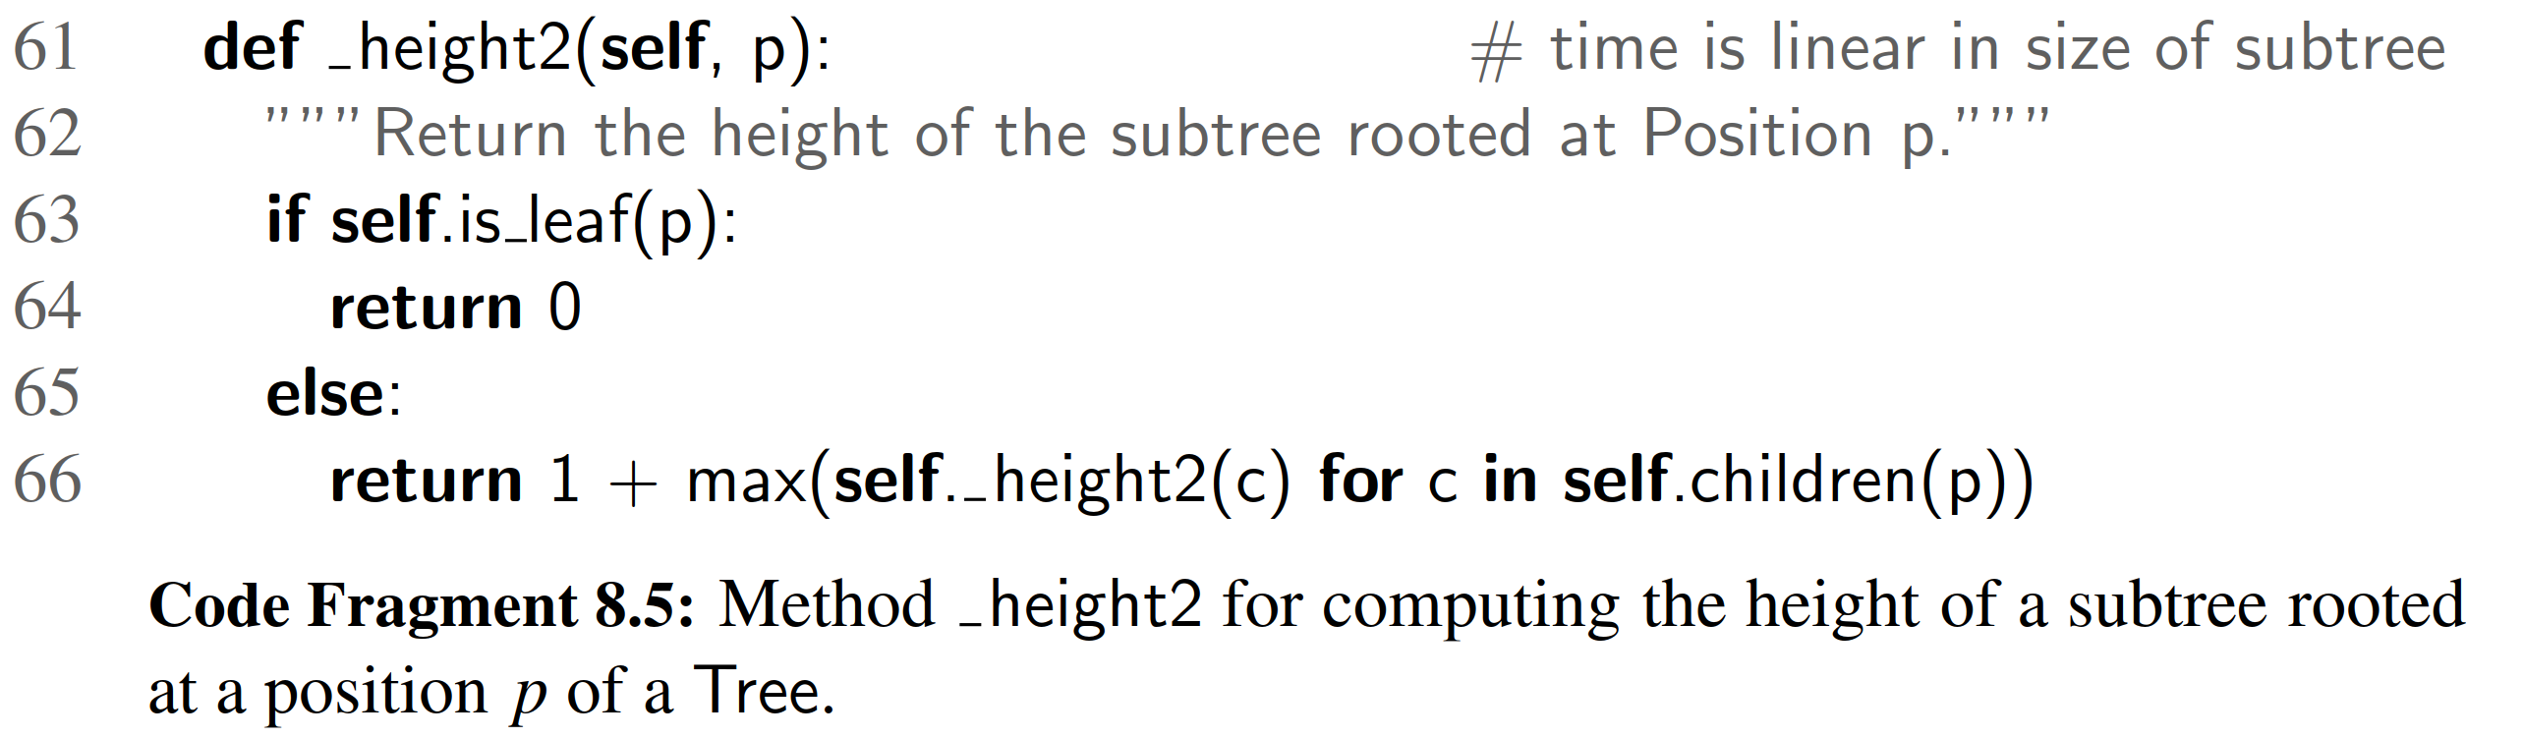

It is important to understand why algorithm height2 is more efﬁcient than height1. The algorithm is recursive, and it progresses in a top-down fashion. If the method is initially called on the root of T , it will eventually be called once for each position of T . This is because the root eventually invokes the recursion on each of its children, which in turn invokes the recursion on each of their children, and so on.

We can determine the running time of the height2 algorithm by summing, over all the positions, the amount of time spent on the nonrecursive part of each call. (Review Section 4.2 for analyses of recursive processes.) In our implementation, there is a constant amount of work per position, plus the overhead of computing the maximum over the iteration of children. Although we do not yet have a concrete implementation of children(p), we assume that such an iteration is generated in O(cp + 1) time, where cp denotes the number of children of p. Algorithm height2 spends O(cp + 1) time at each position p to compute the maximum, and its overall running time is O(p(cp + 1)) = O(n + p cp). In order to complete the analysis, we make use of the following property.

Proposition 8.5: Let T be a tree with n positions, and let cp denote the number of children of a position p of T . Then, summing over the positions of T , p cp = n − 1.

Justiﬁcation: Each position of T , with the exception of the root, is a child of another position, and thus contributes one unit to the above sum.

By Proposition 8.5, the running time of algorithm height2, when called on the root of T , is O(n), where n is the number of positions of T .

Revisiting the public interface for our Tree class, the ability to compute heights of subtrees is beneﬁcial, but a user might expect to be able to compute the height of the entire tree without explicitly designating the tree root. We can wrap the non- public height2 in our implementation with a public height method that provides a default interpretation when invoked on tree T with syntax T.height(). Such an implementation is given in Code Fragment 8.6.

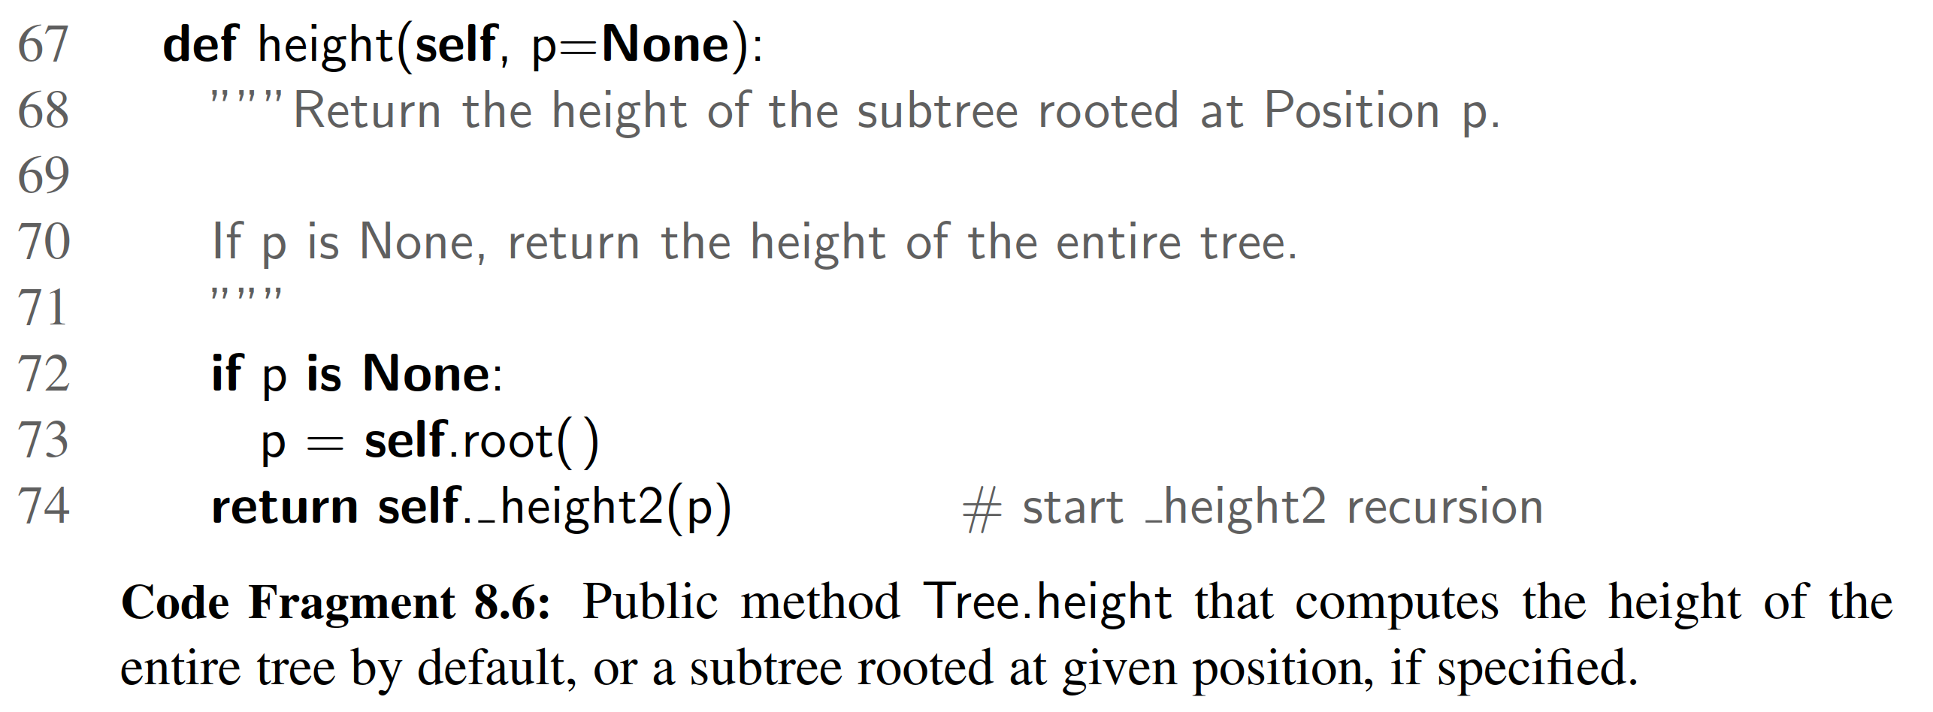

8.2 Binary Trees

A binary tree is an ordered tree with the following properties:

1. Every node has at most two children.

2. Each child node is labeled as being either a left child or a right child.

3. A left child precedes a right child in the order of children of a node.

The subtree rooted at a left or right child of an internal node v is called a left subtree or right subtree, respectively, of v. A binary tree is proper if each node has either zero or two children. Some people also refer to such trees as being full binary trees. Thus, in a proper binary tree, every internal node has exactly two children. A binary tree that is not proper is improper.

Example 8.6: An important class of binary trees arises in contexts where we wish to represent a number of different outcomes that can result from answering a series of yes-or-no questions. Each internal node is associated with a question. Starting at the root, we go to the left or right child of the current node, depending on whether the answer to the question is “Yes” or “No.” With each decision, we follow an edge from a parent to a child, eventually tracing a path in the tree from the root to a leaf. Such binary trees are known as decision trees, because a leaf position p in such a tree represents a decision of what to do if the questions associated with p’s ancestors are answered in a way that leads to p. A decision tree is a proper binary tree. Figure 8.7 illustrates a decision tree that provides recommendations to a prospective investor.

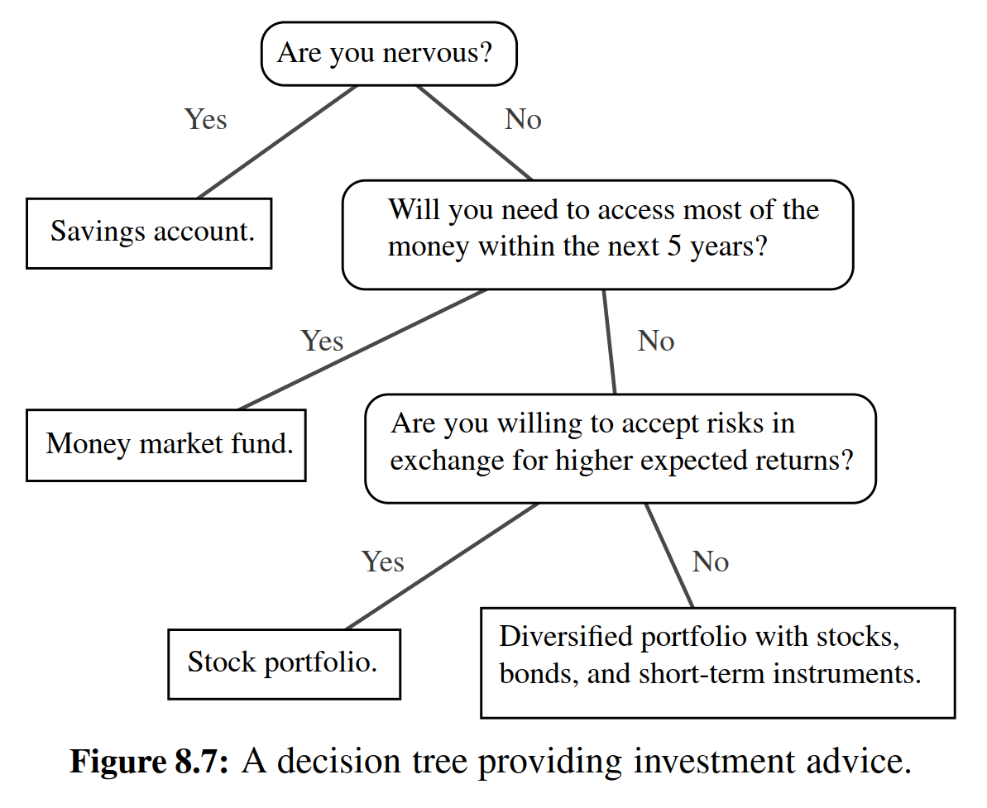

Example 8.7: An arithmetic expression can be represented by a binary tree whose leaves are associated with variables or constants, and whose internal nodes are associated with one of the operators +, , , and /. (See Figure 8.8.) Each node in such a tree has a value associated with it.

• If a node is leaf, then its value is that of its variable or constant.

If a node is internal, then its value is deﬁned by applying its operation to the values of its children.

An arithmetic expression tree is a proper binary tree, since each operator +, −, ×, and / takes exactly two operands. Of course, if we were to allow unary operators, like negation (−), as in “−x,” then we could have an improper binary tree.

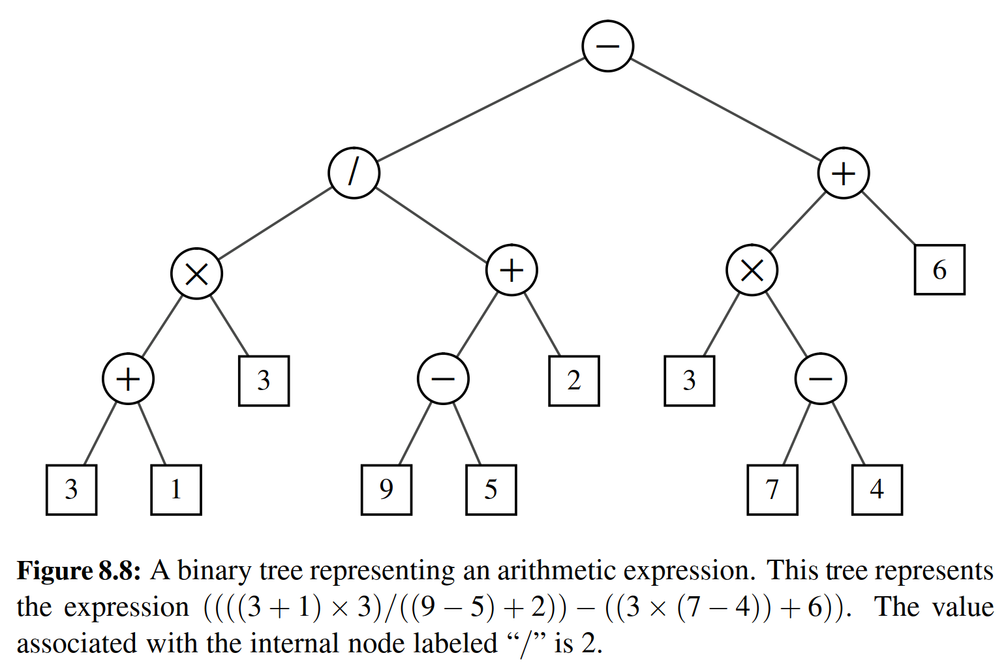

A Recursive Binary Tree Deﬁnition

Incidentally, we can also deﬁne a binary tree in a recursive way such that a binary tree is either empty or consists of:

• A node r, called the root of T , that stores an element

• A binary tree (possibly empty), called the left subtree of T

• A binary tree (possibly empty), called the right subtree of T

8.2.1 The Binary Tree Abstract Data Type

As an abstract data type, a binary tree is a specialization of a tree that supports three additional accessor methods:

T.left(p): Return the position that represents the left child of p, or None if p has no left child.

T.right(p): Return the position that represents the right child of p, or None if p has no right child.

T.sibling(p): Return the position that represents the sibling of p, or None if p has no sibling.

Just as in Section 8.1.2 for the tree ADT, we do not deﬁne specialized update meth- ods for binary trees here. Instead, we will consider some possible update methods when we describe speciﬁc implementations and applications of binary trees.

**The BinaryTree Abstract Base Class in Python**

Just as Tree was deﬁned as an abstract base class in Section 8.1.2, we deﬁne a new BinaryTree class associated with the binary tree ADT. We rely on inheritance to deﬁne the BinaryTree class based upon the existing Tree class. However, our BinaryTree class remains abstract, as we still do not provide complete speciﬁca- tions for how such a structure will be represented internally, nor implementations for some necessary behaviors.

Our Python implementation of the BinaryTree class is given in Code Frag- ment 8.7. By using inheritance, a binary tree supports all the functionality that was deﬁned for general trees (e.g., parent, is leaf, root). Our new class also inherits the nested Position class that was originally deﬁned within the Tree class deﬁnition. In addition, the new class provides declarations for new abstract methods left and right that should be supported by concrete subclasses of BinaryTree.

Our new class also provides two concrete implementations of methods. The new sibling method is derived from the combination of left, right, and parent. Typ- ically, we identify the sibling of a position p as the “other” child of p’s parent. However, if p is the root, it has no parent, and thus no sibling. Also, p may be the only child of its parent, and thus does not have a sibling.

Finally, Code Fragment 8.7 provides a concrete implementation of the children method; this method is abstract in the Tree class. Although we have still not speci- ﬁed how the children of a node will be stored, we derive a generator for the ordered children based upon the implied behavior of abstract methods left and right.

8.2.2 Properties of Binary Trees

Binary trees have several interesting properties dealing with relationships between their heights and number of nodes. We denote the set of all nodes of a tree T at the same depth d as level d of T . In a binary tree, level 0 has at most one node (the root), level 1 has at most two nodes (the children of the root), level 2 has at most four nodes, and so on. (See Figure 8.9.) In general, level d has at most 2d nodes.

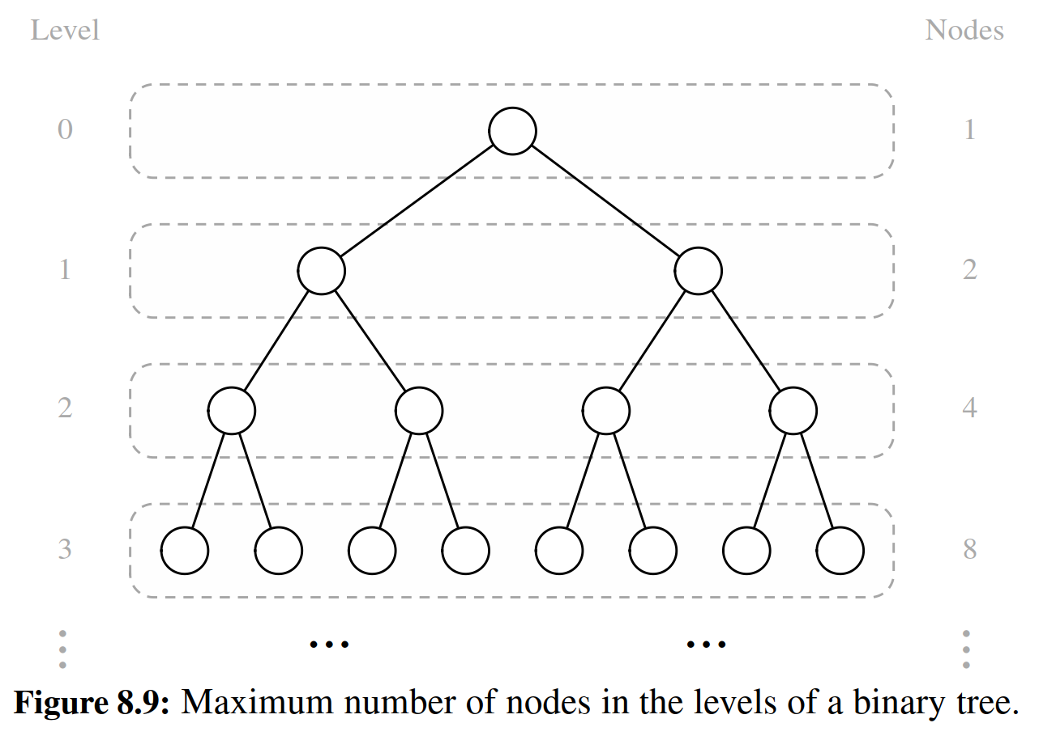

We can see that the maximum number of nodes on the levels of a binary tree grows exponentially as we go down the tree. From this simple observation, we can derive the following properties relating the height of a binary tree T with its number of nodes. A detailed justiﬁcation of these properties is left as Exercise R-8.8.

Proposition 8.8: Let T be a nonempty binary tree, and let n, nE , nI and h denote the number of nodes, number of external nodes, number of internal nodes, and height of T , respectively. Then T has the following properties:

1. h + 1 ≤ n ≤ 2h+1 − 1

2. 1 ≤ nE ≤ 2h

3. h ≤ nI ≤ 2h − 1

4. log(n + 1) − 1 ≤ h ≤ n − 1

Also, if T is proper, then T has the following properties:

1. 2h + 1 ≤ n ≤ 2h+1 − 1

2. h + 1 ≤ nE ≤ 2h

3. h ≤ nI ≤ 2h − 1

4. log(n + 1) − 1 ≤ h ≤ (n − 1)/2

Relating Internal Nodes to External Nodes in a Proper Binary Tree

In addition to the earlier binary tree properties, the following relationship exists between the number of internal nodes and external nodes in a proper binary tree. Proposition 8.9: In a nonempty proper binary tree T , with nE external nodes and

nI internal nodes, we have nE = nI + 1.

Justiﬁcation: We justify this proposition by removing nodes from T and divid- ing them up into two “piles,” an internal-node pile and an external-node pile, until T becomes empty. The piles are initially empty. By the end, we will show that the external-node pile has one more node than the internal-node pile. We consider two cases:

Case 1: If T has only one node v, we remove v and place it on the external-node pile. Thus, the external-node pile has one node and the internal-node pile is empty.

Case 2: Otherwise (T has more than one node), we remove from T an (arbitrary) external node w and its parent v, which is an internal node. We place w on the external-node pile and v on the internal-node pile. If v has a parent u, then we reconnect u with the former sibling z of w, as shown in Figure 8.10. This operation, removes one internal node and one external node, and leaves the tree being a proper binary tree.

Repeating this operation, we eventually are left with a ﬁnal tree consisting of a single node. Note that the same number of external and internal nodes have been removed and placed on their respective piles by the sequence of operations leading to this ﬁnal tree. Now, we remove the node of the ﬁnal tree and we place it on the external-node pile. Thus, the the external-node pile has one more node than the internal-node pile.

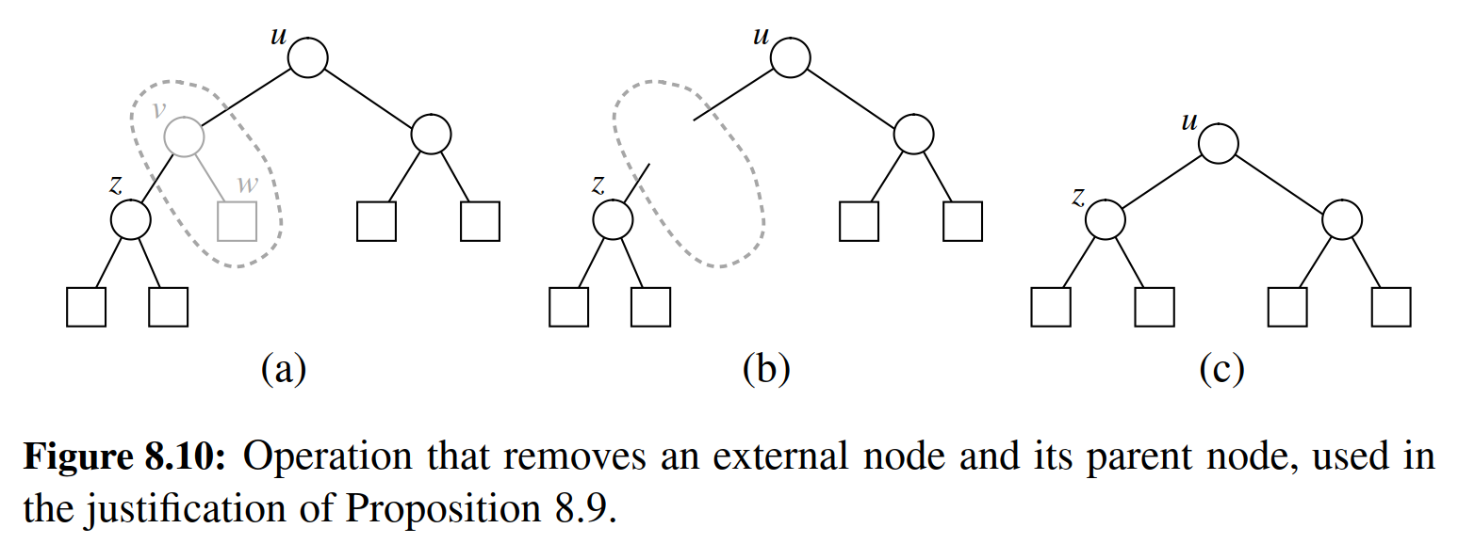

Note that the above relationship does not hold, in general, for improper binary trees and nonbinary trees, although there are other interesting relationships that do hold. (See Exercises C-8.32 through C-8.34.)

8.3 Implementing Trees

The Tree and BinaryTree classes that we have deﬁned thus far in this chapter are both formally abstract base classes. Although they provide a great deal of support, neither of them can be directly instantiated. We have not yet deﬁned key imple- mentation details for how a tree will be represented internally, and how we can effectively navigate between parents and children. Speciﬁcally, a concrete imple- mentation of a tree must provide methods root, parent, num children, children,

len , and in the case of BinaryTree, the additional accessors left and right.

There are several choices for the internal representation of trees. We describe the most common representations in this section. We begin with the case of a binary tree, since its shape is more narrowly deﬁned.

8.3.1 Linked Structure for Binary Trees

A natural way to realize a binary tree T is to use a linked structure, with a node (see Figure 8.11a) that maintains references to the element stored at a position p and to the nodes associated with the children and parent of p. If p is the root of T , then the parent ﬁeld of p is None. Likewise, if p does not have a left child (respectively, right child), the associated ﬁeld is None. The tree itself maintains an instance variable storing a reference to the root node (if any), and a variable, called size, that represents the overall number of nodes of T . We show such a linked structure representation of a binary tree in Figure 8.11b.

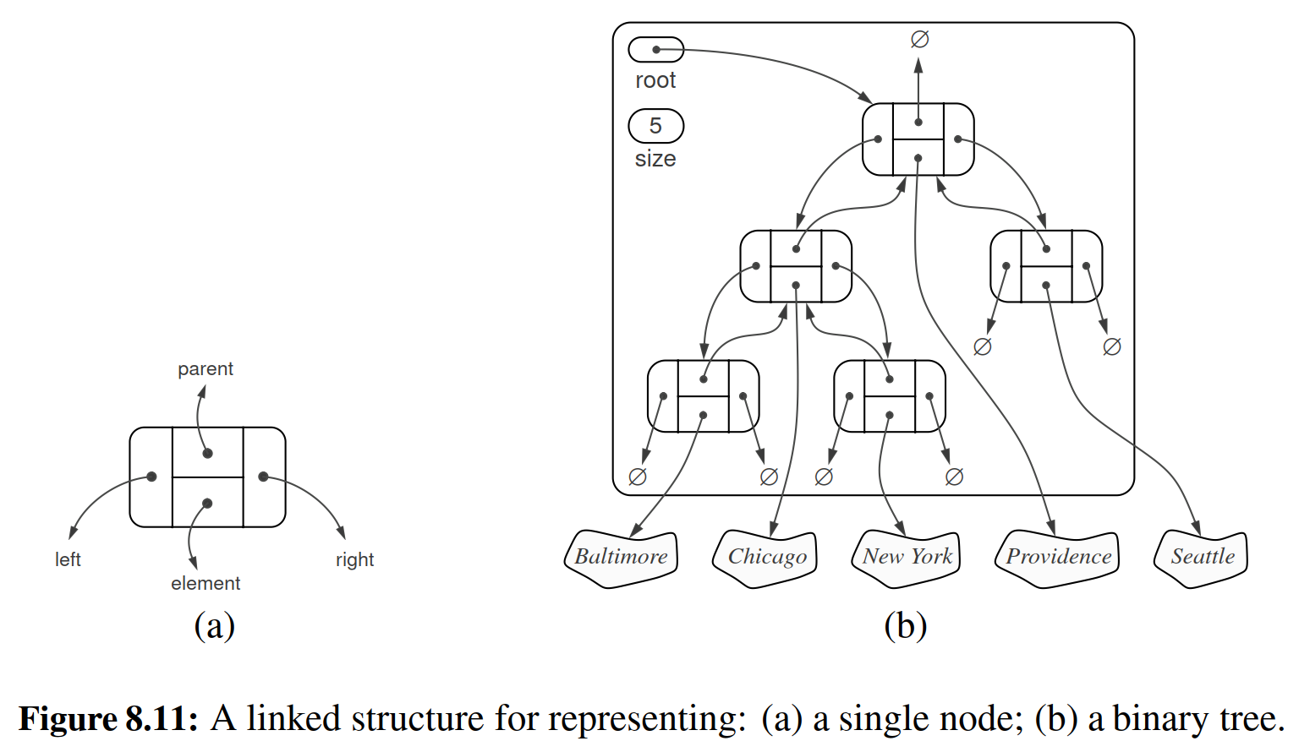

Python Implementation of a Linked Binary Tree Structure

In this section, we deﬁne a concrete LinkedBinaryTree class that implements the binary tree ADT by subclassing the BinaryTree class. Our general approach is very similar to what we used when developing the PositionalList in Section 7.4: We deﬁne a simple, nonpublic Node class to represent a node, and a public Position class that wraps a node. We provide a validate utility for robustly checking the validity of a given position instance when unwrapping it, and a make position utility for wrapping a node as a position to return to a caller.

Those deﬁnitions are provided in Code Fragment 8.8. As a formality, the new Position class is declared to inherit immediately from BinaryTree.Position. Tech- nically, the BinaryTree class deﬁnition (see Code Fragment 8.7) does not formally declare such a nested class; it trivially inherits it from Tree.Position. A minor ben- eﬁt from this design is that our position class inherits the ne special method so that syntax p != q is derived appropriately relative to eq .

Our class deﬁnition continues, in Code Fragment 8.9, with a constructor and with concrete implementations for the methods that remain abstract in the Tree and BinaryTree classes. The constructor creates an empty tree by initializing root to None and size to zero. These accessor methods are implemented with careful use of the validate and make position utilities to safeguard against boundary cases.

Operations for Updating a Linked Binary Tree

Thus far, we have provided functionality for examining an existing binary tree. However, the constructor for our LinkedBinaryTree class results in an empty tree and we have not provided any means for changing the structure or content of a tree. We chose not to declare update methods as part of the Tree or BinaryTree ab- stract base classes for several reasons. First, although the principle of encapsula- tion suggests that the outward behaviors of a class need not depend on the internal representation, the efﬁciency of the operations depends greatly upon the representa- tion. We prefer to have each concrete implementation of a tree class offer the most

suitable options for updating a tree.

The second reason we do not provide update methods in the base class is that we may not want such update methods to be part of a public interface. There are many applications of trees, and some forms of update operations that are suitable for one application may be unacceptable in another. However, if we place an update method in a base class, any class that inherits from that base will inherit the update method. Consider, for example, the possibility of a method T.replace(p, e) that replaces the element stored at position p with another element e. Such a general method may be unacceptable in the context of an arithmetic expression tree (see Example 8.7 on page 312, and a later case study in Section 8.5), because we may want to enforce that internal nodes store only operators as elements.

For linked binary trees, a reasonable set of update methods to support for gen- eral usage are the following:

T.add root(e): Create a root for an empty tree, storing e as the element, and return the position of that root; an error occurs if the tree is not empty.

T.add left(p, e): Create a new node storing element e, link the node as the left child of position p, and return the resulting position; an error occurs if p already has a left child.

T.add right(p, e): Create a new node storing element e, link the node as the right child of position p, and return the resulting position; an error occurs if p already has a right child.

T.replace(p, e): Replace the element stored at position p with element e, and return the previously stored element.

T.delete(p): Remove the node at position p, replacing it with its child, if any, and return the element that had been stored at p; an error occurs if p has two children.

T.attach(p, T1, T2): Attach the internal structure of trees T1 and T2, respec-

tively, as the left and right subtrees of leaf position p of T, and reset T1 and T2 to empty trees; an error condition occurs if p is not a leaf.

We have speciﬁcally chosen this collection of operations because each can be implemented in O(1) worst-case time with our linked representation. The most complex of these are delete and attach, due to the case analyses involving the various parent-child relationships and boundary conditions, yet there remains only a constant number of operations to perform. (The implementation of both methods could be greatly simpliﬁed if we used a tree representation with a sentinel node, akin to our treatment of positional lists; see Exercise C-8.40).

To avoid the problem of undesirable update methods being inherited by sub- classes of LinkedBinaryTree, we have chosen an implementation in which none of the above methods are publicly supported. Instead, we provide nonpublic ver- sions of each, for example, providing the underscored delete in lieu of a public delete. Our implementations of these six update methods are provided in Code Fragments 8.10 and 8.11.

In particular applications, subclasses of LinkedBinaryTree can invoke the non- public methods internally, while preserving a public interface that is appropriate for the application. A subclass may also choose to wrap one or more of the non- public update methods with a public method to expose it to the user. We leave as an exercise (R-8.15), the task of deﬁning a MutableLinkedBinaryTree subclass that provides public methods wrapping each of these six update methods.

Performance of the Linked Binary Tree Implementation

To summarize the efﬁciencies of the linked structure representation, we analyze the running times of the LinkedBinaryTree methods, including derived methods that are inherited from the Tree and BinaryTree classes:

• The len method, implemented in LinkedBinaryTree, uses an instance variable storing the number of nodes of T and takes O(1) time. Method is empty, inherited from Tree, relies on a single call to len and thus takes O(1) time.

• The accessor methods root, left, right, parent, and num children are imple- mented directly in LinkedBinaryTree and take O(1) time. The sibling and children methods are derived in BinaryTree based on a constant number of calls to these other accessors, so they run in O(1) time as well.

• The is root and is leaf methods, from the Tree class, both run in O(1) time, as is root calls root and then relies on equivalence testing of positions, while is leaf calls left and right and veriﬁes that None is returned by both.

• Methods depth and height were each analyzed in Section 8.1.3. The depth method at position p runs in O(dp + 1) time where dp is its depth; the height method on the root of the tree runs in O(n) time.

• The various update methods add root, add left, add right, replace, delete, and attach (that is, their nonpublic implementations) each run in O(1) time, as they involve relinking only a constant number of nodes per operation.

Table 8.1 summarizes the performance of the linked structure implementation of a binary tree.

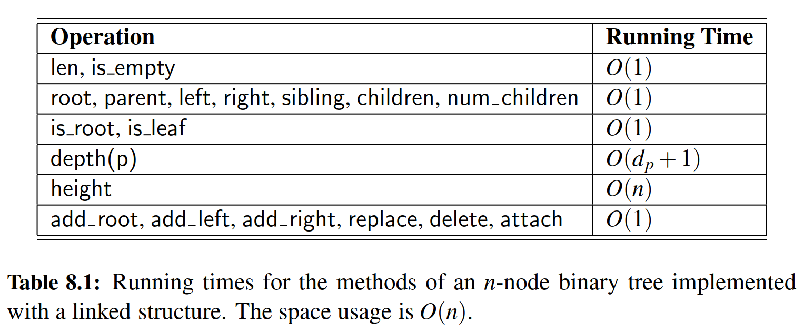

8.3.2 Array-Based Representation of a Binary Tree

An alternative representation of a binary tree T is based on a way of numbering the positions of T . For every position p of T , let f (p) be the integer deﬁned as follows.

• If p is the root of T , then f (p)= 0.

• If p is the left child of position q, then f (p)= 2 f (q)+ 1.

• If p is the right child of position q, then f (p)= 2 f (q)+ 2.

The numbering function f is known as a level numbering of the positions in a binary tree T , for it numbers the positions on each level of T in increasing order from left to right. (See Figure 8.12.) Note well that the level numbering is based on potential positions within the tree, not actual positions of a given tree, so they are not necessarily consecutive. For example, in Figure 8.12(b), there are no nodes with level numbering 13 or 14, because the node with level numbering 6 has no children.

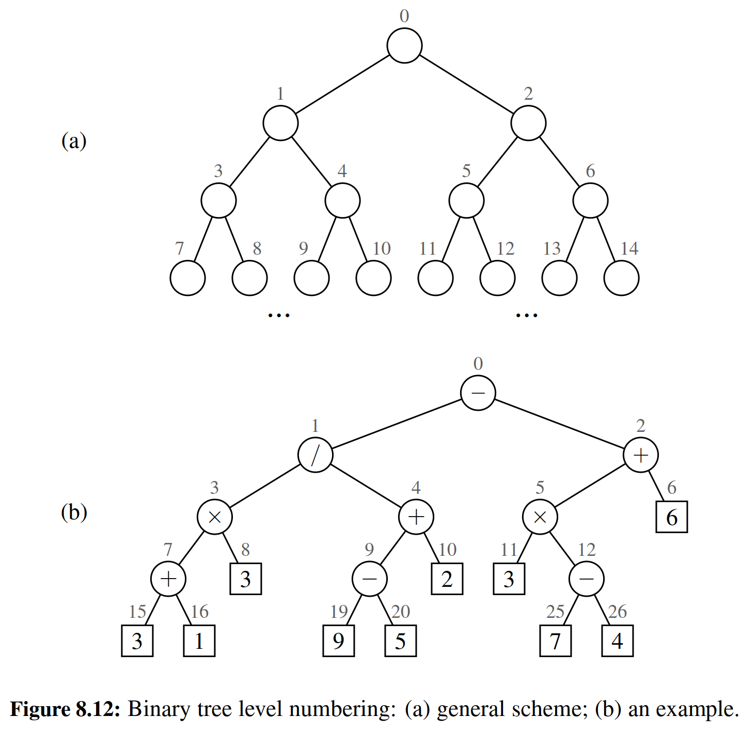

The level numbering function f suggests a representation of a binary tree T by means of an array-based structure A (such as a Python list), with the element at position p of T stored at index f (p) of the array. We show an example of an array-based representation of a binary tree in Figure 8.13.

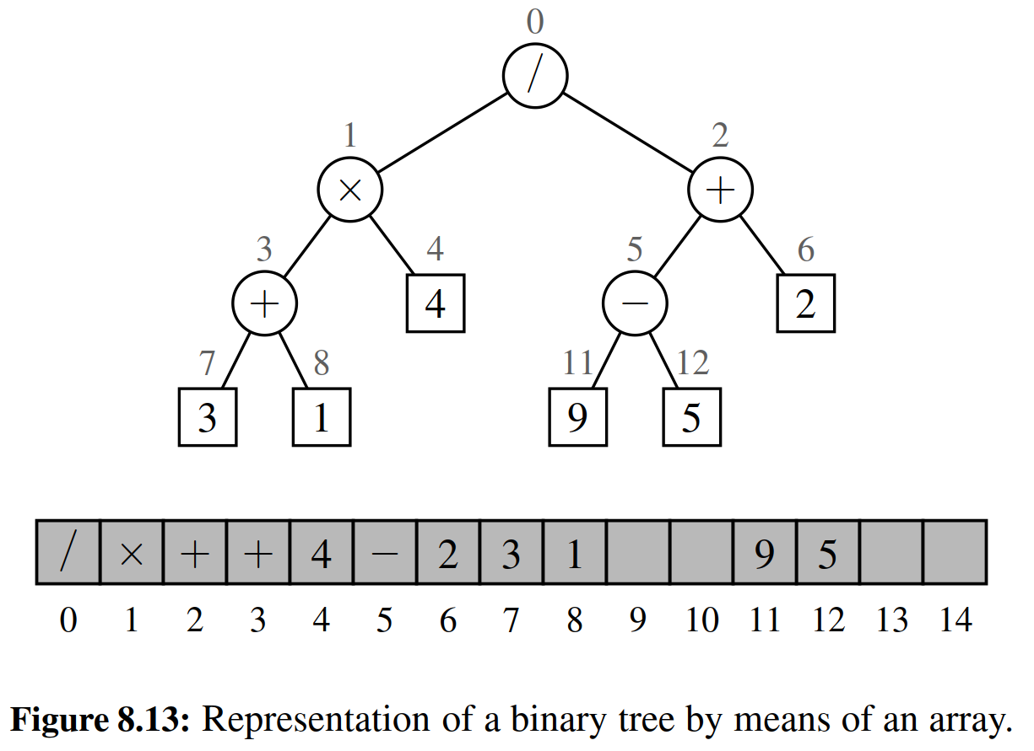

One advantage of an array-based representation of a binary tree is that a posi- tion p can be represented by the single integer f (p), and that position-based meth- ods such as root, parent, left, and right can be implemented using simple arithmetic operations on the number f (p). Based on our formula for the level numbering, the left child of p has index 2 f (p)+ 1, the right child of p has index 2 f (p)+ 2, and

the parent of p has index ( f (p) − 1)/2 囚 . We leave the details of a complete im- plementation as an exercise (R-8.18).

The space usage of an array-based representation depends greatly on the shape of the tree. Let n be the number of nodes of T , and let fM be the maximum value of f (p) over all the nodes of T . The array A requires length N = 1 + fM, since elements range from A[0] to A[ fM]. Note that A may have a number of empty cells

that do not refer to existing nodes of T . In fact, in the worst case, N = 2n − 1,

the justiﬁcation of which is left as an exercise (R-8.16). In Section 9.3, we will see a class of binary trees, called “heaps” for which N = n. Thus, in spite of the worst-case space usage, there are applications for which the array representation of a binary tree is space efﬁcient. Still, for general binary trees, the exponential worst-case space requirement of this representation is prohibitive.

Another drawback of an array representation is that some update operations for trees cannot be efﬁciently supported. For example, deleting a node and promoting its child takes O(n) time because it is not just the child that moves locations within the array, but all descendants of that child.

8.3.3 Linked Structure for General Trees

When representing a binary tree with a linked structure, each node explicitly main- tains ﬁelds left and right as references to individual children. For a general tree, there is no a priori limit on the number of children that a node may have. A natural way to realize a general tree T as a linked structure is to have each node store a single container of references to its children. For example, a children ﬁeld of a node can be a Python list of references to the children of the node (if any). Such a linked representation is schematically illustrated in Figure 8.14.

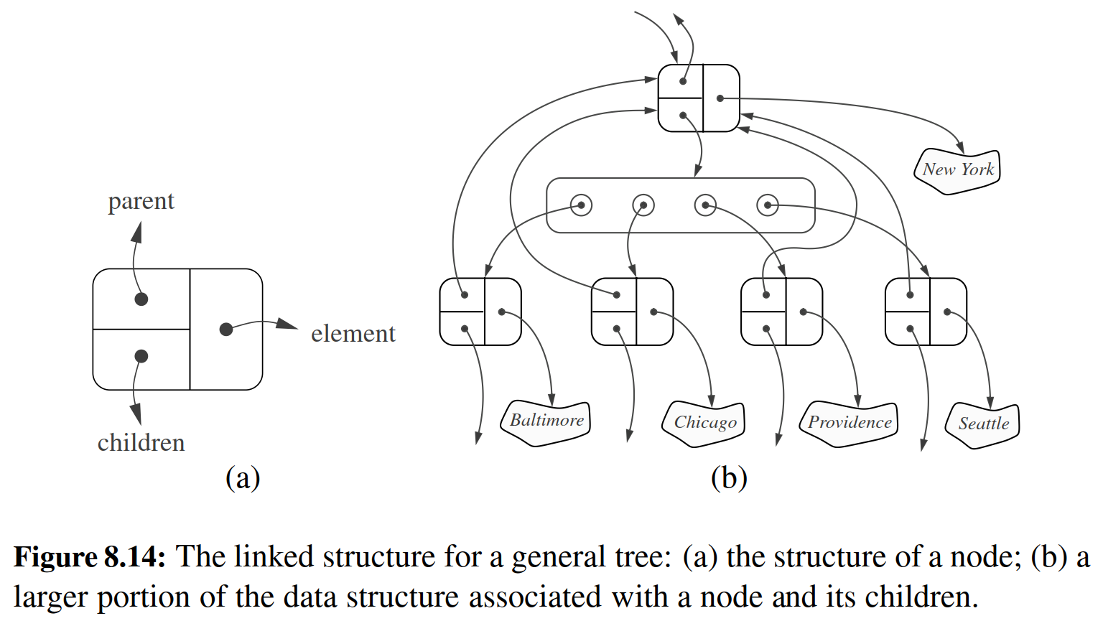

Table 8.2 summarizes the performance of the implementation of a general tree using a linked structure. The analysis is left as an exercise (R-8.14), but we note that, by using a collection to store the children of each position p, we can implement children(p) by simply iterating that collection.

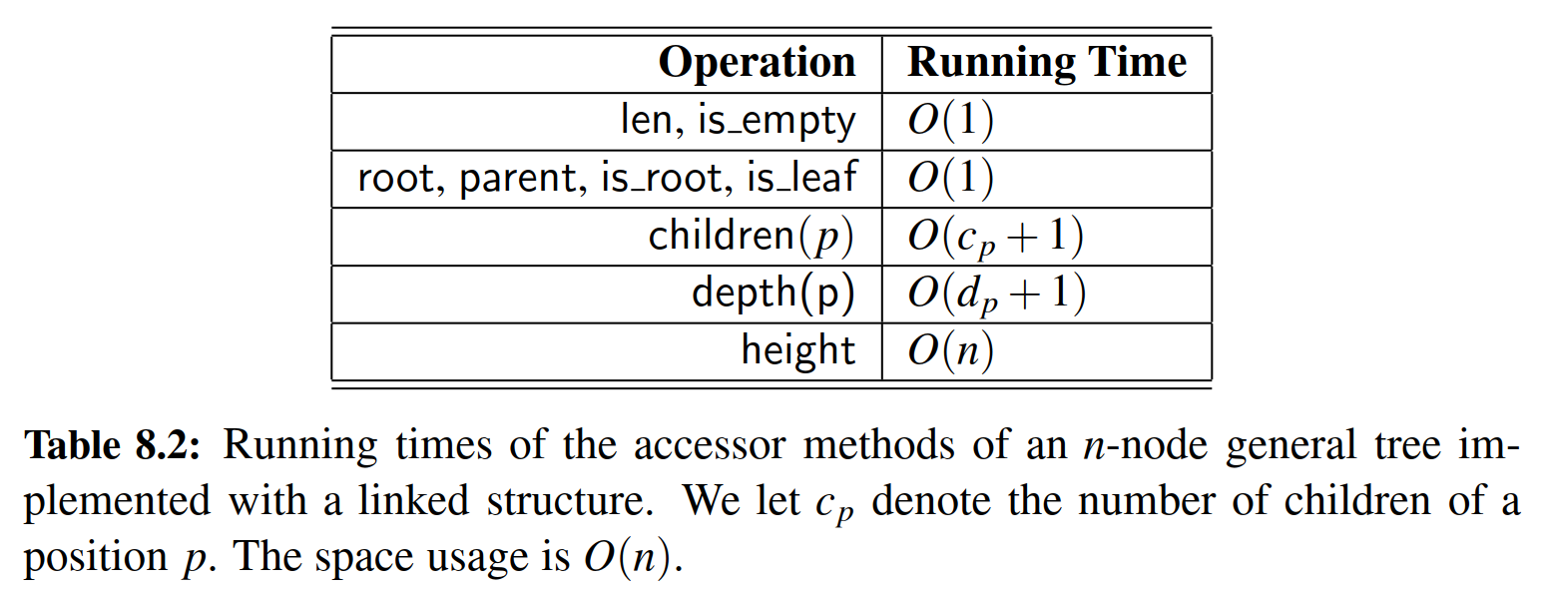

8.4 Tree Traversal Algorithms

A traversal of a tree T is a systematic way of accessing, or “visiting,” all the posi- tions of T . The speciﬁc action associated with the “visit” of a position p depends on the application of this traversal, and could involve anything from increment- ing a counter to performing some complex computation for p. In this section, we describe several common traversal schemes for trees, implement them in the con- text of our various tree classes, and discuss several common applications of tree traversals.

8.4.1 Preorder and Postorder Traversals of General Trees

In a preorder traversal of a tree T , the root of T is visited ﬁrst and then the sub- trees rooted at its children are traversed recursively. If the tree is ordered, then the subtrees are traversed according to the order of the children. The pseudo-code for the preorder traversal of the subtree rooted at a position p is shown in Code Fragment 8.12.

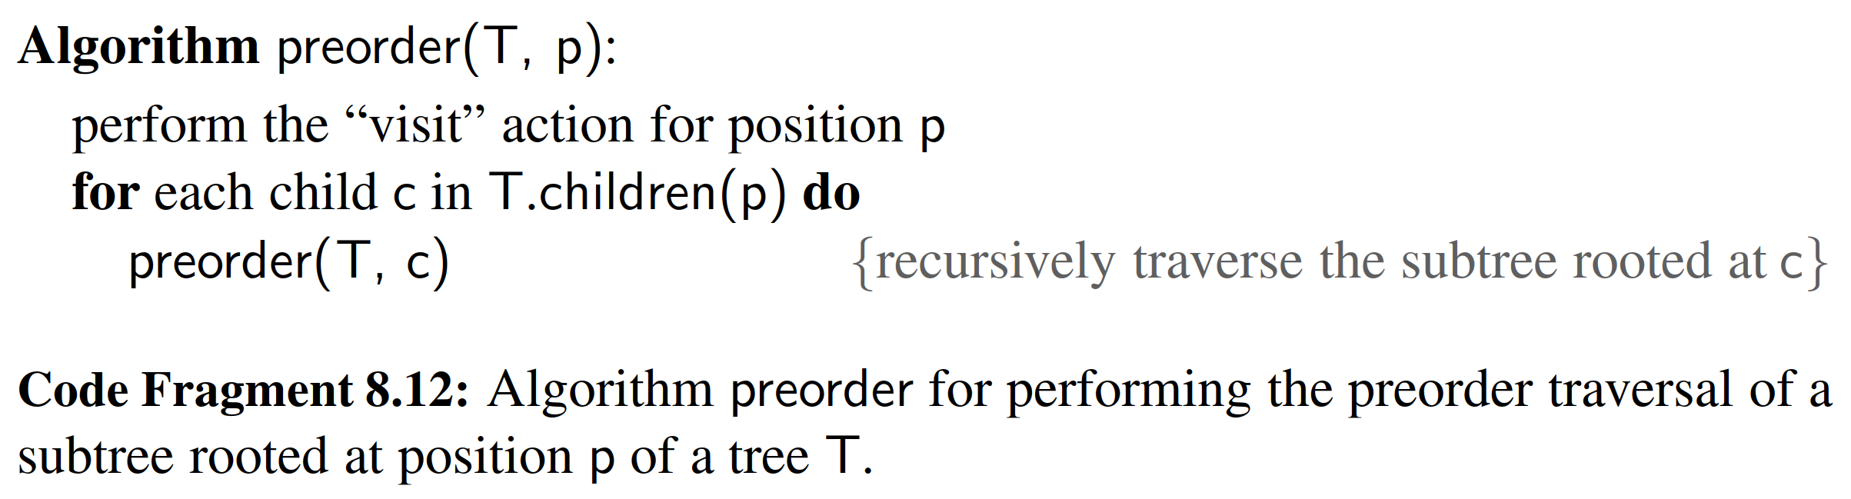

Figure 8.15 portrays the order in which positions of a sample tree are visited during an application of the preorder traversal algorithm.

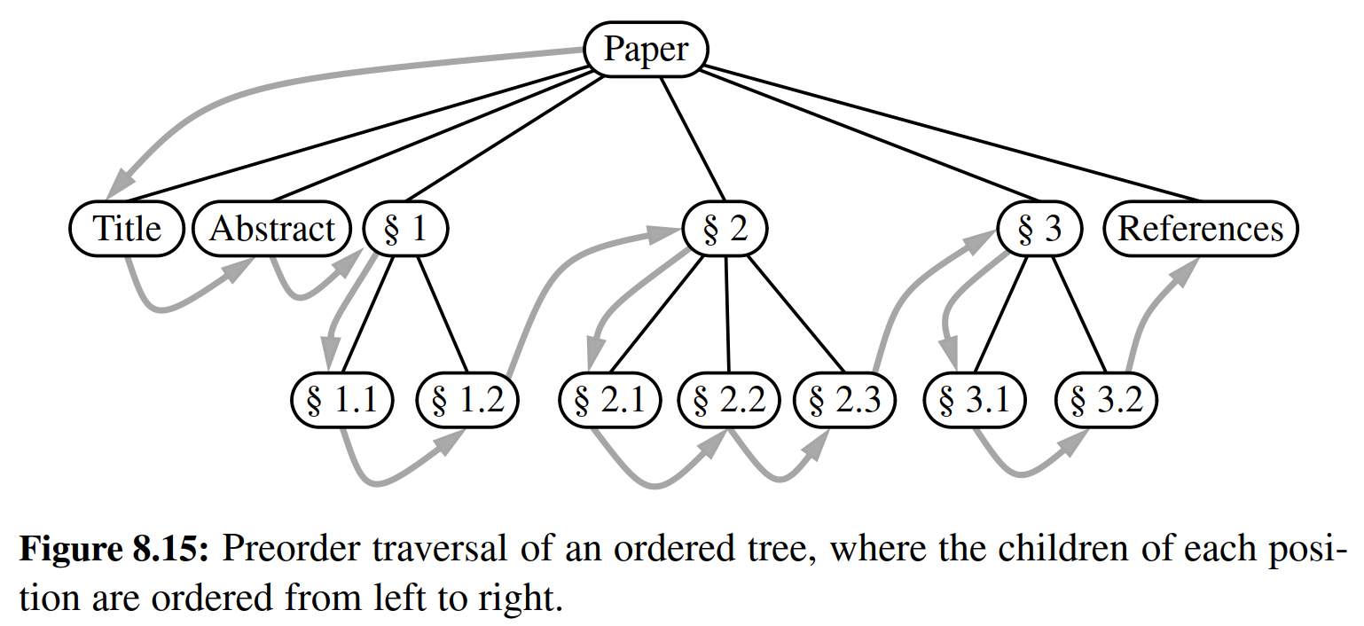

Postorder Traversal

Another important tree traversal algorithm is the postorder traversal. In some sense, this algorithm can be viewed as the opposite of the preorder traversal, be- cause it recursively traverses the subtrees rooted at the children of the root ﬁrst, and then visits the root (hence, the name “postorder”). Pseudo-code for the postorder traversal is given in Code Fragment 8.13, and an example of a postorder traversal is portrayed in Figure 8.16.

Algorithm postorder(T, p):

for each child c in T.children(p) do

postorder(T, c) {recursively traverse the subtree rooted at c}

perform the “visit” action for position p

Code Fragment 8.13: Algorithm postorder for performing the postorder traversal of a subtree rooted at position p of a tree T.

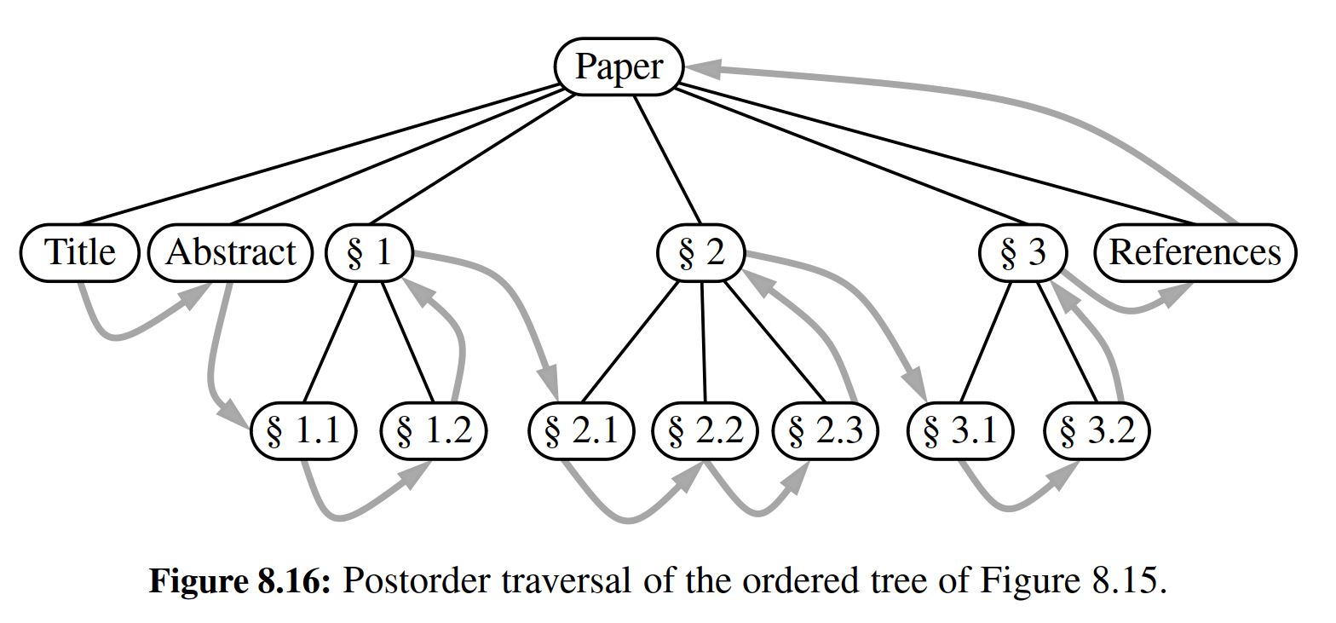

Running-Time Analysis

Both preorder and postorder traversal algorithms are efﬁcient ways to access all the positions of a tree. The analysis of either of these traversal algorithms is similar to that of algorithm height2, given in Code Fragment 8.5 of Section 8.1.3. At each position p, the nonrecursive part of the traversal algorithm requires time O(cp + 1), where cp is the number of children of p, under the assumption that the “visit” itself takes O(1) time. By Proposition 8.5, the overall running time for the traversal of tree T is O(n), where n is the number of positions in the tree. This running time is asymptotically optimal since the traversal must visit all the n positions of the tree.

8.4.2 Breadth-First Tree Traversal

Although the preorder and postorder traversals are common ways of visiting the positions of a tree, another common approach is to traverse a tree so that we visit all the positions at depth d before we visit the positions at depth d + 1. Such an algorithm is known as a breadth-ﬁrst traversal.

A breadth-ﬁrst traversal is a common approach used in software for playing games. A game tree represents the possible choices of moves that might be made by a player (or computer) during a game, with the root of the tree being the initial conﬁguration for the game. For example, Figure 8.17 displays a partial game tree for Tic-Tac-Toe.

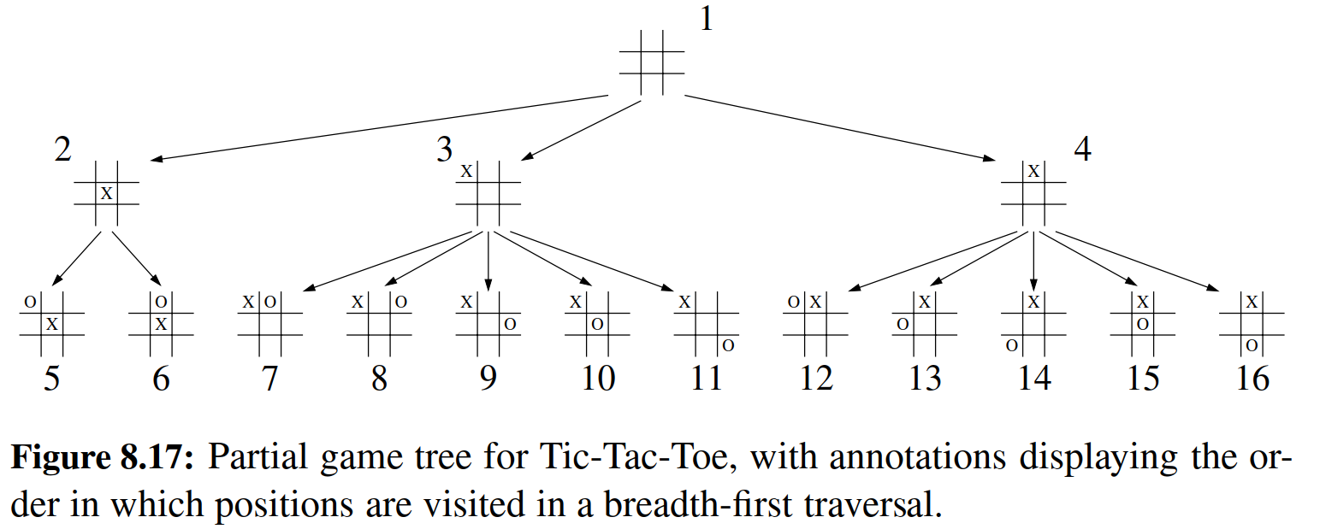

A breadth-ﬁrst traversal of such a game tree is often performed because a computer may be unable to explore a complete game tree in a limited amount of time. So the computer will consider all moves, then responses to those moves, going as deep as computational time allows.

Pseudo-code for a breadth-ﬁrst traversal is given in Code Fragment 8.14. The process is not recursive, since we are not traversing entire subtrees at once. We use a queue to produce a FIFO (i.e., ﬁrst-in ﬁrst-out) semantics for the order in which we visit nodes. The overall running time is O(n), due to the n calls to enqueue and n calls to dequeue.

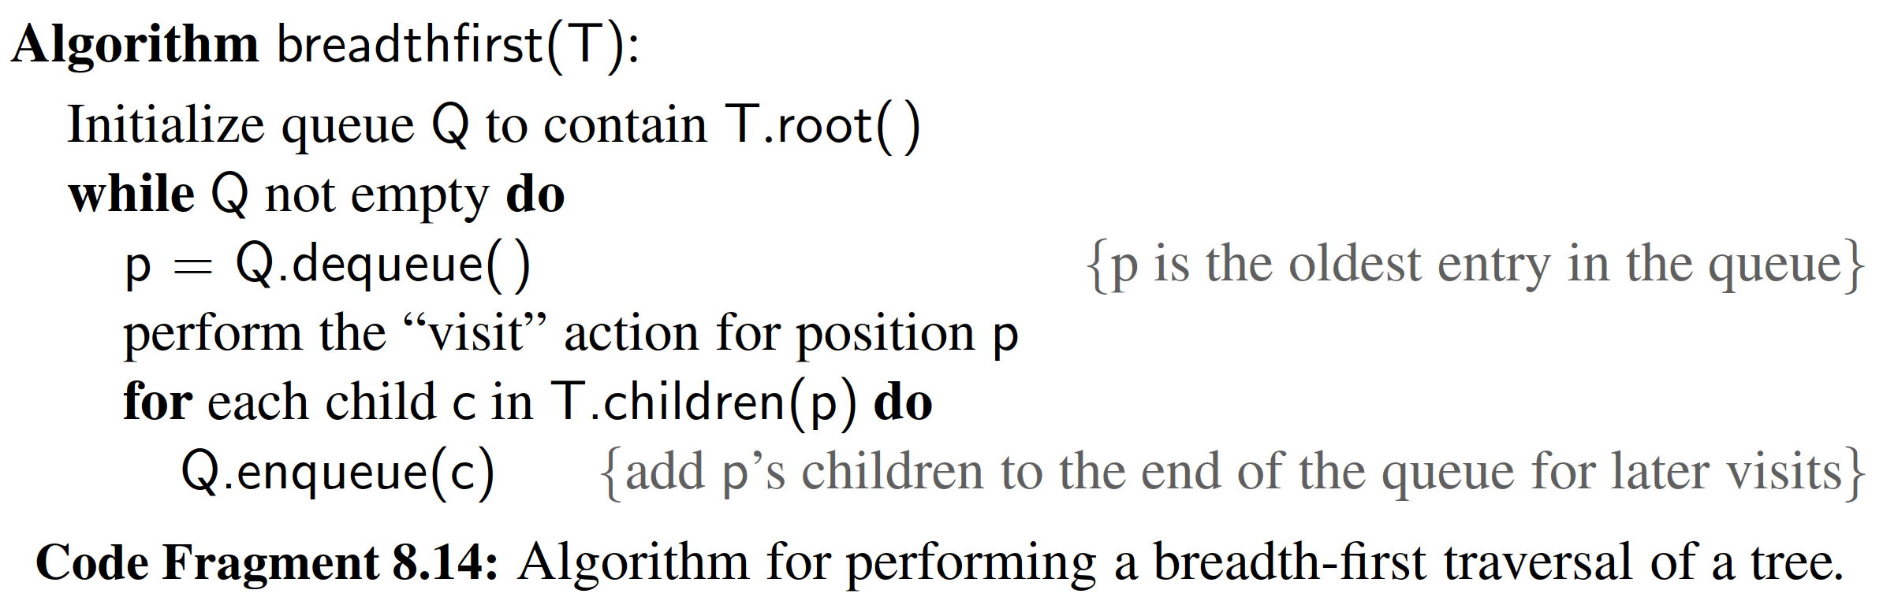

8.4.3 Inorder Traversal of a Binary Tree

The standard preorder, postorder, and breadth-ﬁrst traversals that were introduced for general trees, can be directly applied to binary trees. In this section, we intro- duce another common traversal algorithm speciﬁcally for a binary tree.

During an inorder traversal, we visit a position between the recursive traver- sals of its left and right subtrees. The inorder traversal of a binary tree T can be informally viewed as visiting the nodes of T “from left to right.” Indeed, for every position p, the inorder traversal visits p after all the positions in the left subtree of p and before all the positions in the right subtree of p. Pseudo-code for the inorder traversal algorithm is given in Code Fragment 8.15, and an example of an inorder traversal is portrayed in Figure 8.18.

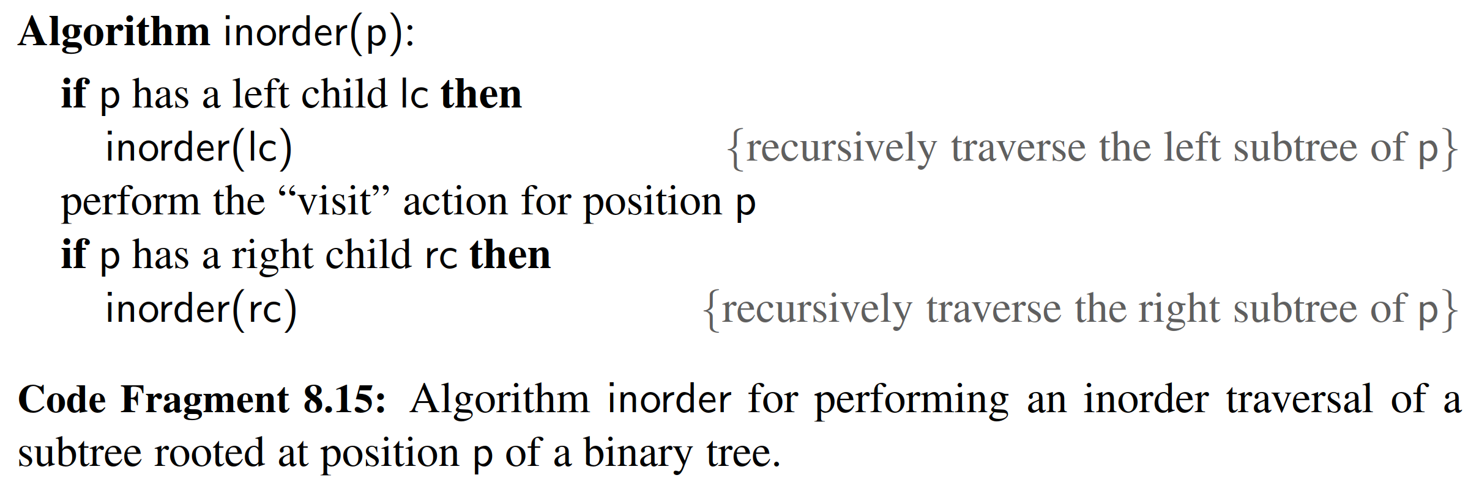

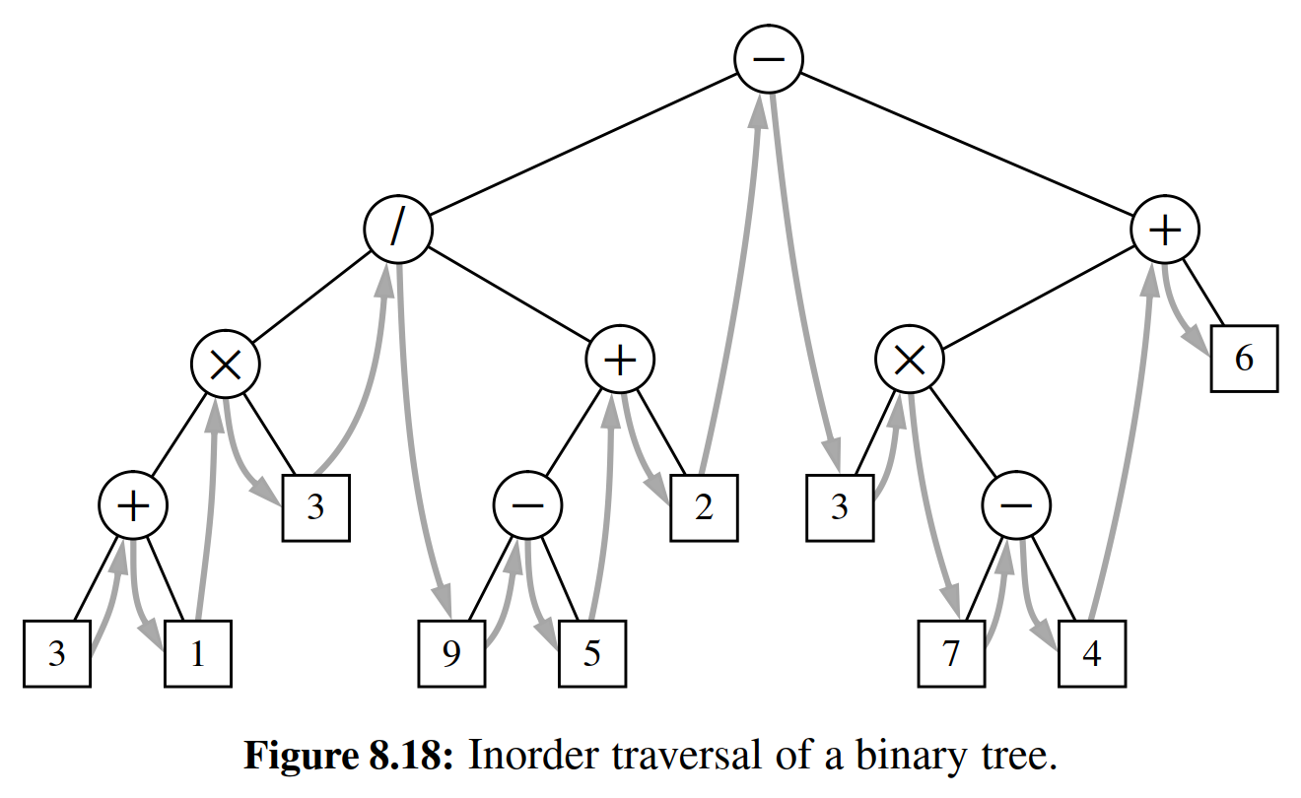

The inorder traversal algorithm has several important applications. When using a binary tree to represent an arithmetic expression, as in Figure 8.18, the inorder

traversal visits positions in a consistent order with the standard representation of the expression, as in 3 + 1 × 3/9 − 5 + 2 ... (albeit without parentheses).

Binary Search Trees

An important application of the inorder traversal algorithm arises when we store an ordered sequence of elements in a binary tree, deﬁning a structure we call a binary search tree. Let S be a set whose unique elements have an order relation. For example, S could be a set of integers. A binary search tree for S is a binary tree T such that, for each position p of T :

• Position p stores an element of S, denoted as e(p).

• Elements stored in the left subtree of p (if any) are less than e(p).

• Elements stored in the right subtree of p (if any) are greater than e(p).

An example of a binary search tree is shown in Figure 8.19. The above properties assure that an inorder traversal of a binary search tree T visits the elements in nondecreasing order.

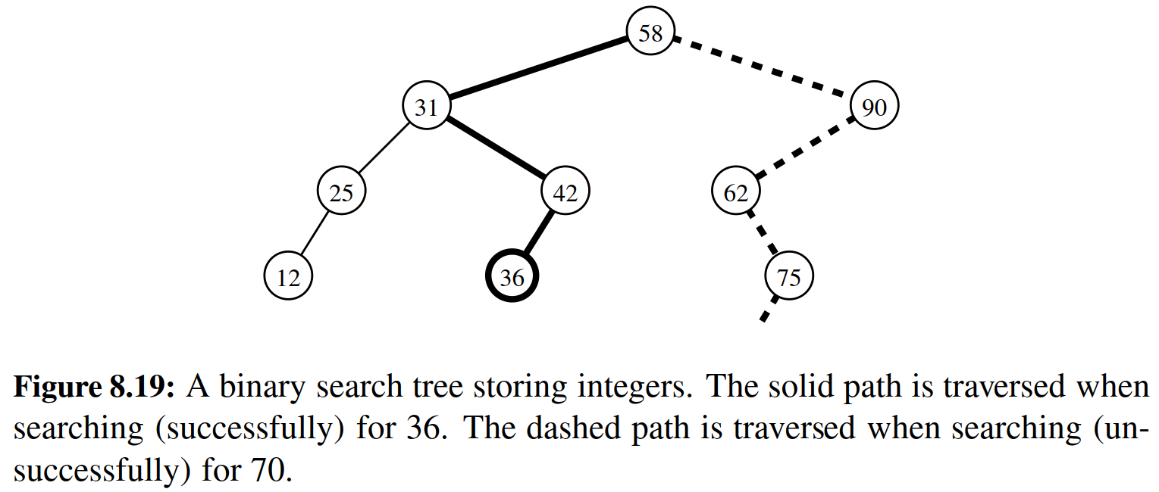

We can use a binary search tree T for set S to ﬁnd whether a given search value v is in S, by traversing a path down the tree T , starting at the root. At each internal position p encountered, we compare our search value v with the element e(p) stored at p. If v < e(p), then the search continues in the left subtree of p. If v = e(p), then the search terminates successfully. If v > e(p), then the search continues in the right subtree of p. Finally, if we reach an empty subtree, the search terminates unsuccessfully. In other words, a binary search tree can be viewed as a binary decision tree (recall Example 8.6), where the question asked at each internal node is whether the element at that node is less than, equal to, or larger than the element being searched for. We illustrate several examples of the search operation in Figure 8.19.

Note that the running time of searching in a binary search tree T is proportional to the height of T . Recall from Proposition 8.8 that the height of a binary tree with n nodes can be as small as log(n + 1) 1 or as large as n 1. Thus, binary search trees are most efﬁcient when they have small height. Chapter 11 is devoted to the study of search trees.

8.4.4 Implementing Tree Traversals in Python

When ﬁrst deﬁning the tree ADT in Section 8.1.2, we stated that tree T should include support for the following methods:

T.positions( ): Generate an iteration of all positions of tree T.

iter(T): Generate an iteration of all elements stored within tree T.

At that time, we did not make any assumption about the order in which these iterations report their results. In this section, we demonstrate how any of the tree traversal algorithms we have introduced could be used to produce these iterations. To begin, we note that it is easy to produce an iteration of all elements of a tree, if we rely on a presumed iteration of all positions. Therefore, support for the iter(T) syntax can be formally provided by a concrete implementation of the special method iter within the abstract base class Tree. We rely on Python’s generator syntax as the mechanism for producing iterations. (See Section 1.8.) Our

implementation of Tree. iter is given in Code Fragment 8.16.

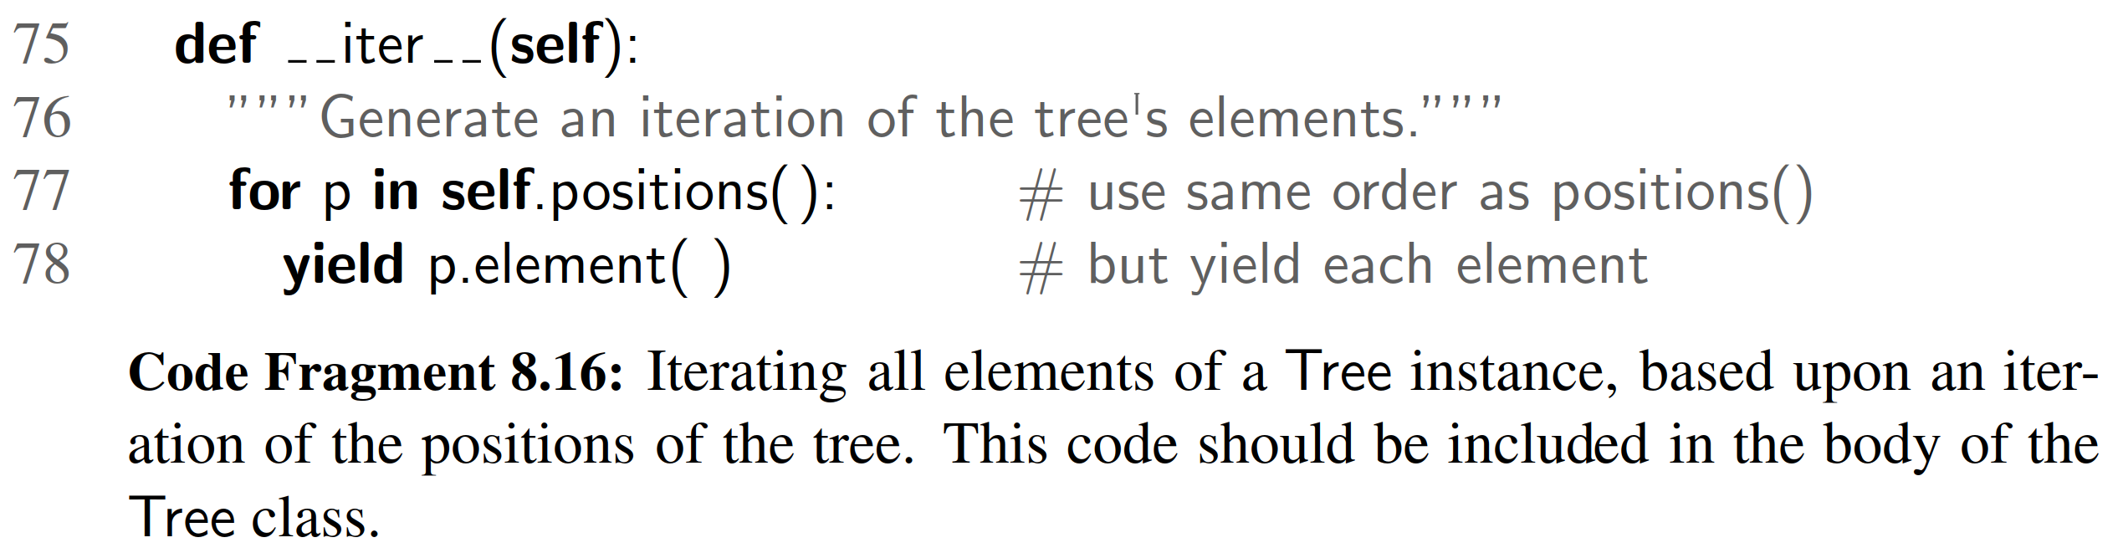

To implement the positions method, we have a choice of tree traversal algo- rithms. Given that there are advantages to each of those traversal orders, we will provide independent implementations of each strategy that can be called directly by a user of our class. We can then trivially adapt one of those as a default order for the positions method of the tree ADT.

Preorder Traversal

We begin by considering the preorder traversal algorithm. We will support a public method with calling signature T.preorder( ) for tree T, which generates a preorder iteration of all positions within the tree. However, the recursive algorithm for gen- erating a preorder traversal, as originally described in Code Fragment 8.12, must be parameterized by a speciﬁc position within the tree that serves as the root of a subtree to traverse. A standard solution for such a circumstance is to deﬁne a non- public utility method with the desired recursive parameterization, and then to have the public method preorder invoke the nonpublic method upon the root of the tree. Our implementation of such a design is given in Code Fragment 8.17.

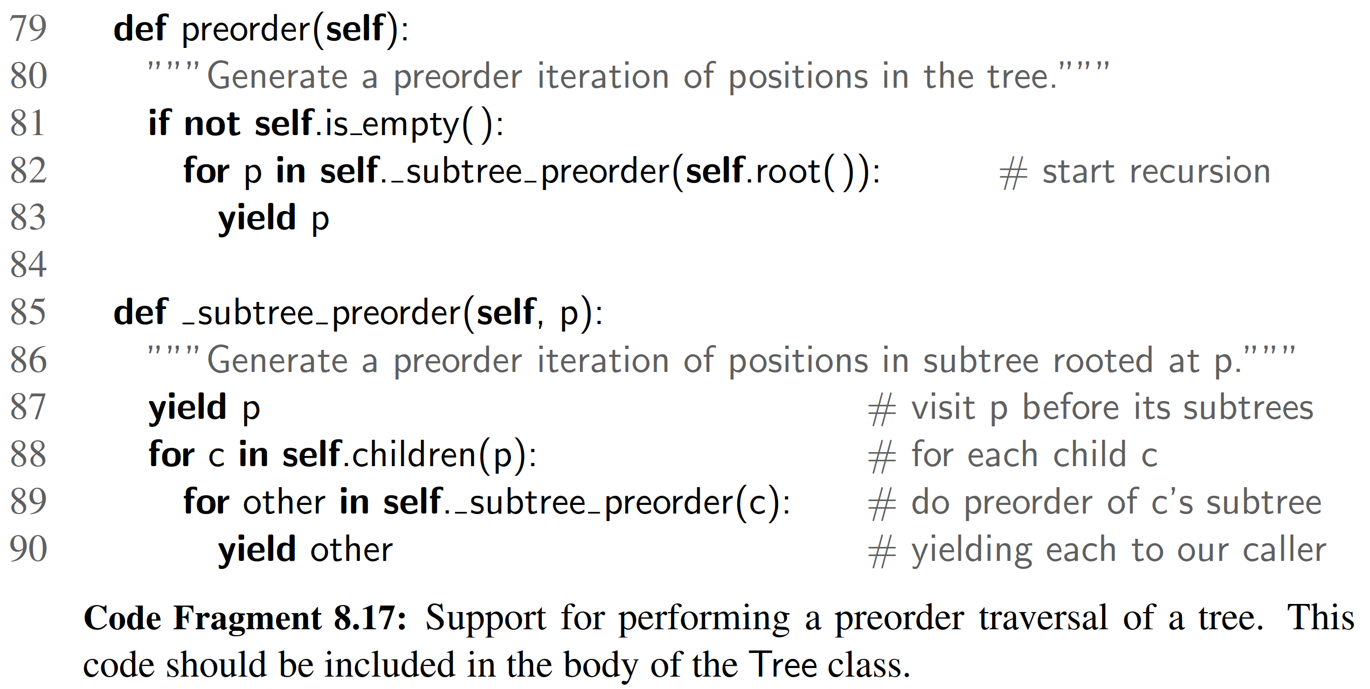

Formally, both preorder and the utility subtree preorder are generators. Rather than perform a “visit” action from within this code, we yield each position to the caller and let the caller decide what action to perform at that position.

The subtree preorder method is the recursive one. However, because we are relying on generators rather than traditional functions, the recursion has a slightly different form. In order to yield all positions within the subtree of child c, we loop over the positions yielded by the recursive call self. subtree preorder(c), and re- yield each position in the outer context. Note that if p is a leaf, the for loop over self.children(p) is trivial (this is the base case for our recursion).

We rely on a similar technique in the public preorder method to re-yield all positions that are generated by the recursive process starting at the root of the tree; if the tree is empty, nothing is yielded. At this point, we have provided full support for the preorder generator. A user of the class can therefore write code such as

for p in T.preorder( ):

# ”visit” position p

The ofﬁcial tree ADT requires that all trees support a positions method as well. To use a preorder traversal as the default order of iteration, we include the deﬁnition shown in Code Fragment 8.18 within our Tree class. Rather than loop over the results returned by the preorder call, we return the entire iteration as an object.

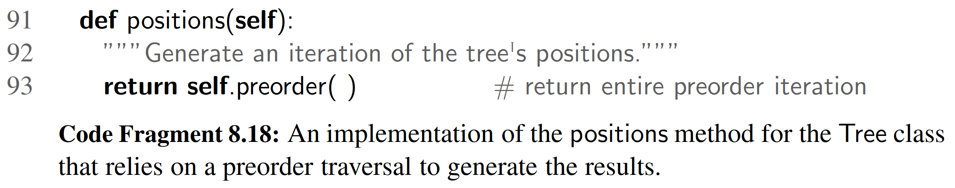

Postorder Traversal

We can implement a postorder traversal using very similar technique as with a preorder traversal. The only difference is that within the recursive utility for a post- order we wait to yield position p until after we have recursively yield the positions in its subtrees. An implementation is given in Code Fragment 8.19.

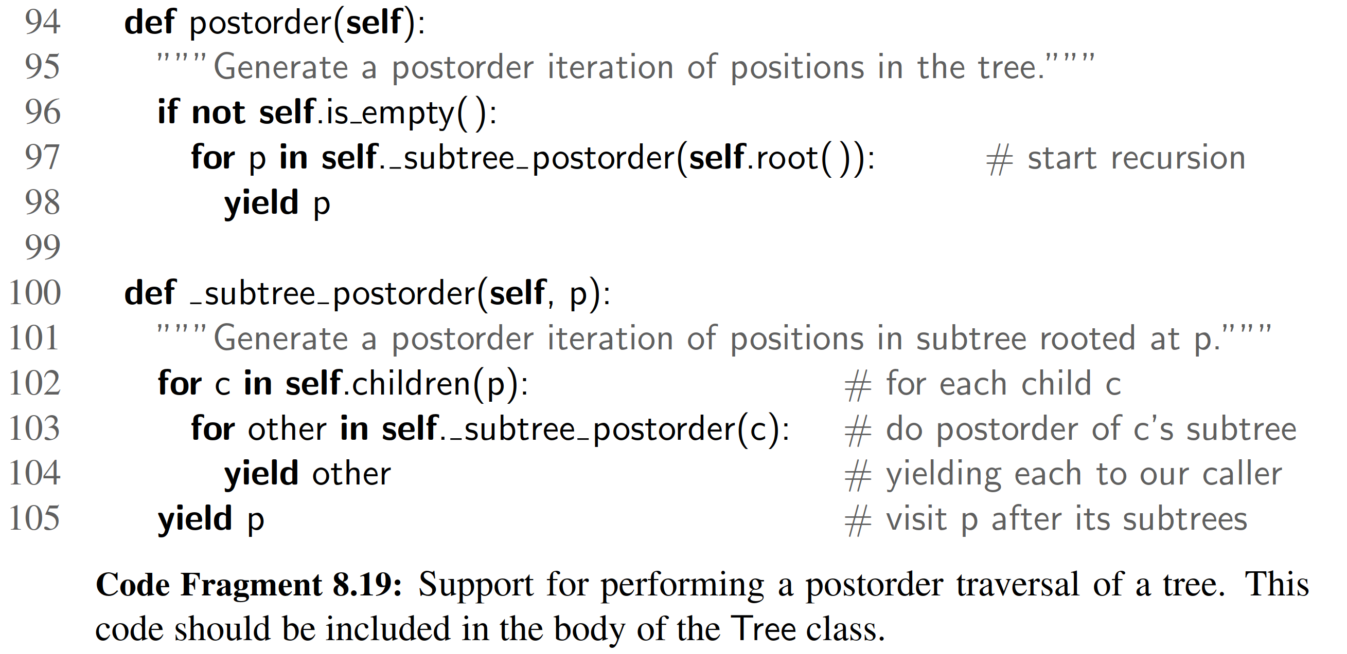

Breadth-First Traversal

In Code Fragment 8.20, we provide an implementation of the breadth-ﬁrst traversal algorithm in the context of our Tree class. Recall that the breadth-ﬁrst traversal algorithm is not recursive; it relies on a queue of positions to manage the traver- sal process. Our implementation uses the LinkedQueue class from Section 7.1.2, although any implementation of the queue ADT would sufﬁce.

Inorder Traversal for Binary Trees

The preorder, postorder, and breadth-ﬁrst traversal algorithms are applicable to all trees, and so we include their implementations within the Tree abstract base class. Those methods are inherited by the abstract BinaryTree class, the concrete LinkedBinaryTree class, and any other dependent tree classes we might develop.

The inorder traversal algorithm, because it explicitly relies on the notion of a left and right child of a node, only applies to binary trees. We therefore include its deﬁnition within the body of the BinaryTree class. We use a similar technique to implement an inorder traversal (Code Fragment 8.21) as we did with preorder and postorder traversals.

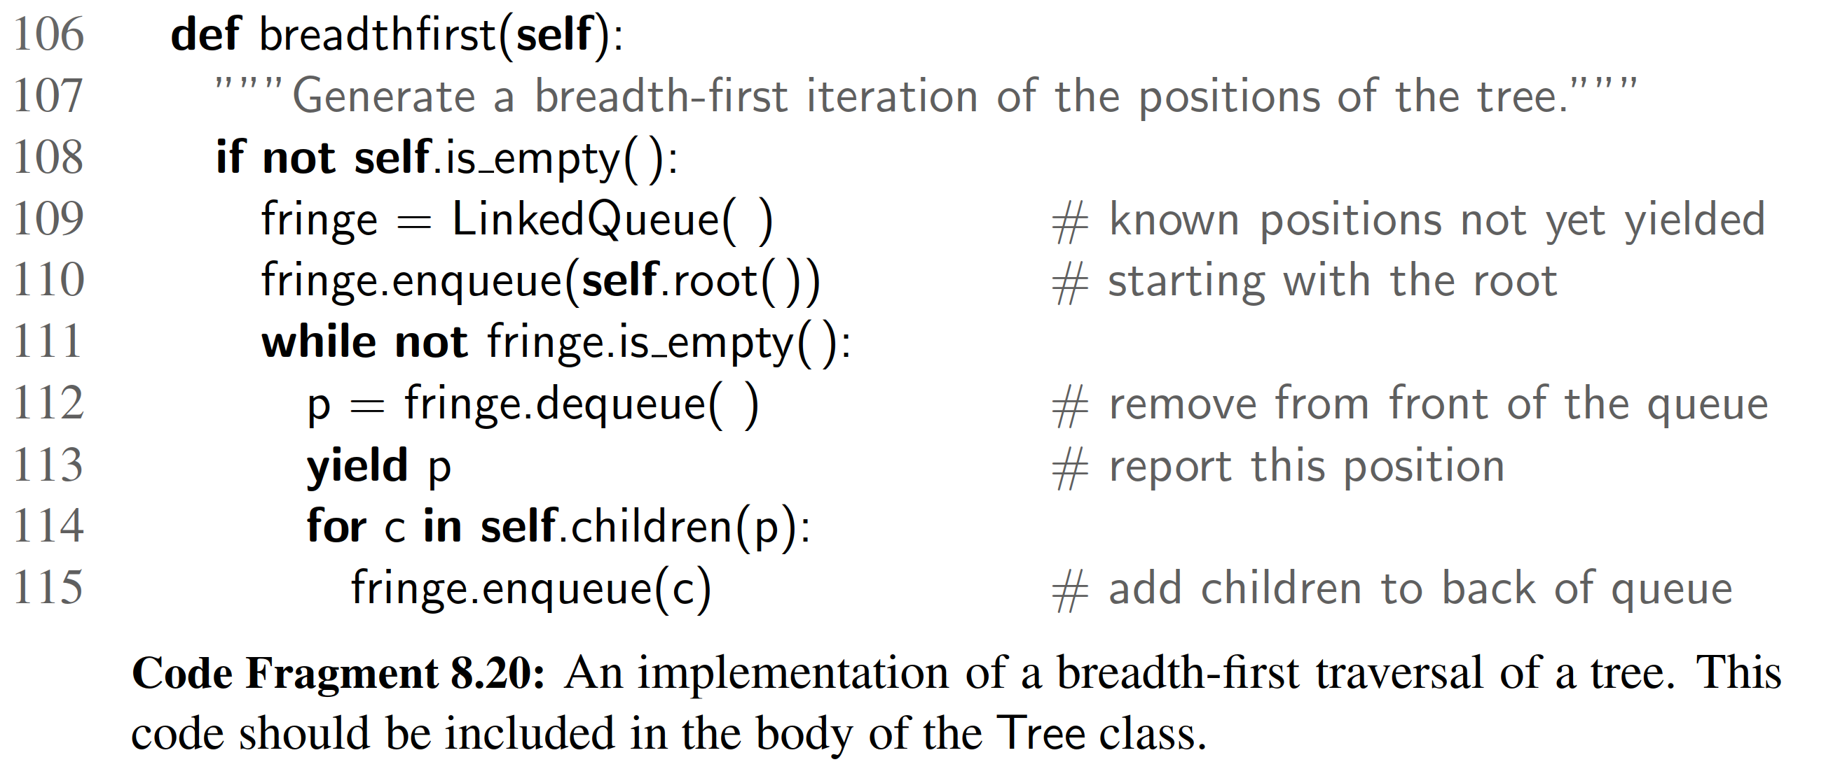

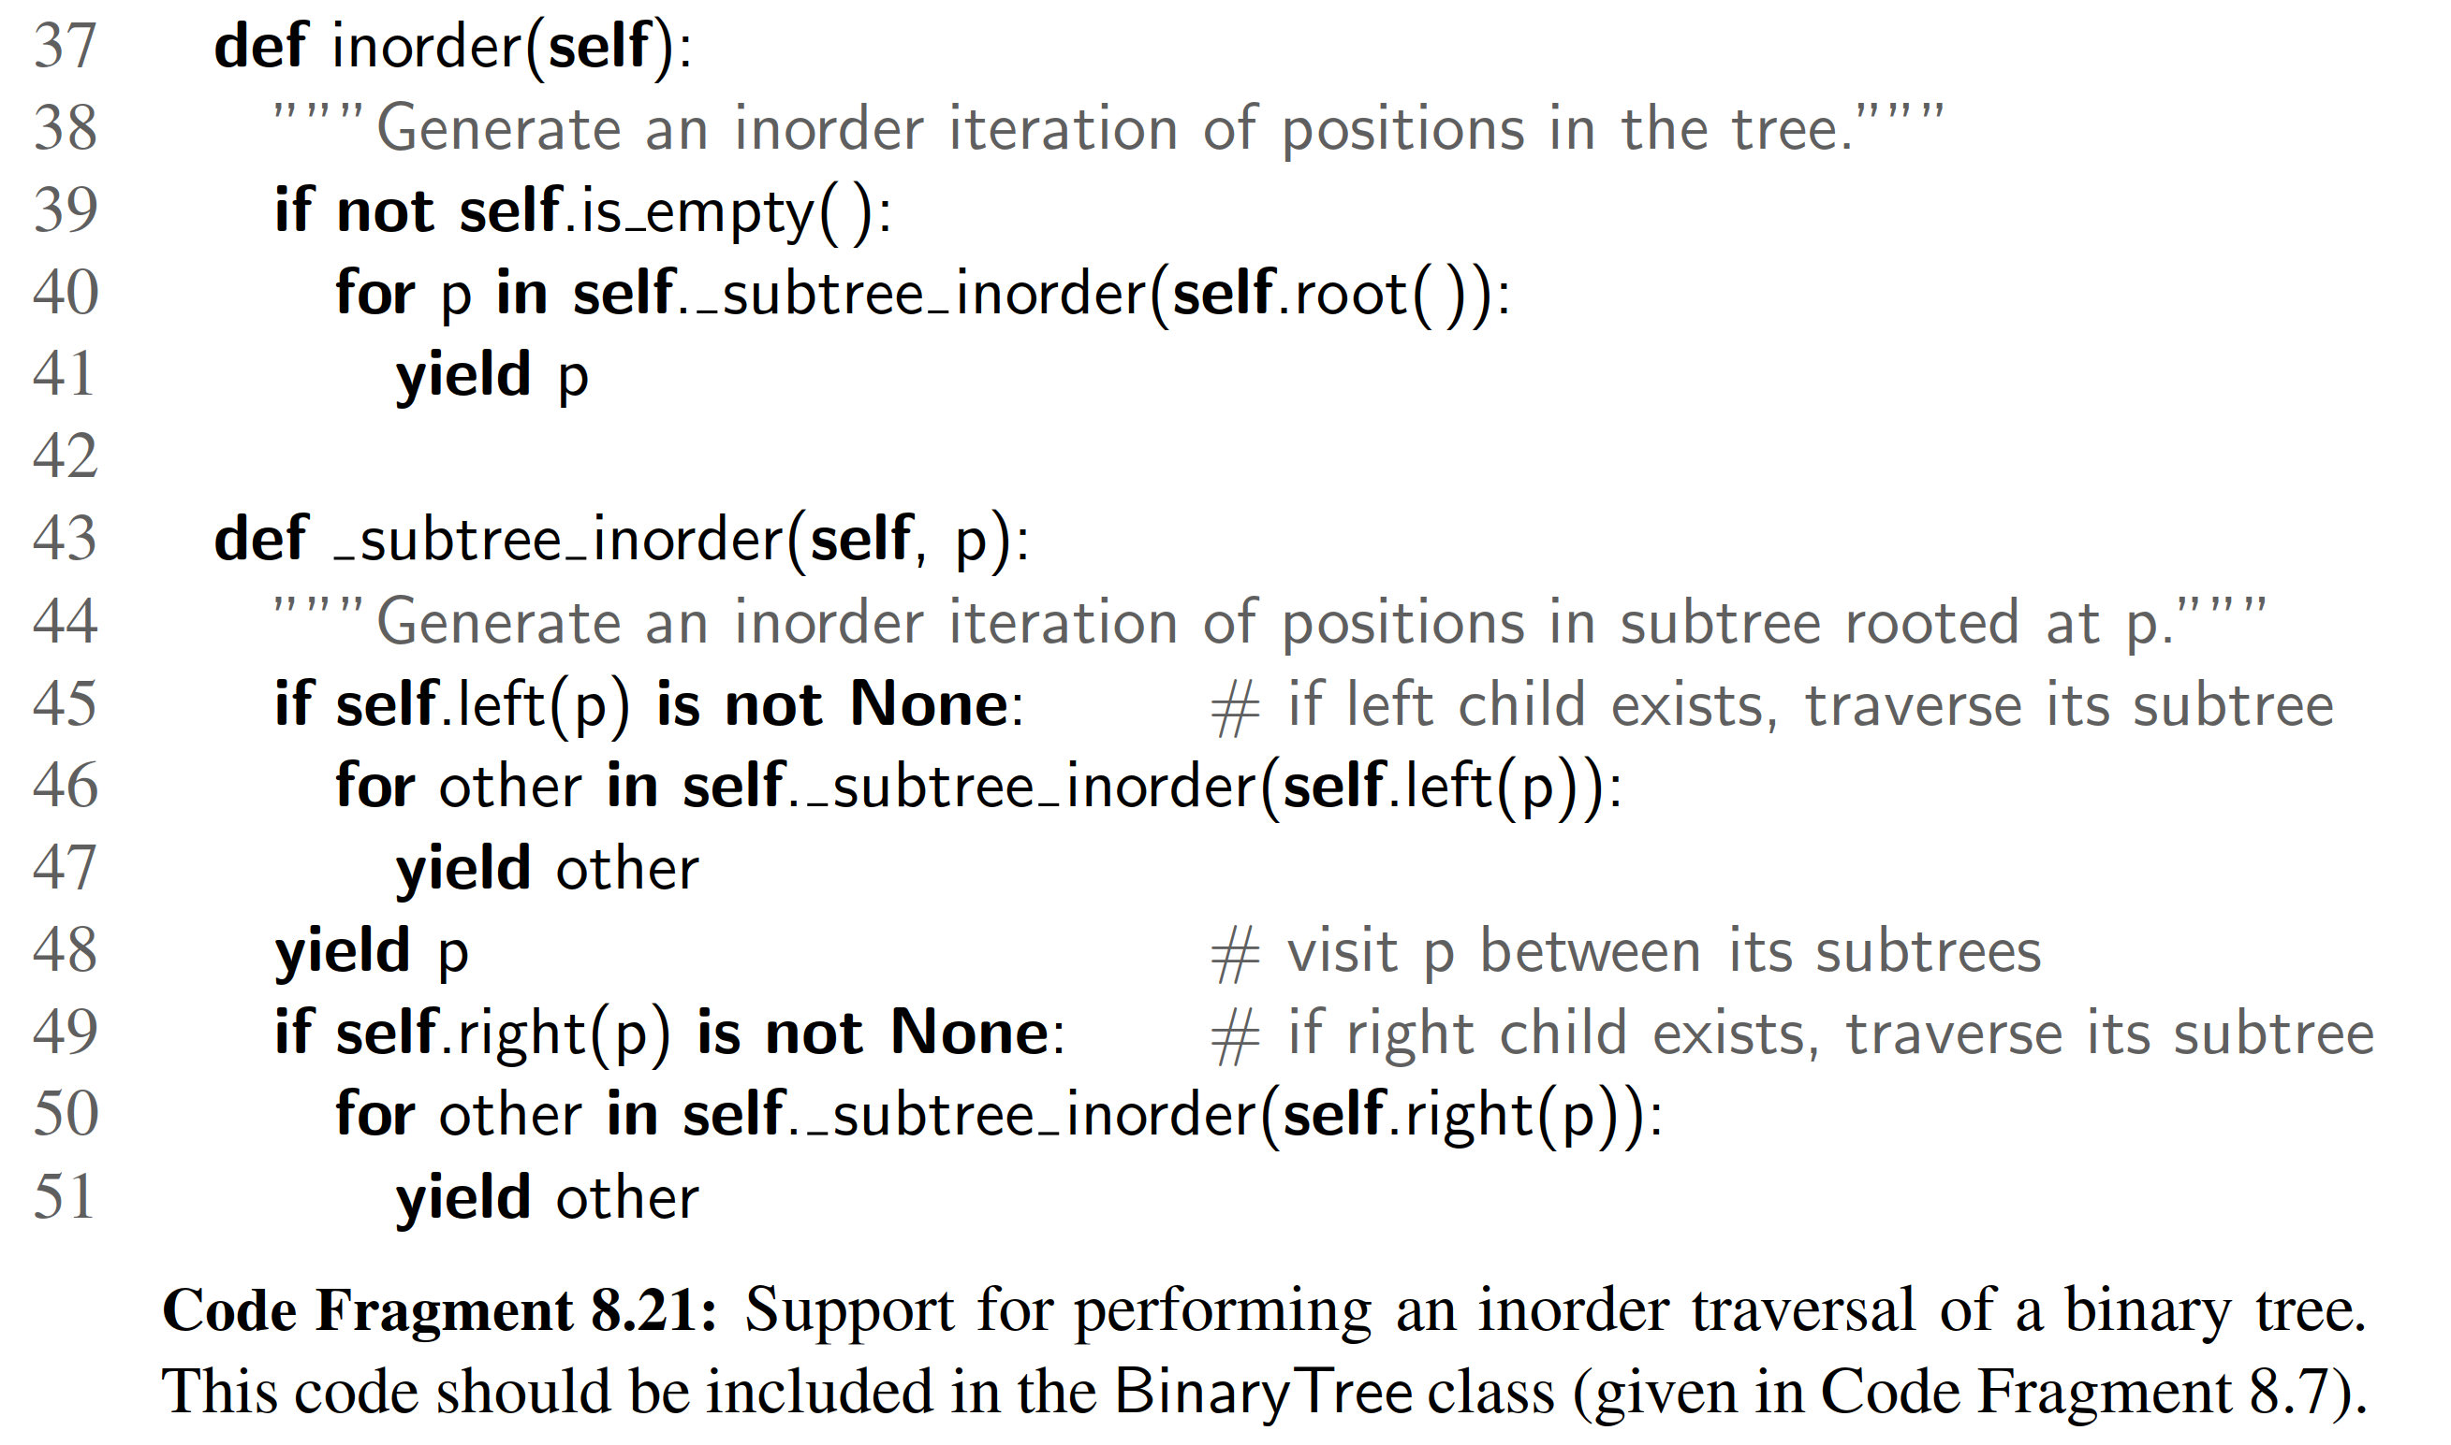

For many applications of binary trees, an inorder traversal provides a natural iteration. We could make it the default for the BinaryTree class by overriding the positions method that was inherited from the Tree class (see Code Fragment 8.22).

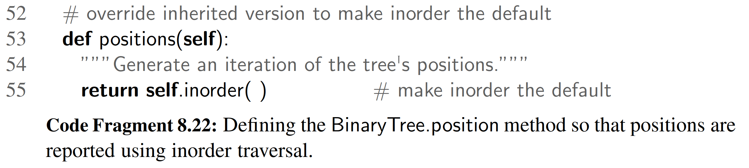

8.4.5 Applications of Tree Traversals

In this section, we demonstrate several representative applications of tree traversals, including some customizations of the standard traversal algorithms.

Table of Contents

When using a tree to represent the hierarchical structure of a document, a preorder traversal of the tree can naturally be used to produce a table of contents for the doc- ument. For example, the table of contents associated with the tree from Figure 8.15 is displayed in Figure 8.20. Part (a) of that ﬁgure gives a simple presentation with one element per line; part (b) shows a more attractive presentation produced by indenting each element based on its depth within the tree. A similar presentation could be used to display the contents of a computer’s ﬁle system, based on its tree representation (as in Figure 8.3).

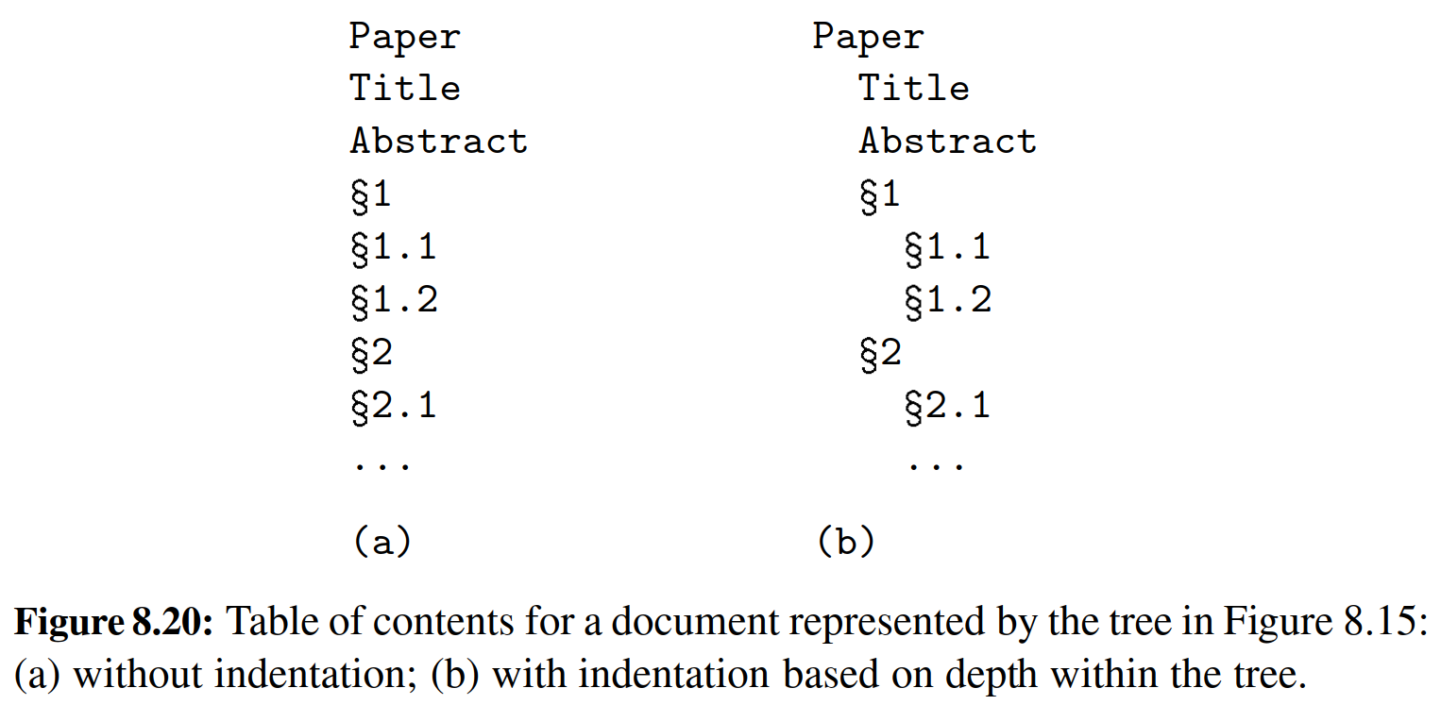

The unindented version of the table of contents, given a tree T , can be produced with the following code:

for p in T.preorder( ): print(p.element( ))

To produce the presentation of Figure 8.20(b), we indent each element with a number of spaces equal to twice the element’s depth in the tree (hence, the root ele- ment was unindented). Although we could replace the body of the above loop with the statement print(2 T.depth(p) + str(p.element())), such an approach is unnecessarily inefﬁcient. Although the work to produce the preorder traversal runs in O(n) time, based on the analysis of Section 8.4.1, the calls to depth incur a hid- den cost. Making a call to depth from every position of the tree results in O(n2) worst-case time, as noted when analyzing the algorithm height1 in Section 8.1.3.

A preferred approach to producing an indented table of contents is to redesign a top-down recursion that includes the current depth as an additional parameter. Such an implementation is provided in Code Fragment 8.23. This implementation runs in worst-case O(n) time (except, technically, the time it takes to print strings of increasing lengths).

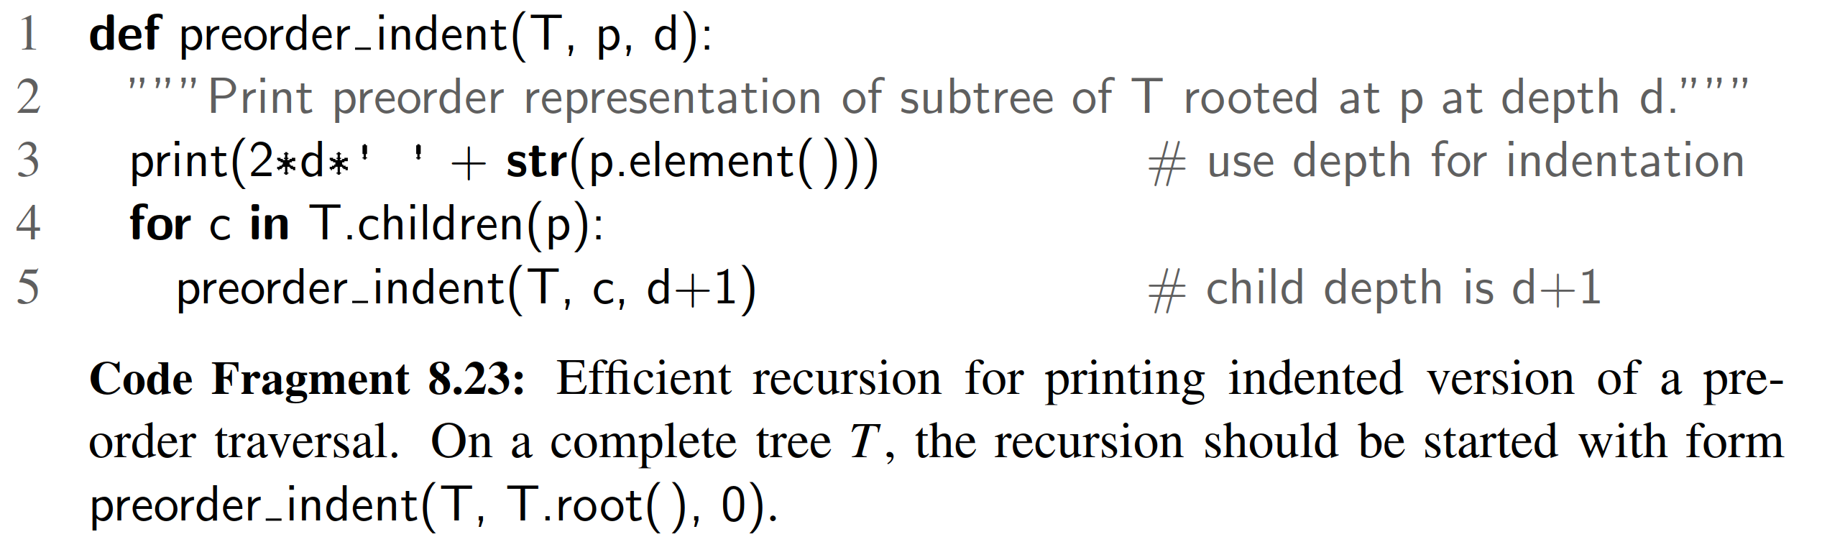

In the example of Figure 8.20, we were fortunate in that the numbering was embedded within the elements of the tree. More generally, we might be interested in using a preorder traversal to display the structure of a tree, with indentation and also explicit numbering that was not present in the tree. For example, we might display the tree from Figure 8.2 beginning as:

Electronics R’Us

1 R&D

2 Sales

2.1 Domestic

2.2 International

2.2.1 Canada

2.2.2 S. America

This is more challenging, because the numbers used as labels are implicit in the structure of the tree. A label depends on the index of each position, relative to its siblings, along the path from the root to the current position. To accomplish the task, we add a representation of that path as an additional parameter to the recursive signature. Speciﬁcally, we use a list of zero-indexed numbers, one for each position along the downward path, other than the root. (We convert those numbers to one- indexed form when printing.)

At the implementation level, we wish to avoid the inefﬁciency of duplicating such lists when sending a new parameter from one level of the recursion to the next. A standard solution is to share the same list instance throughout the recursion. At one level of the recursion, a new entry is temporarily added to the end of the list before making further recursive calls. In order to “leave no trace,” that same block of code must remove the extraneous entry from the list before completing its task. An implementation based on this approach is given in Code Fragment 8.24.

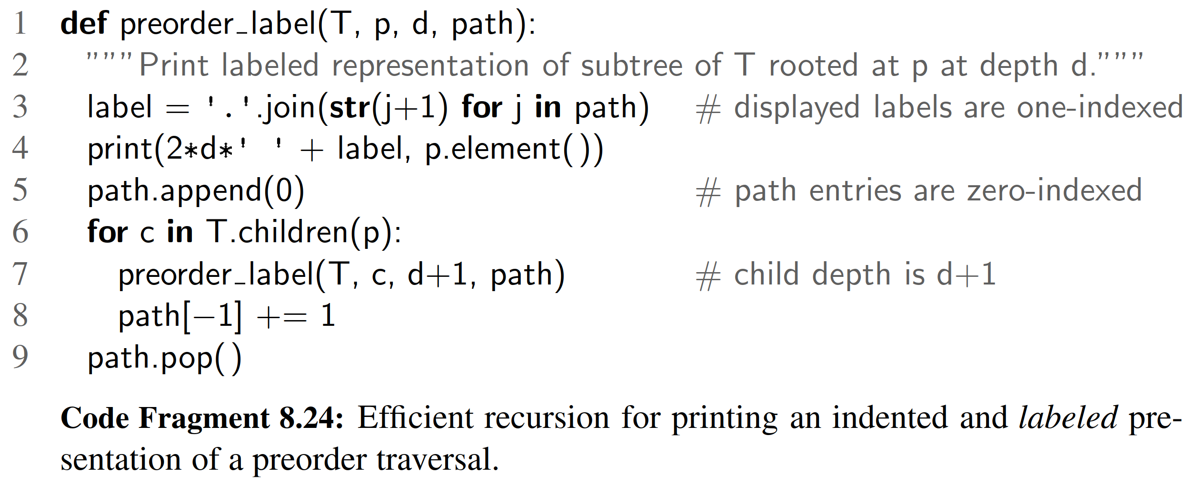

Parenthetic Representations of a Tree

It is not possible to reconstruct a general tree, given only the preorder sequence of elements, as in Figure 8.20(a). Some additional context is necessary for the structure of the tree to be well deﬁned. The use of indentation or numbered labels provides such context, with a very human-friendly presentation. However, there are more concise string representations of trees that are computer-friendly.

In this section, we explore one such representation. The parenthetic string representation P(T ) of tree T is recursively deﬁned as follows. If T consists of a single position p, then

P(T )= str(p.element()).

Otherwise, it is deﬁned recursively as,

P(T )= str(p.element()) + ( + P(T1)+ , + ··· + , + P(Tk)+ )

where p is the root of T and T1, T2,..., Tk are the subtrees rooted at the children of p, which are given in order if T is an ordered tree. We are using “+” here to denote string concatenation. As an example, the parenthetic representation of the tree of Figure 8.2 would appear as follows (line breaks are cosmetic):

Electronics R’Us (R&D, Sales (Domestic, International (Canada,

S. America, Overseas (Africa, Europe, Asia, Australia))), Purchasing, Manufacturing (TV, CD, Tuner))

Although the parenthetic representation is essentially a preorder traversal, we cannot easily produce the additional punctuation using the formal implementation of preorder, as given in Code Fragment 8.17. The opening parenthesis must be produced just before the loop over a position’s children and the closing parenthesis must be produced just after that loop. Furthermore, the separating commas must be produced. The Python function parenthesize, shown in Code Fragment 8.25, is a custom traversal that prints such a parenthetic string representation of a tree T .

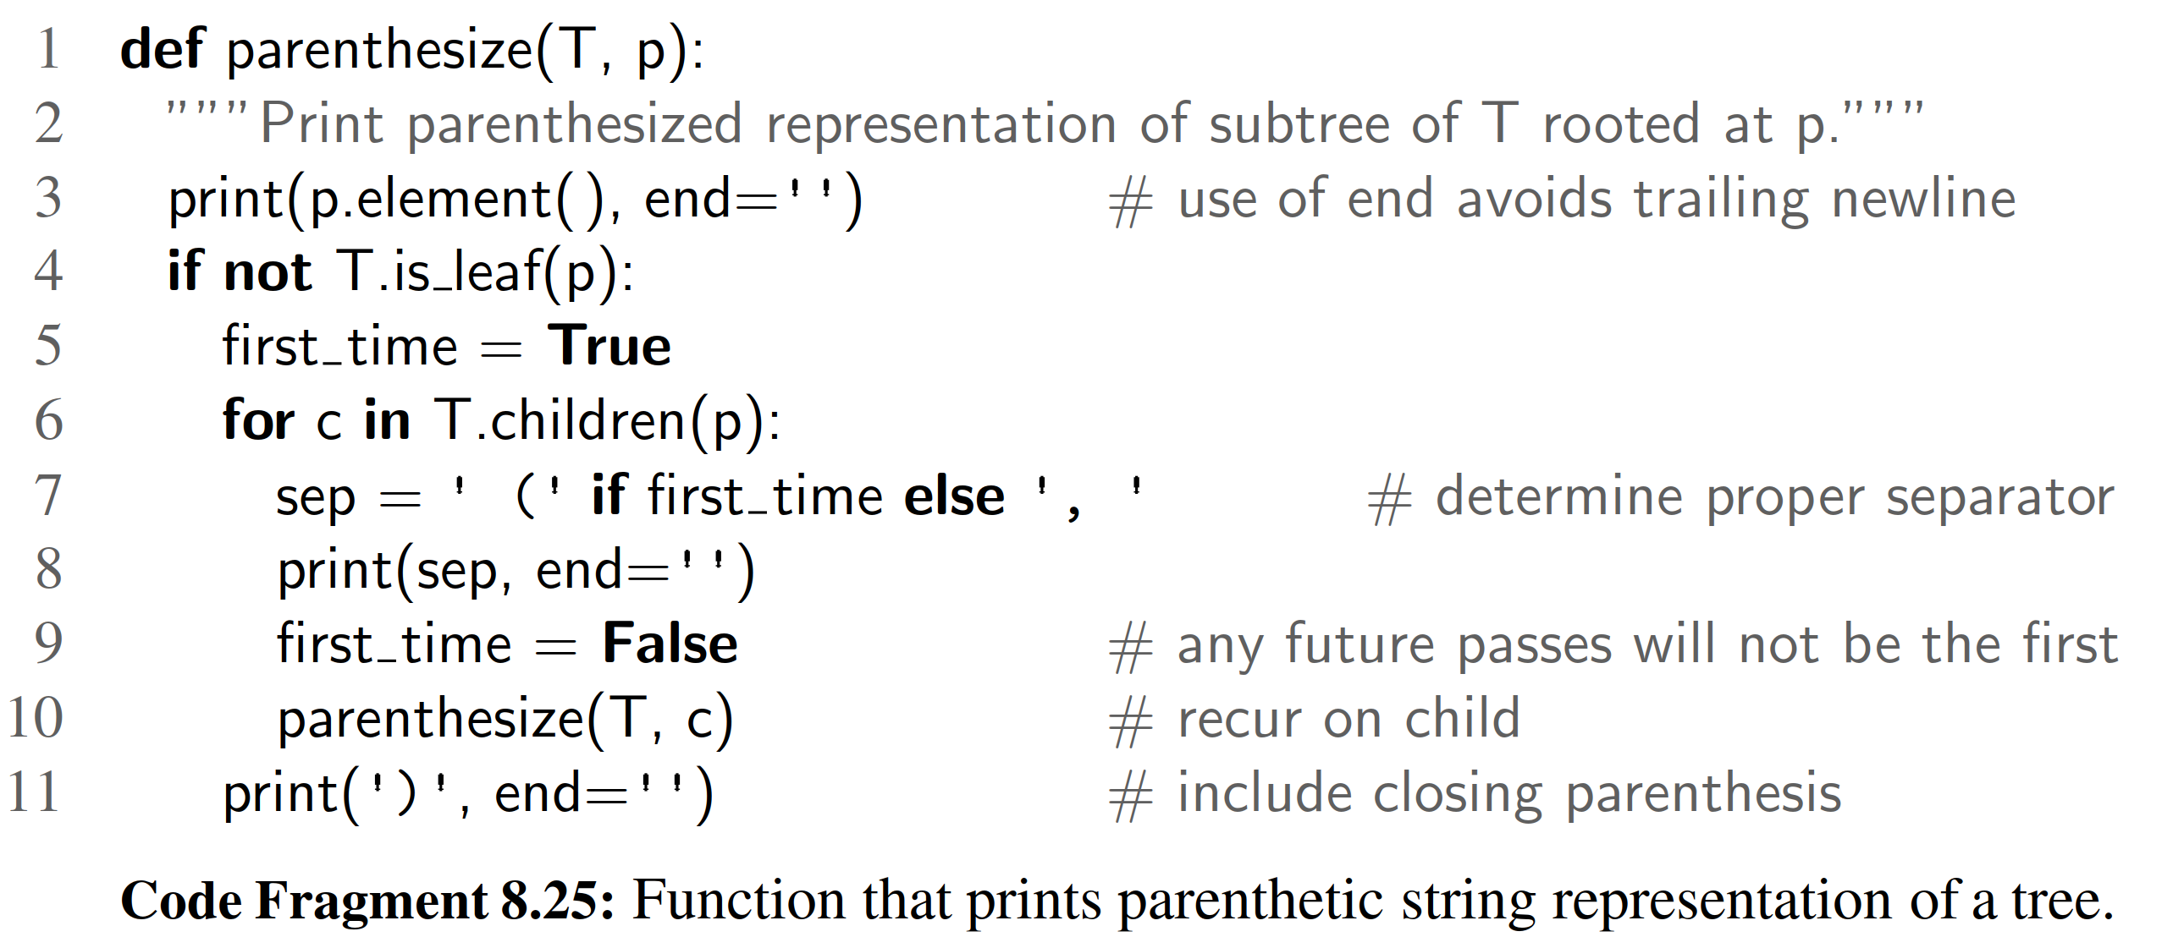

Computing Disk Space

In Example 8.1, we considered the use of a tree as a model for a ﬁle-system struc- ture, with internal positions representing directories and leaves representing ﬁles. In fact, when introducing the use of recursion back in Chapter 4, we speciﬁcally examined the topic of ﬁle systems (see Section 4.1.4). Although we did not explic- itly model it as a tree at that time, we gave an implementation of an algorithm for computing the disk usage (Code Fragment 4.5).

The recursive computation of disk space is emblematic of a postorder traversal, as we cannot effectively compute the total space used by a directory until after we know the space that is used by its children directories. Unfortunately, the formal implementation of postorder, as given in Code Fragment 8.19 does not sufﬁce for this purpose. As it visits the position of a directory, there is no easy way to discern which of the previous positions represent children of that directory, nor how much recursive disk space was allocated.

We would like to have a mechanism for children to return information to the parent as part of the traversal process. A custom solution to the disk space prob- lem, with each level of recursion providing a return value to the (parent) caller, is provided in Code Fragment 8.26.

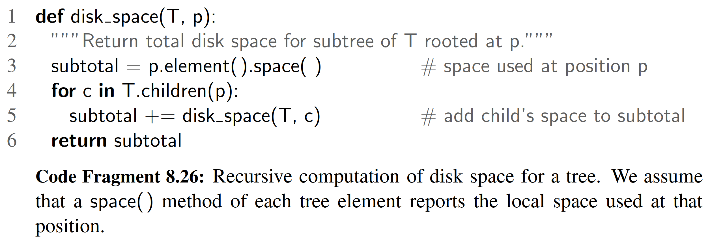

8.4.6 Euler Tours and the Template Method Pattern *

The various applications described in Section 8.4.5 demonstrate the great power of recursive tree traversals. Unfortunately, they also show that the speciﬁc imple- mentations of the preorder and postorder methods of our Tree class, or the inorder method of the BinaryTree class, are not general enough to capture the range of computations we desire. In some cases, we need more of a blending of the ap- proaches, with initial work performed before recurring on subtrees, additional work performed after those recursions, and in the case of a binary tree, work performed between the two possible recursions. Furthermore, in some contexts it was impor- tant to know the depth of a position, or the complete path from the root to that position, or to return information from one level of the recursion to another. For each of the previous applications, we were able to develop a custom implementa- tion to properly adapt the recursive ideas, but the great principles of object-oriented programming introduced in Section 2.1.1 include adaptability and reusability.

In this section, we develop a more general framework for implementing tree traversals based on a concept known as an Euler tour traversal. The Euler tour traversal of a general tree T can be informally deﬁned as a “walk” around T , where we start by going from the root toward its leftmost child, viewing the edges of T as being “walls” that we always keep to our left. (See Figure 8.21.)

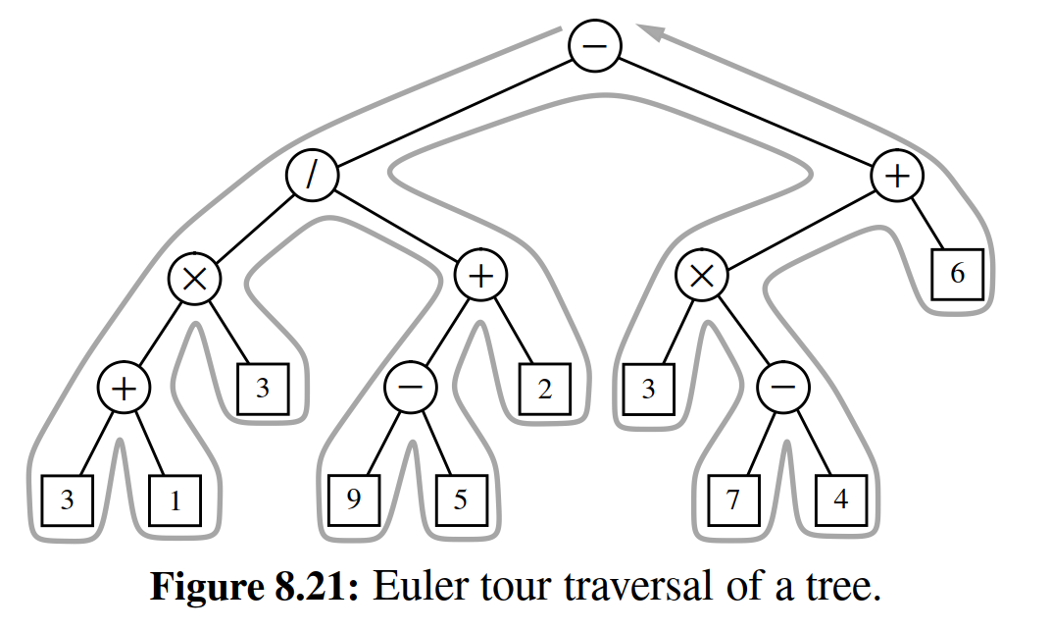

The complexity of the walk is O(n), because it progresses exactly two times along each of the n−1 edges of the tree—once going downward along the edge, and

later going upward along the edge. To unify the concept of preorder and postorder traversals, we can think of there being two notable “visits” to each position p:

• A “pre visit” occurs when ﬁrst reaching the position, that is, when the walk passes immediately left of the node in our visualization.

A “post visit” occurs when the walk later proceeds upward from that position, that is, when the walk passes to the right of the node in our visualization.

The process of an Euler tour can easily be viewed recursively. In between the “pre visit” and “post visit” of a given position will be a recursive tour of each of its subtrees. Looking at Figure 8.21 as an example, there is a contiguous portion of the entire tour that is itself an Euler tour of the subtree of the node with element “/”. That tour contains two contiguous subtours, one traversing that position’s left subtree and another traversing the right subtree. The pseudo-code for an Euler tour traversal of a subtree rooted at a position p is shown in Code Fragment 8.27.

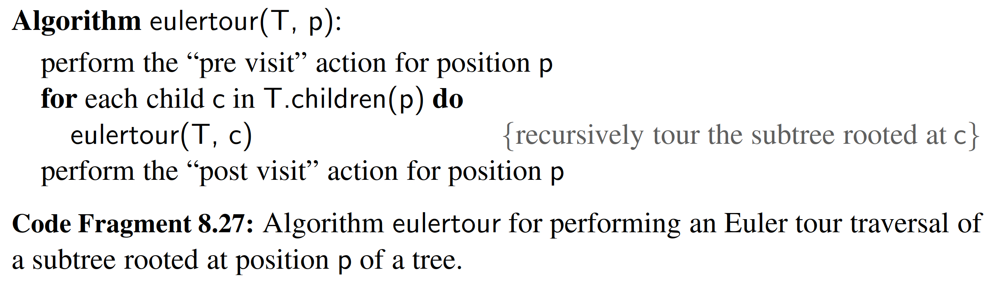

The Template Method Pattern

To provide a framework that is reusable and adaptable, we rely on an interesting object-oriented software design pattern, the template method pattern. The template method pattern describes a generic computation mechanism that can be specialized for a particular application by redeﬁning certain steps. To allow customization, the primary algorithm calls auxiliary functions known as hooks at designated steps of the process.

In the context of an Euler tour traversal, we deﬁne two separate hooks, a pre- visit hook that is called before the subtrees are traversed, and a postvisit hook that is called after the completion of the subtree traversals. Our implementation will take the form of an EulerTour class that manages the process, and deﬁnes trivial deﬁ- nitions for the hooks that do nothing. The traversal can be customized by deﬁning a subclass of EulerTour and overriding one or both hooks to provide specialized behavior.

Python Implementation

Our implementation of an EulerTour class is provided in Code Fragment 8.28. The primary recursive process is deﬁned in the nonpublic tour method. A tour instance is created by sending a reference to a speciﬁc tree to the constructor, and then by calling the public execute method, which beings the tour and returns a ﬁnal result of the computation.

Based on our experience of customizing traversals for sample applications Sec- tion 8.4.5, we build support into the primary EulerTour for maintaining the re- cursive depth and the representation of the recursive path through a tree, using the approach that we introduced in Code Fragment 8.24. We also provide a mechanism for one recursive level to return a value to another when post-processing. Formally, our framework relies on the following two hooks that can be specialized:

• method hook previsit(p, d, path)

This function is called once for each position, immediately before its subtrees (if any) are traversed. Parameter p is a position in the tree, d is the depth of that position, and path is a list of indices, using the convention described in the discussion of Code Fragment 8.24. No return value is expected from this function.

• method hook postvisit(p, d, path, results)

This function is called once for each position, immediately after its subtrees (if any) are traversed. The ﬁrst three parameters use the same convention as did hook previsit. The ﬁnal parameter is a list of objects that were provided as return values from the post visits of the respective subtrees of p. Any value returned by this call will be available to the parent of p during its postvisit.

For more complex tasks, subclasses of EulerTour may also choose to initialize and maintain additional state in the form of instance variables that can be accessed within the bodies of the hooks.

Using the Euler Tour Framework

To demonstrate the ﬂexibility of our Euler tour framework, we revisit the sample applications from Section 8.4.5. As a simple example, an indented preorder traver- sal, akin to that originally produced by Code Fragment 8.23, can be generated with the simple subclass given in Code Fragment 8.29.

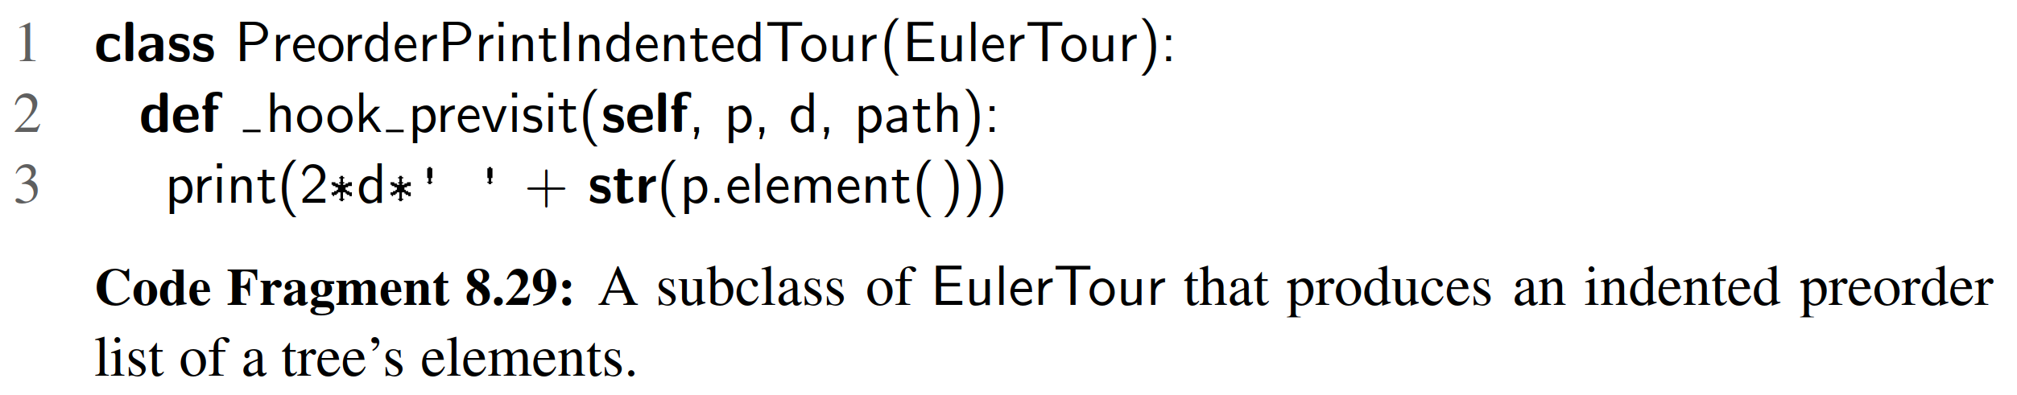

Such a tour would be started by creating an instance of the subclass for a given tree T, and invoking its execute method. This could be expressed as follows:

tour = PreorderPrintIndentedTour(T) tour.execute( )

A labeled version of an indented, preorder presentation, akin to Code Frag- ment 8.24, could be generated by the new subclass of EulerTour shown in Code Fragment 8.30.

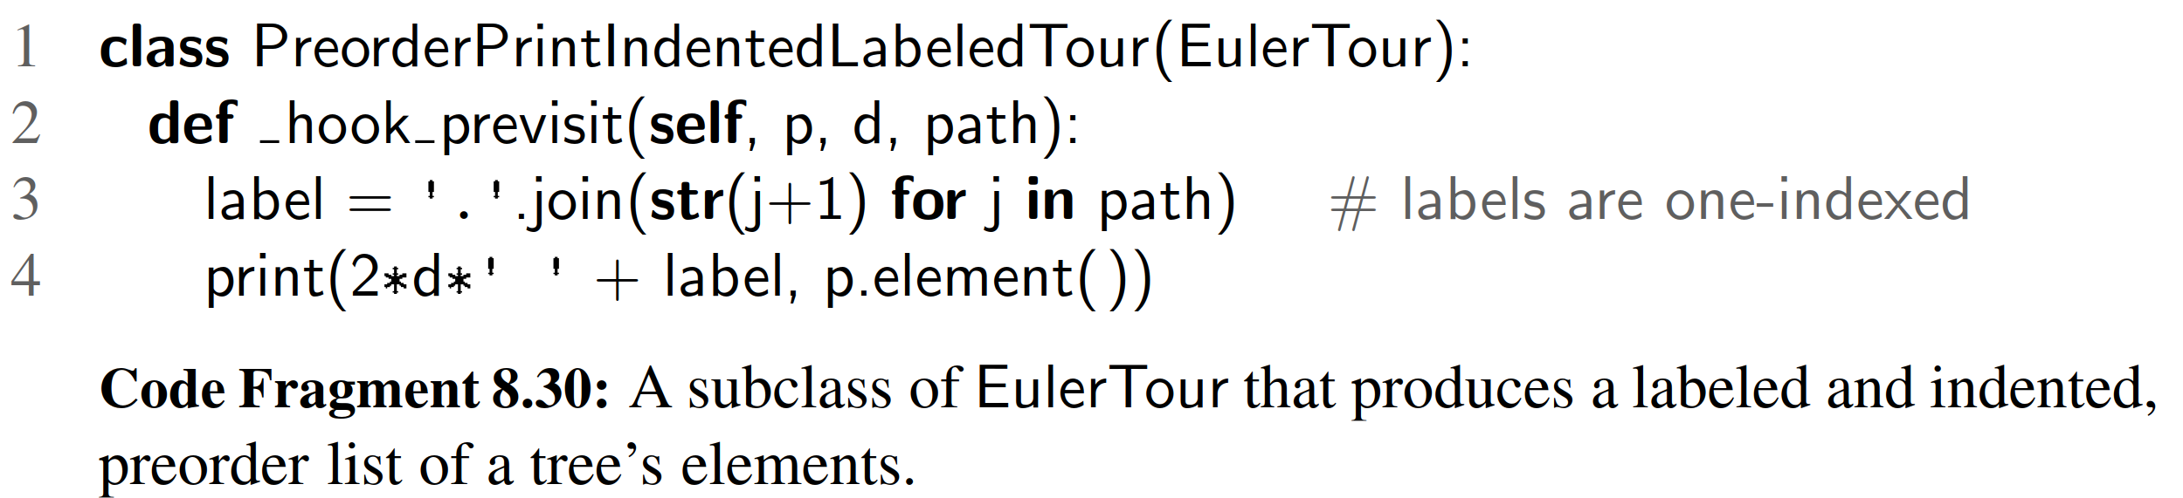

To produce the parenthetic string representation, originally achieved with Code Fragment 8.25, we deﬁne a subclass that overrides both the previsit and postvisit hooks. Our new implementation is given in Code Fragment 8.31.

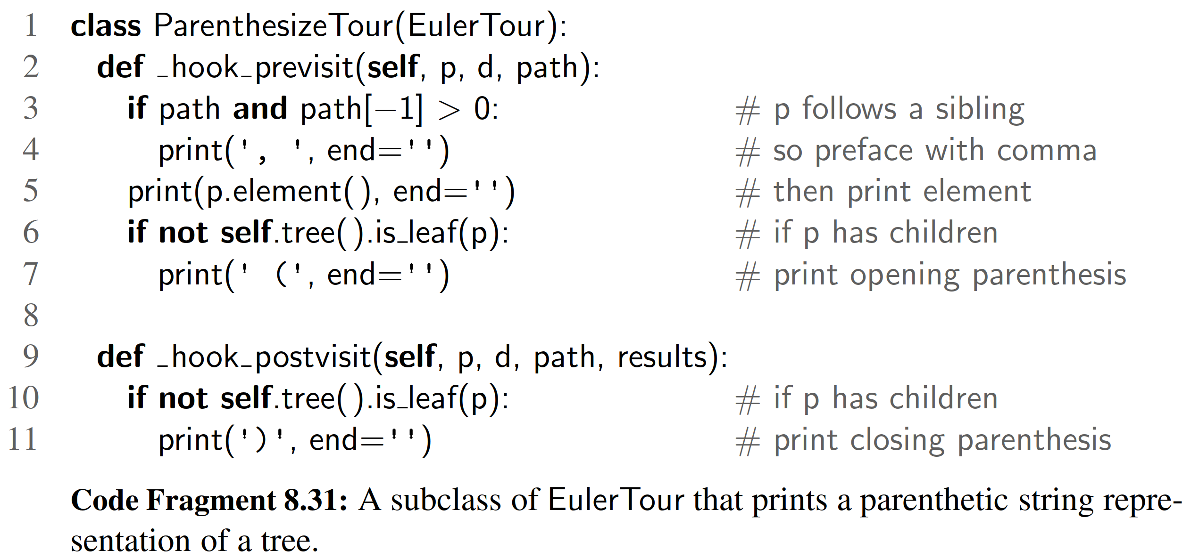

Notice that in this implementation, we need to invoke a method on the tree instance that is being traversed from within the hooks. The public tree( ) method of the EulerTour class serves as an accessor for that tree.

Finally, the task of computing disk space, as originally implemented in Code Fragment 8.26, can be performed quite easily with the EulerTour subclass shown in Code Fragment 8.32. The postvisit result of the root will be returned by the call to execute( ).

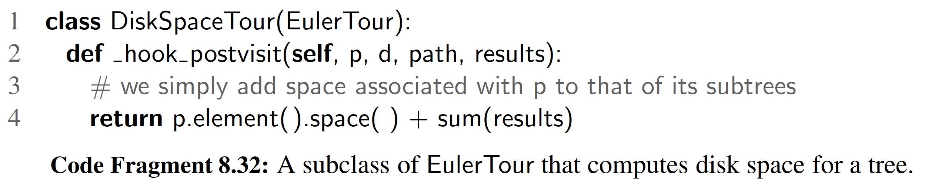

The Euler Tour Traversal of a Binary Tree

In Section 8.4.6, we introduced the concept of an Euler tour traversal of a general graph, using the template method pattern in designing the EulerTour class. That class provided methods hook previsit and hook postvisit that could be overrid- den to customize a tour. In Code Fragment 8.33 we provide a BinaryEulerTour specialization that includes an additional hook invisit that is called once for each position—after its left subtree is traversed, but before its right subtree is traversed. Our implementation of BinaryEulerTour replaces the original tour utility to specialize to the case in which a node has at most two children. If a node has only one child, a tour differentiates between whether that is a left child or a right child, with the “in visit” taking place after the visit of a sole left child, but before the visit

of a sole right child. In the case of a leaf, the three hooks are called in succession.

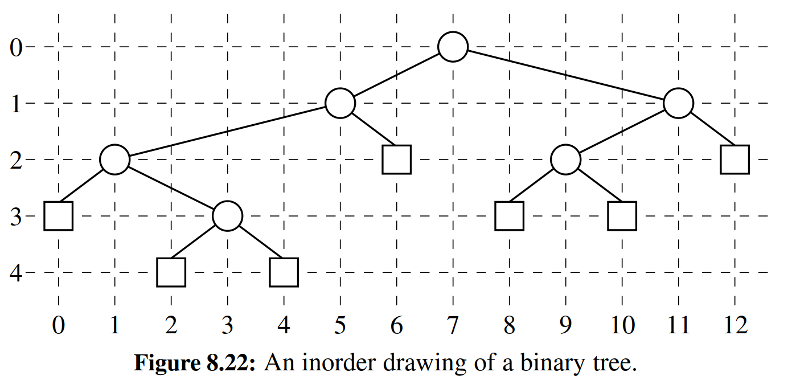

To demonstrate use of the BinaryEulerTour framework, we develop a subclass that computes a graphical layout of a binary tree, as shown in Figure 8.22. The geometry is determined by an algorithm that assigns x- and y-coordinates to each position p of a binary tree T using the following two rules:

• x(p) is the number of positions visited before p in an inorder traversal of T .

• y(p) is the depth of p in T .

In this application, we take the convention common in computer graphics that x- coordinates increase left to right and y-coordinates increase top to bottom. So the origin is in the upper left corner of the computer screen.

Code Fragment 8.34 provides an implementation of a BinaryLayout subclass that implements the above algorithm for assigning (x, y) coordinates to the element stored at each position of a binary tree. We adapt the BinaryEulerTour framework by introducing additional state in the form of a count instance variable that repre- sents the number of “in visits” that we have performed. The x-coordinate for each position is set according to that counter.

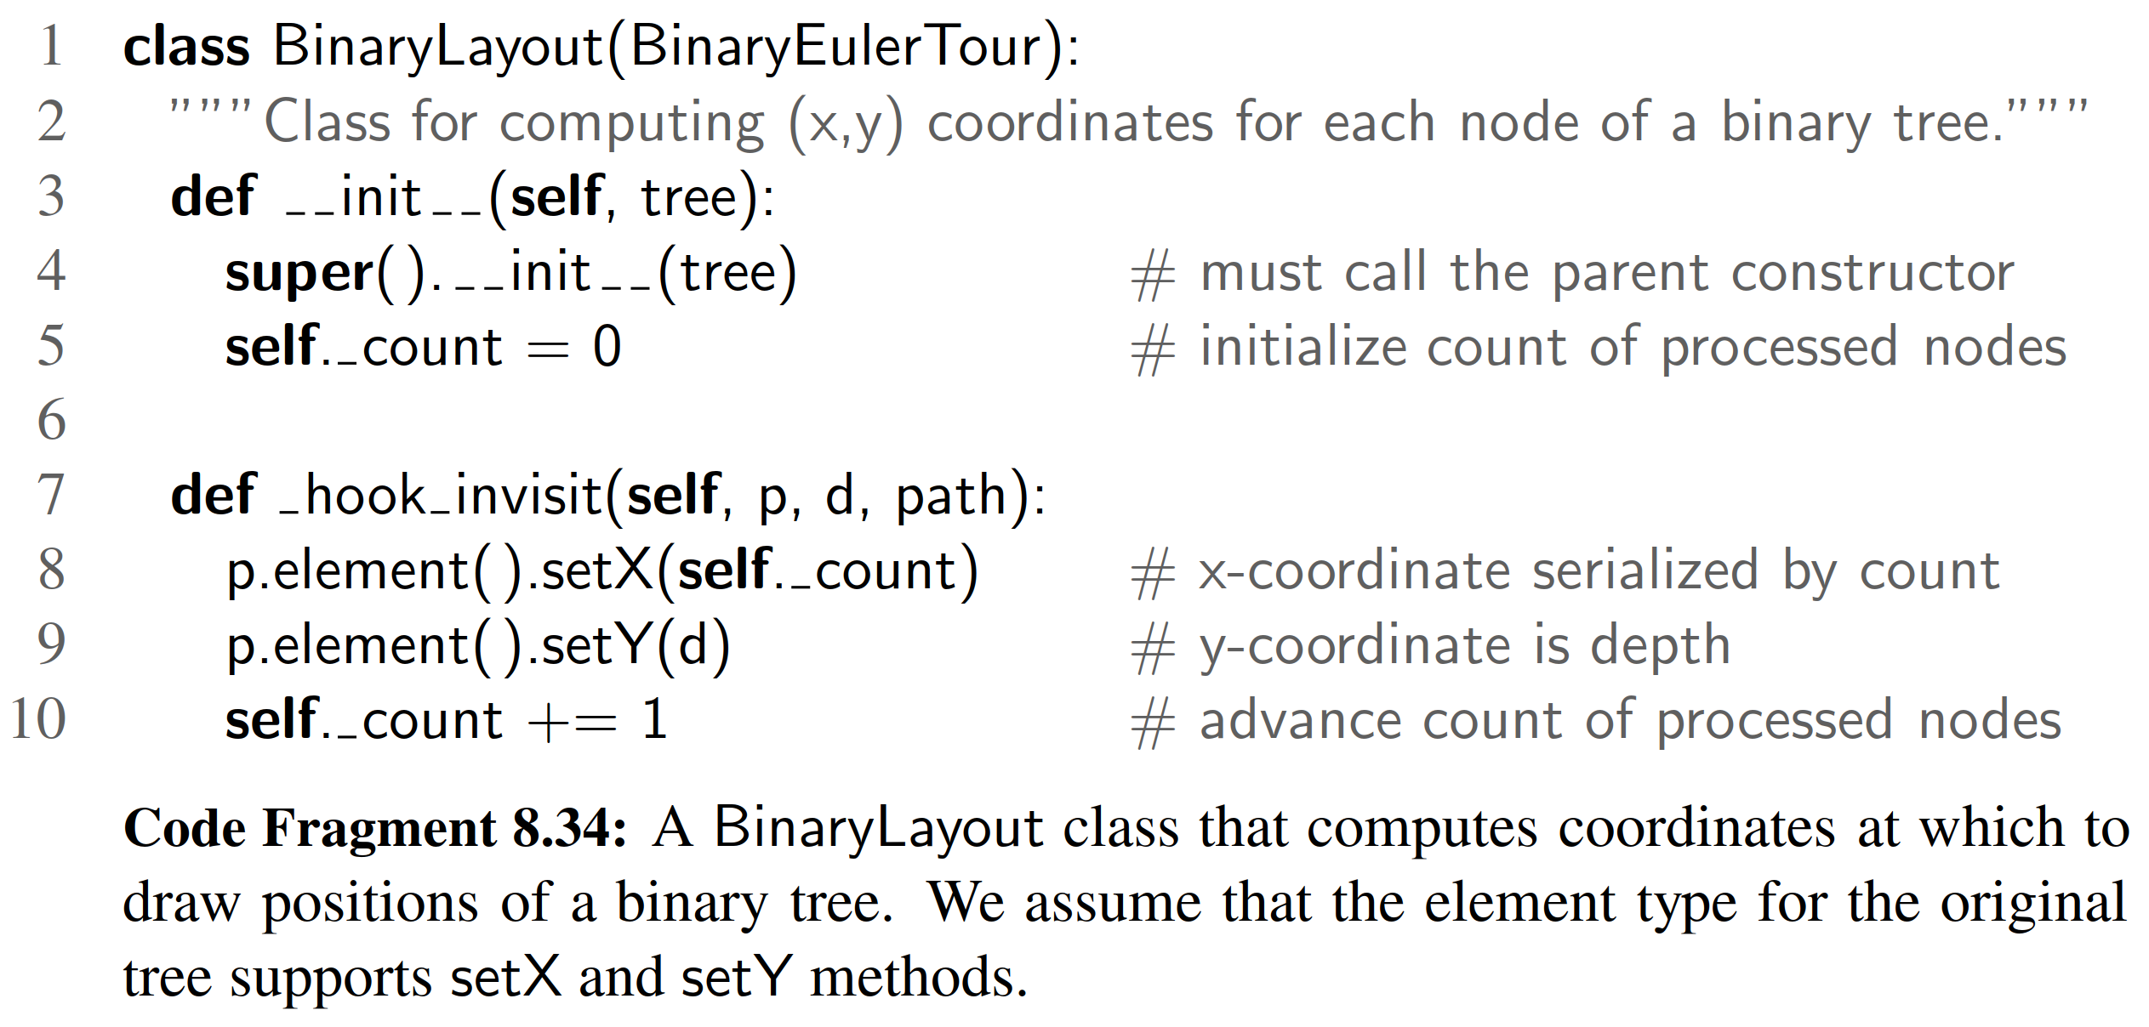

8.5 Case Study: An Expression Tree

In Example 8.7, we introduced the use of a binary tree to represent the structure of an arithmetic expression. In this section, we deﬁne a new ExpressionTree class that provides support for constructing such trees, and for displaying and evaluating the arithmetic expression that such a tree represents. Our ExpressionTree class is de- ﬁned as a subclass of LinkedBinaryTree, and we rely on the nonpublic mutators to construct such trees. Each internal node must store a string that deﬁnes a binary op- erator (e.g., + ), and each leaf must store a numeric value (or a string representing a numeric value).

Our eventual goal is to build arbitrarily complex expression trees for compound arithmetic expressions such as (((3 + 1) × 4)/((9 − 5)+ 2)). However, it sufﬁces for the ExpressionTree class to support two basic forms of initialization:

ExpressionTree(value): Create a tree storing the given value at the root.

ExpressionTree(op, E1, E2): Create a tree storing string op at the root (e.g., +),

and with the structures of existing ExpressionTree instances E1 and E2 as the left and right subtrees of the root, respectively.

Such a constructor for the ExpressionTree class is given in Code Fragment 8.35. The class formally inherits from LinkedBinaryTree, so it has access to all the non- public update methods that were deﬁned in Section 8.3.1. We use add root to cre- ate an initial root of the tree storing the token provided as the ﬁrst parameter. Then we perform run-time checking of the parameters to determine whether the caller invoked the one-parameter version of the constructor (in which case, we are done), or the three-parameter form. In that case, we use the inherited attach method to incorporate the structure of the existing trees as subtrees of the root.

Composing a Parenthesized String Representation

A string representation of an existing expression tree instance, for example, as (((3+1)x4)/((9-5)+2)) , can be produced by displaying tree elements us- ing an inorder traversal, but with opening and closing parentheses inserted with a preorder and postorder step, respectively. In the context of an ExpressionTree class, we support a special str method (see Section 2.3.2) that returns the appropriate string. Because it is more efﬁcient to ﬁrst build a sequence of individ- ual strings to be joined together (see discussion of “Composing Strings” in Sec- tion 5.4.2), the implementation of str relies on a nonpublic, recursive method named parenthesize recur that appends a series of strings to a list. These methods are included in Code 8.35.

Expression Tree Evaluation

The numeric evaluation of an expression tree can be accomplished with a simple application of a postorder traversal. If we know the values represented by the two subtrees of an internal position, we can calculate the result of the computation that position designates. Pseudo-code for the recursive evaluation of the value repre- sented by a subtree rooted at position p is given in Code Fragment 8.36.

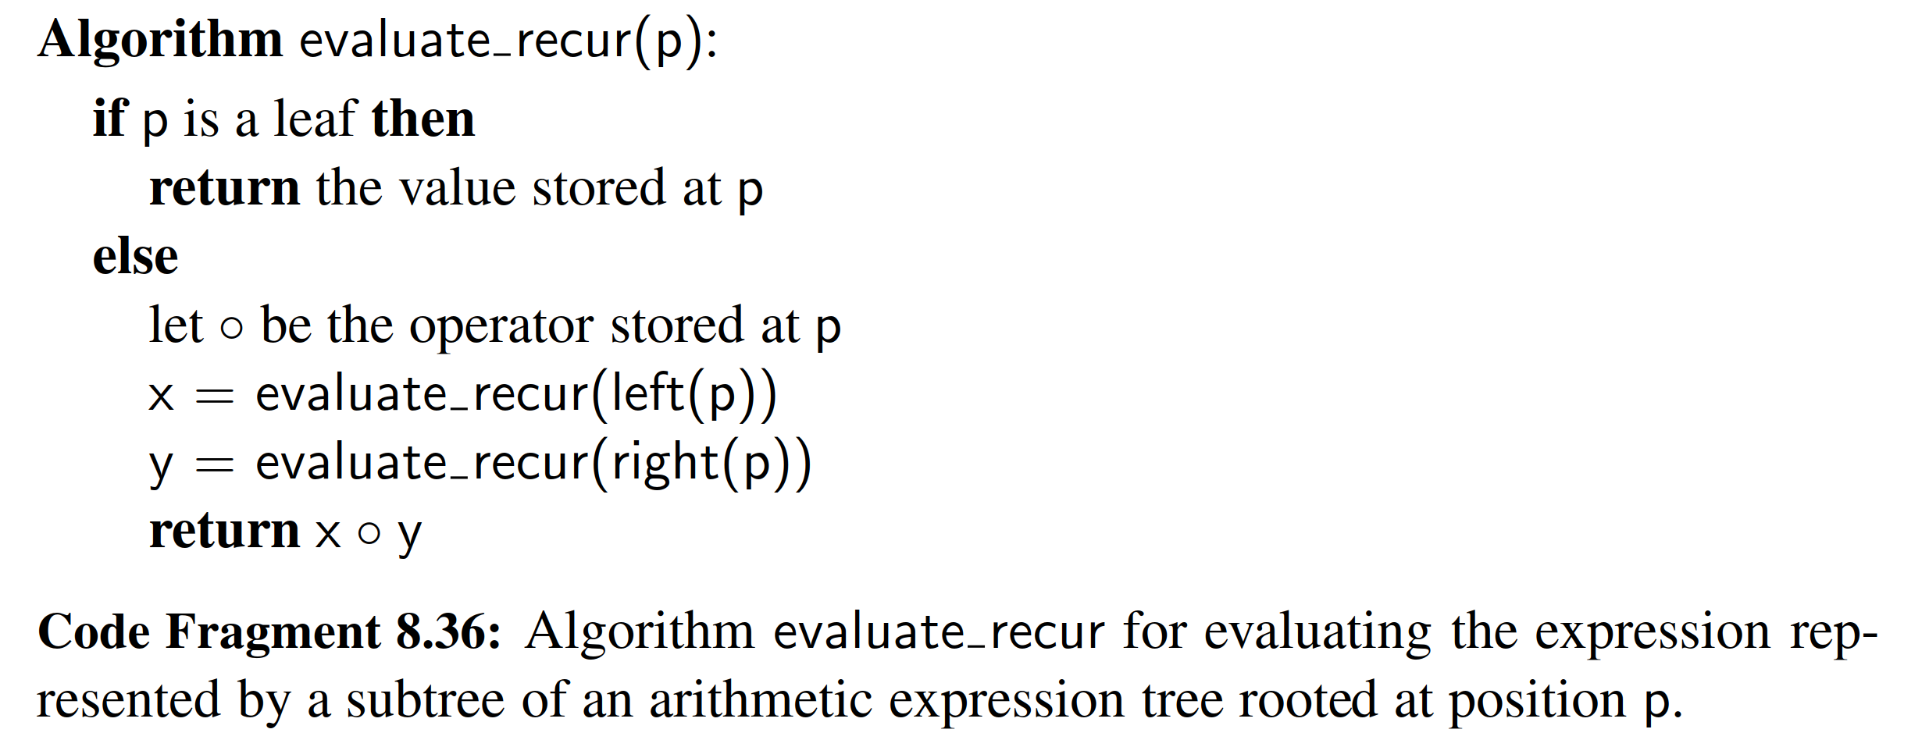

To implement this algorithm in the context of a Python ExpressionTree class, we provide a public evaluate method that is invoked on instance T as T.evaluate(). Code Fragment 8.37 provides such an implementation, relying on a nonpublic evaluate recur method that computes the value of a designated subtree.



Building an Expression Tree

The constructor for the ExpressionTree class, from Code Fragment 8.35, provides basic functionality for combining existing trees to build larger expression trees. However, the question still remains how to construct a tree that represents an ex- pression for a given string, such as (((3+1)x4)/((9-5)+2)) .

To automate this process, we rely on a bottom-up construction algorithm, as- suming that a string can ﬁrst be tokenized so that multidigit numbers are treated atomically (see Exercise R-8.30), and that the expression is fully parenthesized. The algorithm uses a stack S while scanning tokens of the input expression E to ﬁnd values, operators, and right parentheses. (Left parentheses are ignored.)

• When we see an operator ◦, we push that string on the stack.

• When we see a literal value v, we create a single-node expression tree T

storing v, and push T on the stack.

• When we see a right parenthesis, ) , we pop the top three items from the stack S, which represent a subexpression (E1 ◦ E2). We then construct a tree T using trees for E1 and E2 as subtrees of the root storing ◦, and push the resulting tree T back on the stack.

We repeat this until the expression E has been processed, at which time the top element on the stack is the expression tree for E. The total running time is O(n).

An implementation of this algorithm is given in Code Fragment 8.38 in the form of a stand-alone function named build expression tree, which produces and returns an appropriate ExpressionTree instance, assuming the input has been tokenized.

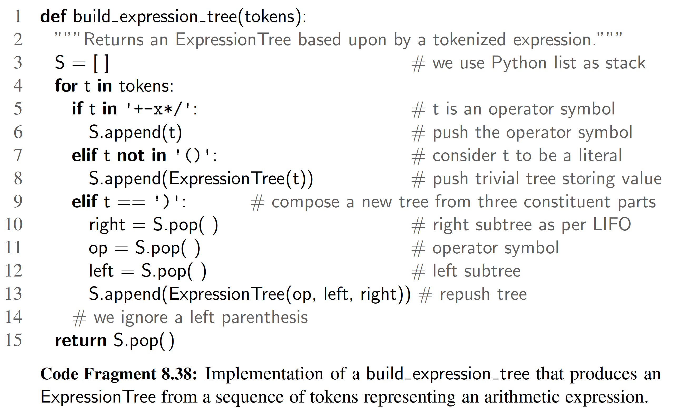

**END**

# 六、实验体会

# 七、参考文献

[1] Michael T. Goodrich, Roberto Tamassia, Michael H. Goldwasser, Data Structures and Algorithms in Python

[2] 数据结构与算法分析：C语言描述（原书第二版），（美）维斯著；冯舜玺译. 北京：机械工业出版社

[3] 算法导论（原书第三版），（美）科尔曼（Cormen，T.H.）等；殷建平等译. 北京：机械工业出版社